**PERSONAL EXPENSE TRACKER APPLICATION**

**A PROJECT REPORT**

***Submitted by***

**HARSHITHA M S 113219031051**

**YUKTHA SRI K H 113219031166**

**NEERAJA Y 113219031098  
ZAINAB NUSAIBA 113219031169**

**TEAM ID: PNT2022TMID23434**

**VELAMMAL ENGINEERING COLLEGE -CHENNAI**

**TABLE OF CONTENTS:**

|  |  |
| --- | --- |
| **S.NO** | **TITLE** |
| **1** | **INTRODUCTION** |
| 1.1 | Project Overview |
| 1.2 | Purpose |
| **2** | **LITERATURE SURVEY** |
| 2.1 | Existing problem |
| 2.2 | References |
| 2.3 | Problem Statement Definition |
| **3** | **IDEATION & PROPOSED SOLUTION** |
| 3.1 | Empathy Map Canvas |
| 3.2 | Ideation & Brainstorming |
| 3.3 | Proposed Solution |
| 3.4 | Problem Solution Fit |

|  |  |
| --- | --- |
| **4** | **REQUIREMENT ANALYSIS** |
| 4.1 | Functional requirements |
| 4.2 | Non-Functional requirements |
| **5** | **PROJECT DESIGN** |
| 5.1 | Data Flow Diagrams |
| 5.2 | Solution &Technical Architecture |
| 5.3 | User Stories |
| **6** | **PROJECT PLANNING & SCHEDULING** |
| 6.1 | Sprint Planning & Estimation |
| 6.2 | Sprint Delivery Schedule |
| **7** | **CODING & SOLUTIONING** |
| 7.1 | Feature 1 |
| 7.2 | Feature 2 |

|  |  |
| --- | --- |
| 7.3 | Database Schema |
| **8** | **TESTING** |
| 8.1 | Test Cases |
| 8.2 | User Acceptance Testing |
| **9** | **RESULTS** |
| 9.1 | Performance Metrics |
| **10** | **ADVANTAGES & DISADVANTAGES** |
| **11** | **CONCLUSION** |
| **12** | **FUTURE SCOPE** |
| **13** | **APPENDIX** |

1. **INTRODUCTION** 
   1. **Project Overview**.

* **Personal expense tracker is a windows store application to be designed for tracking daily personal and business expense transaction.**
* **The main feature includes manage account book of different user, management daily transaction, report generation, supplier management, set limit for expense etc.**
* **This application helps you to track all the expenses, incomes, accounts of different user and analyzing income /expense reports.**
* **It is flexible and adaptive application suited to personal and business man.**
* **This application will help us to reduce the manual calculators for their daily expenses and also keep the track of the expenses.** 
  1. **Purpose**

**The Purpose of our Project is**

* **Report generation system(income/expense).**
* **Provide notifications to user using limit set for expense if it increases the limit .**
* **Managing the account books of different user .**
* **It will include the date of transaction and also will capture the photo of receipt of transaction.**
* **It will also add a location from where transaction had made .**
* **Managing returned payment of policy ,or debited income.**

1. **LITERATURE SURVEY** 
   1. **Existing Problem:**

➤**A personal finance app will not only help you with budgeting and accounting but also give you helpful in sights about money management .**

➤**They have an option to set a limit for the amount to be used for that particular month if the limit is exceeded the user will be notified with an email alert .**

➤**This is a personal budget management app that tracks your expenditures and income and gives you recommendations to make you economically strong.**

* 1. **References:**

https://www.researchgate.net/publication/347972162_Expense_Manager_Application

https://www.researchgate.net/publication/357644872_An_Android_Based_Mobile_Applicati on_for_Tracking_Daily_Expenses

1. **IDEATION & PROPOSED SOLUTION** 
   1. **EMPATHY MAP CANVAS**

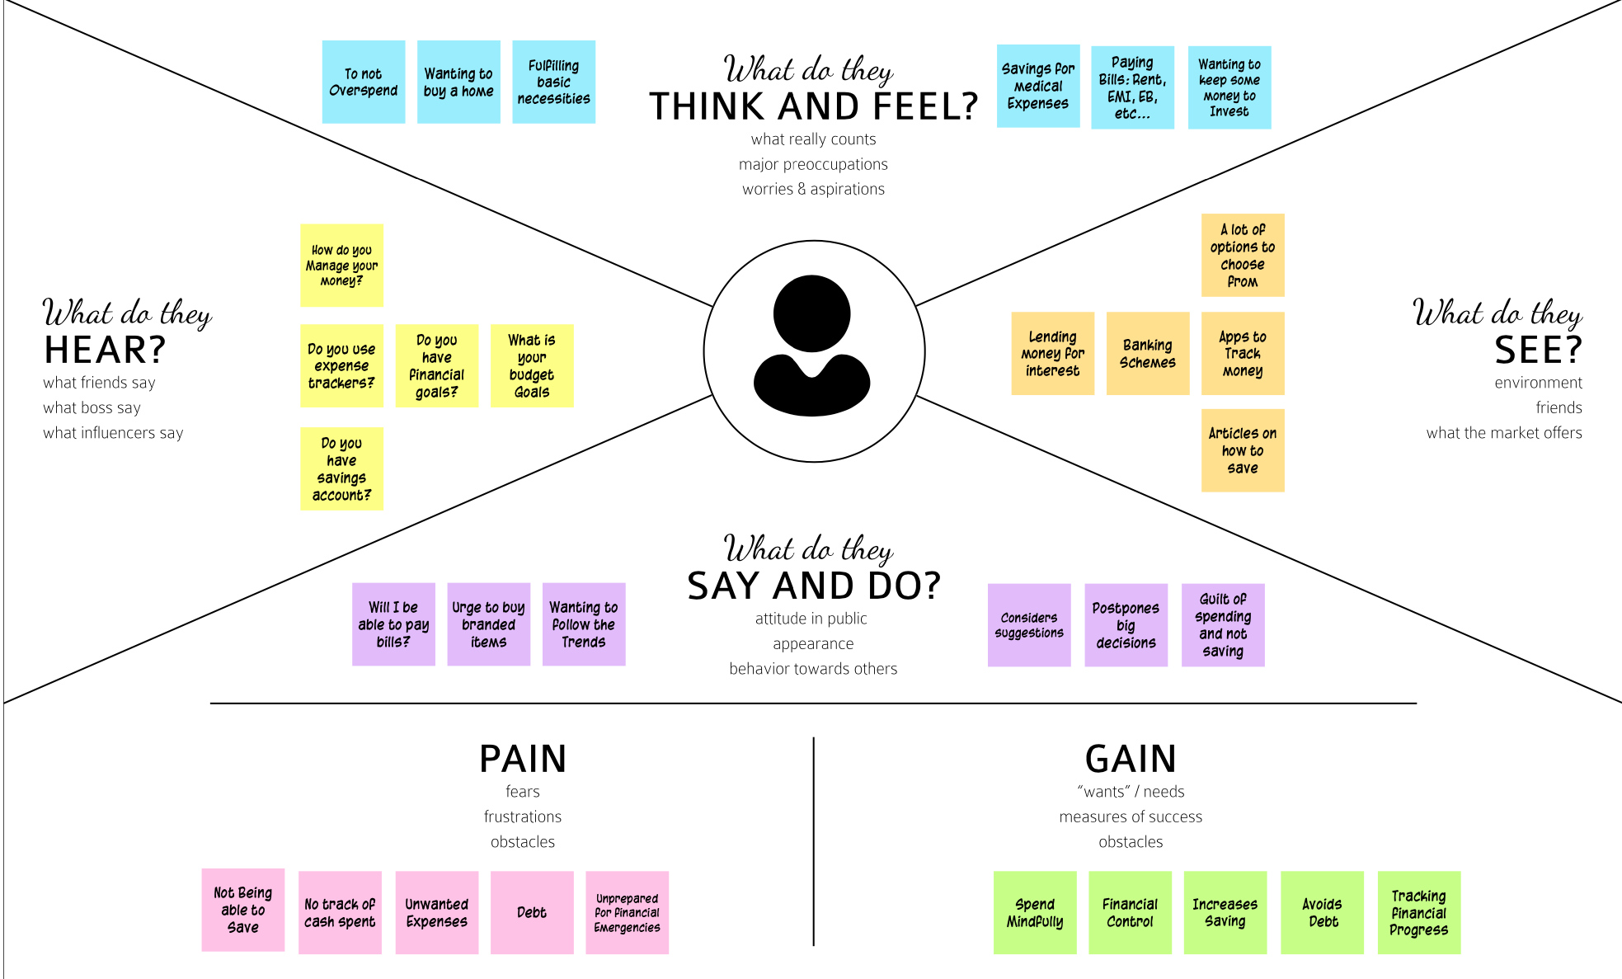

**Link:**

**https://app.mural.co/t/nandha5209/m/nandha5209/1663403322685/25e79a31a 22cc8b819ca0d9c96bbd1909626b177?sender=u80aec0d3bca7bbaa1df83835**

* 1. **Ideation & Brainstromings**

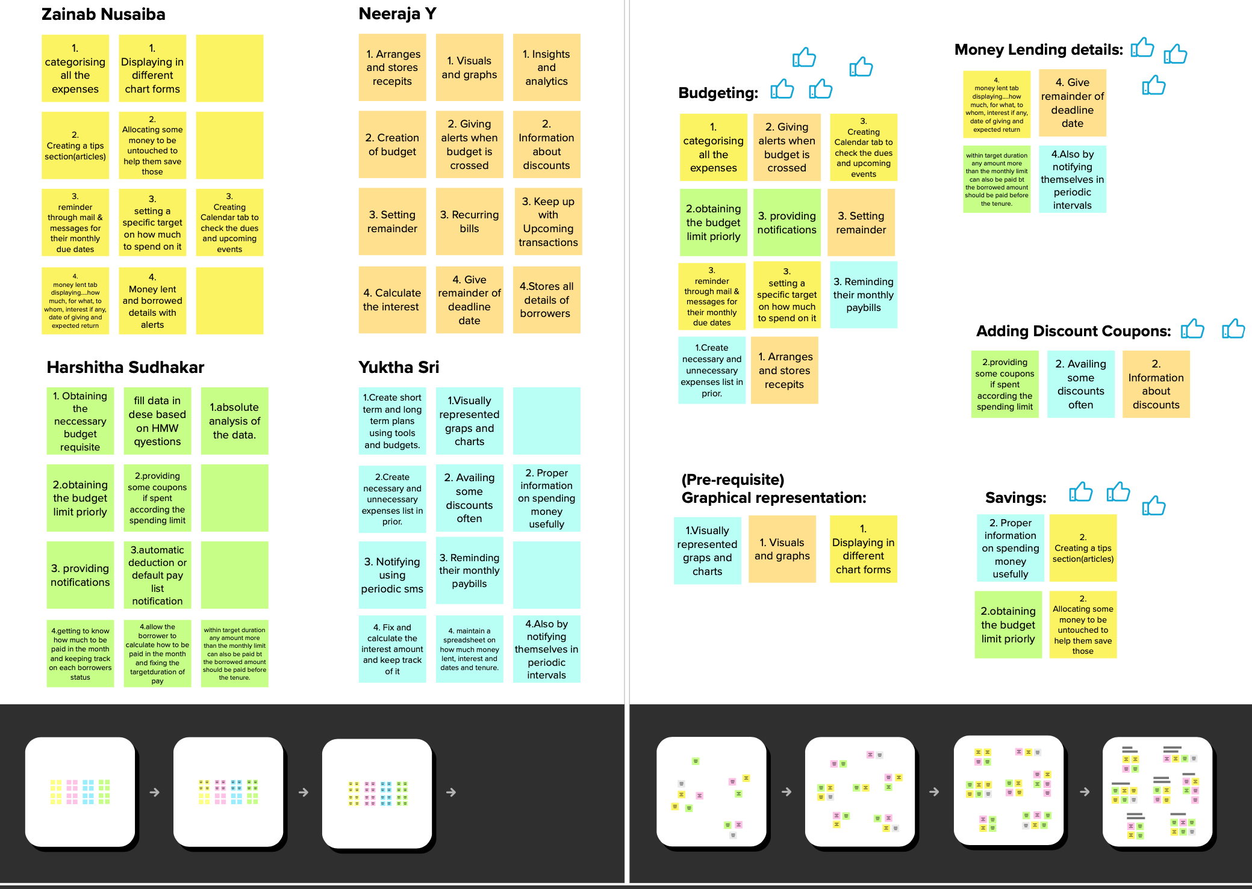

**Link: https://app.mural.co/t/ibmproject4978/m/ibmproject4978/1665222728593/a6fc027d68001365fa9ce98629b7fdf6716a0d77?invited=true&sender=u01f470fac3a4953fe1935959**

* 1. **Proposed Solution**

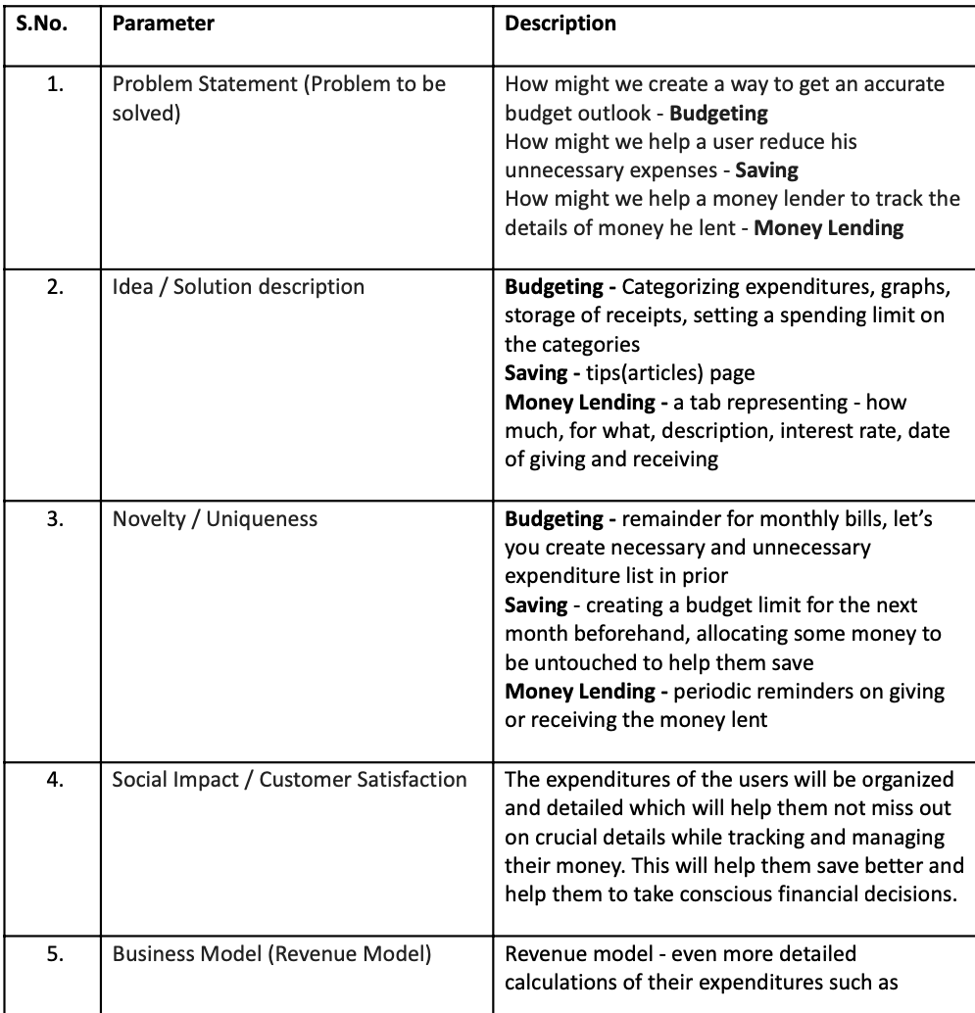

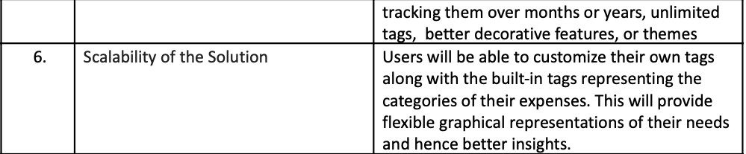

* 1. **Problem Solution fit**

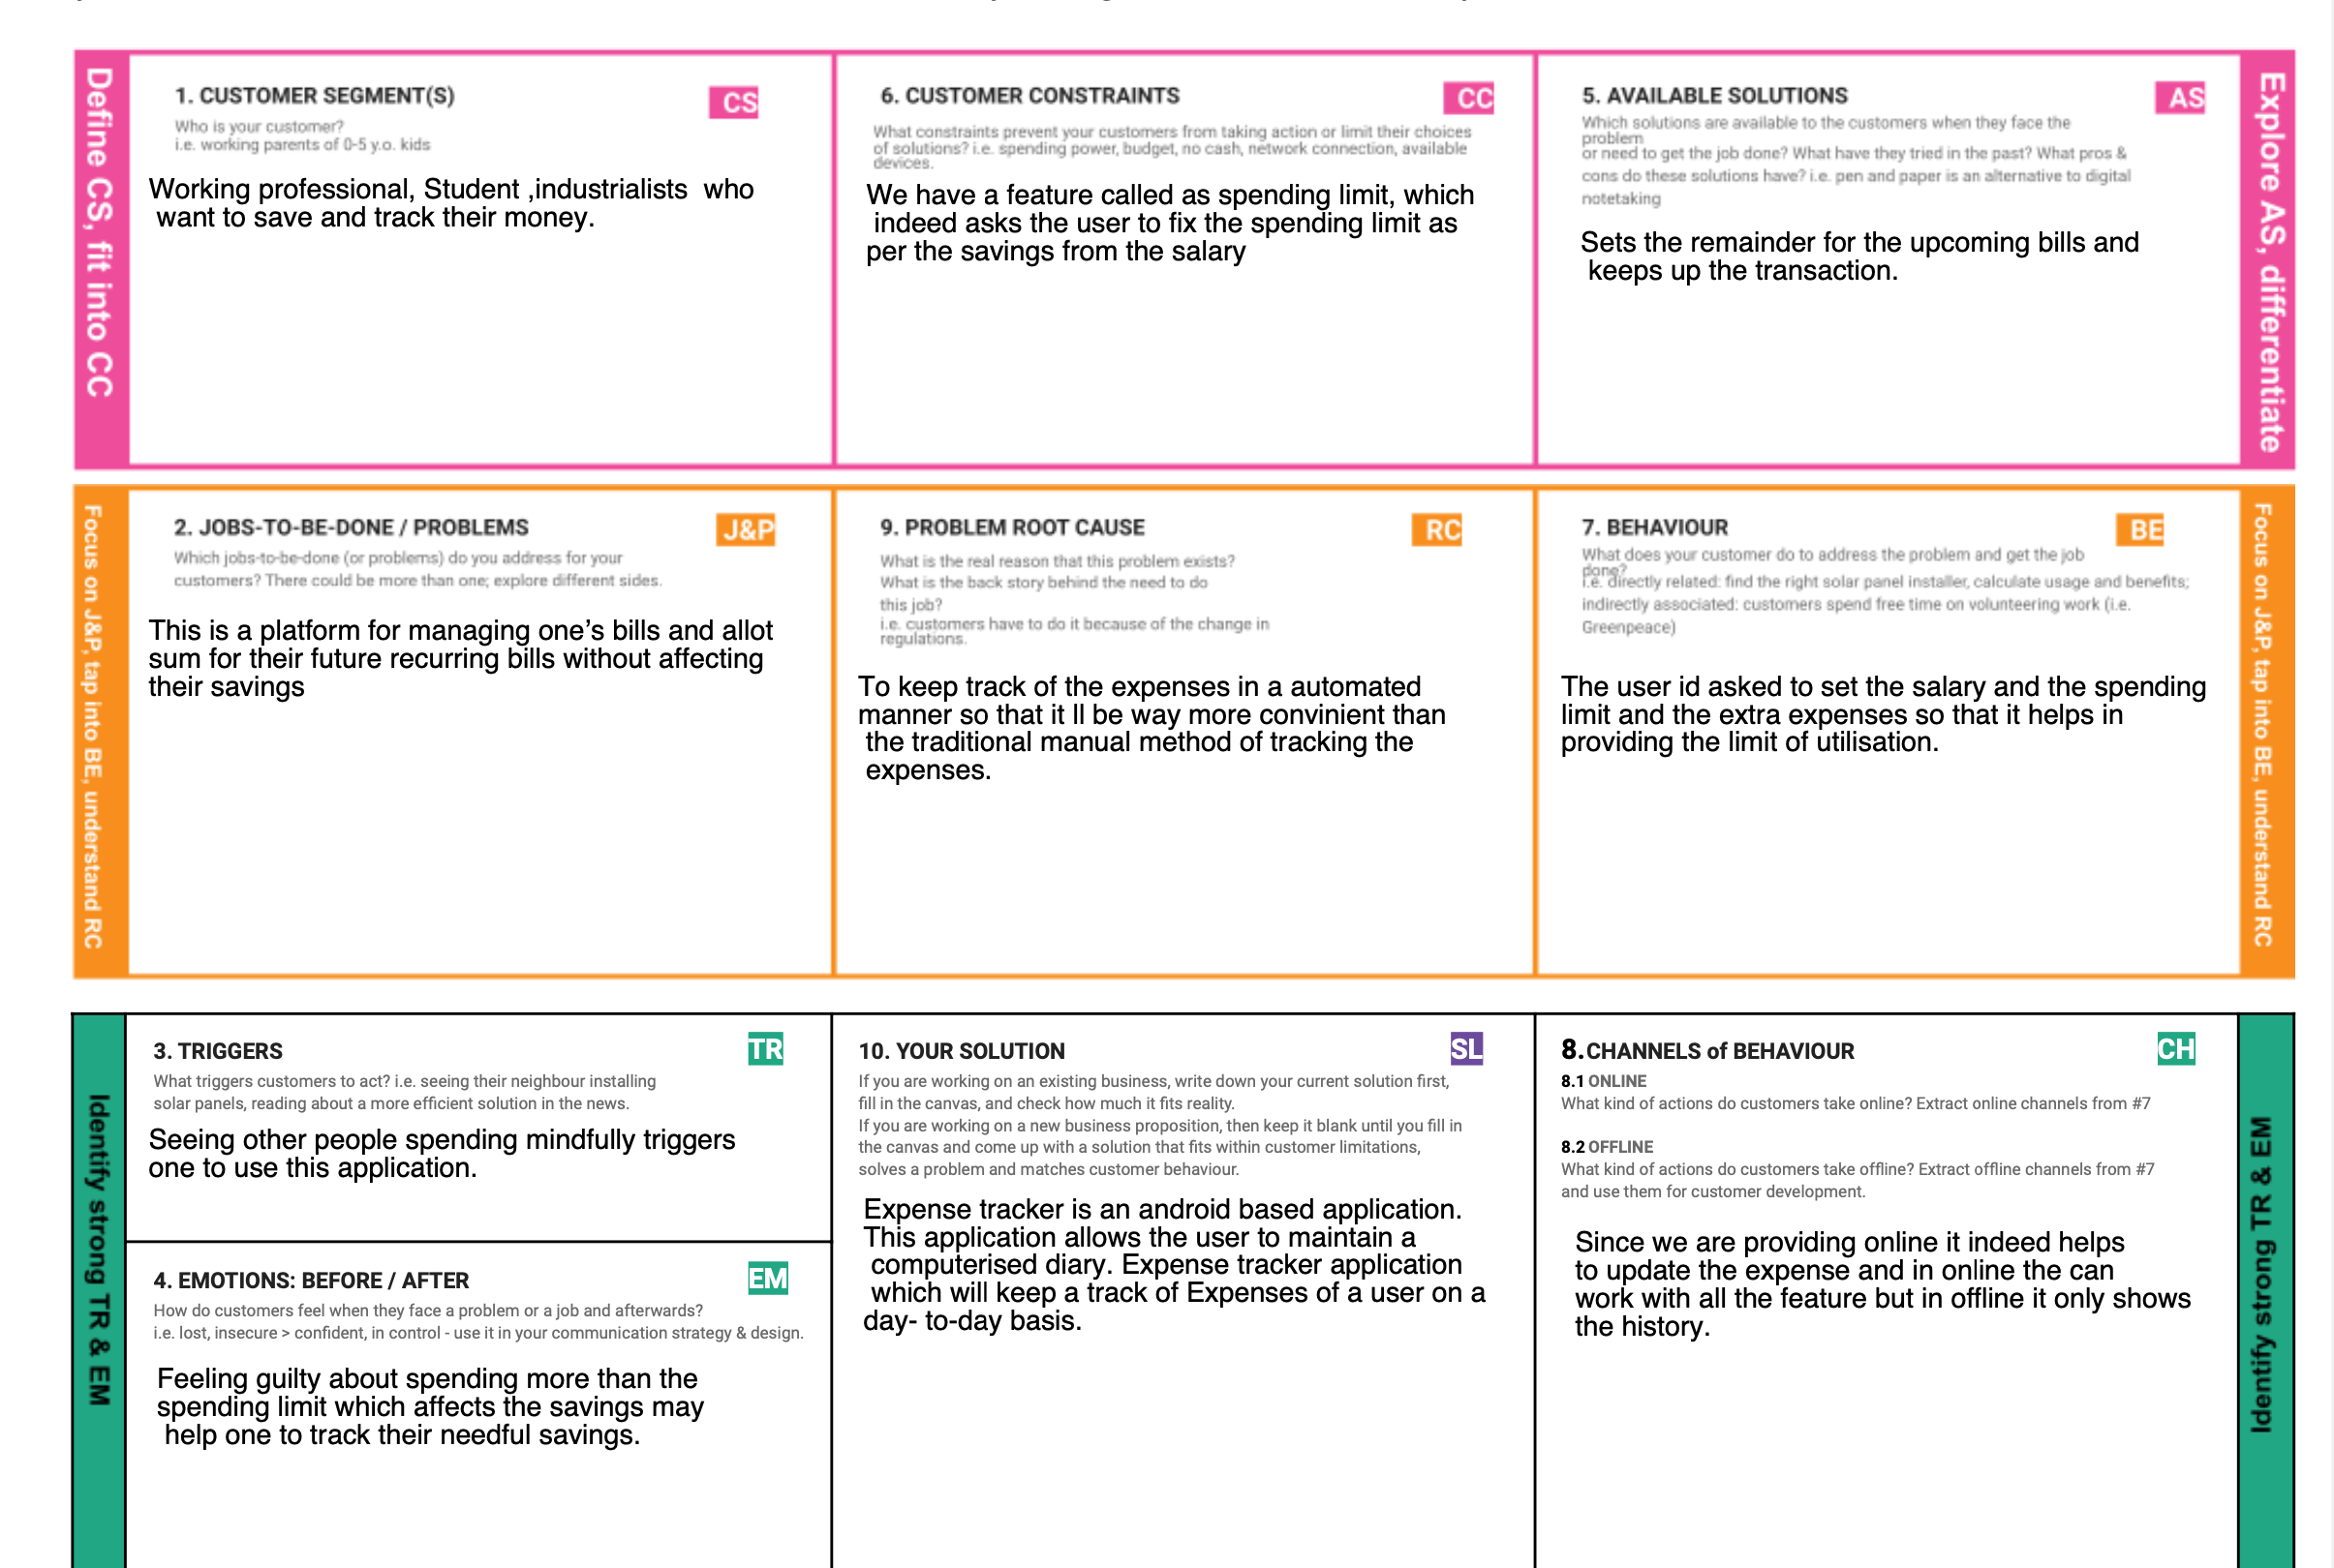

1. **REQUIREMENTANALYSIS** 
   1. **Functional requirements**

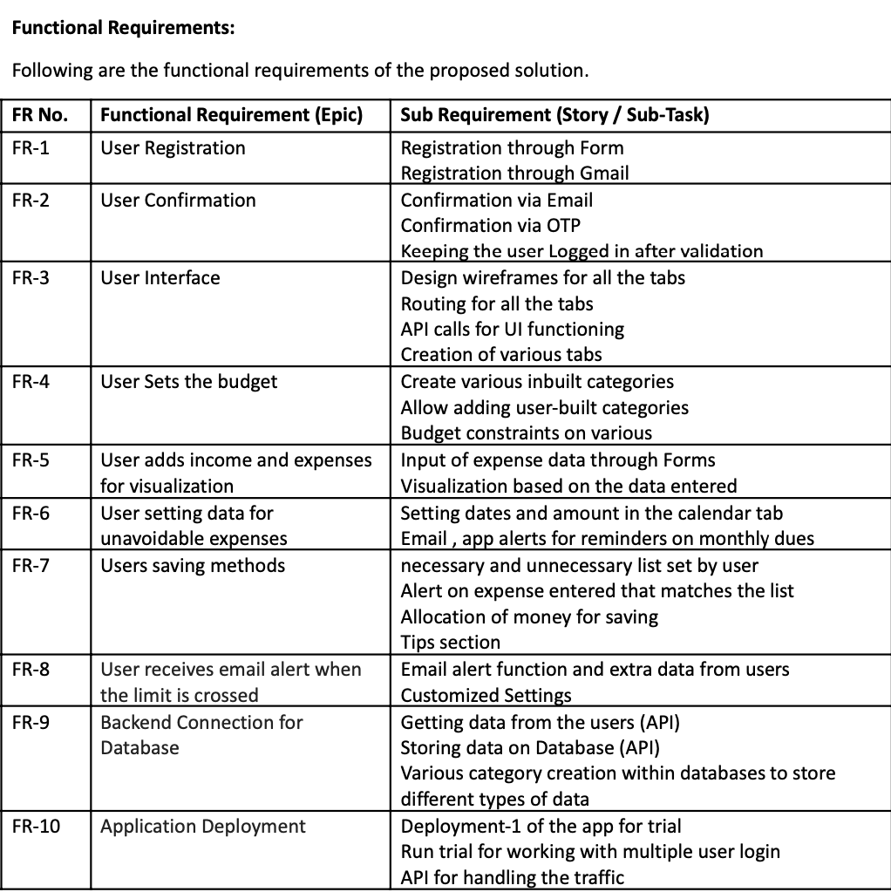

* 1. **Non-functional requirements**

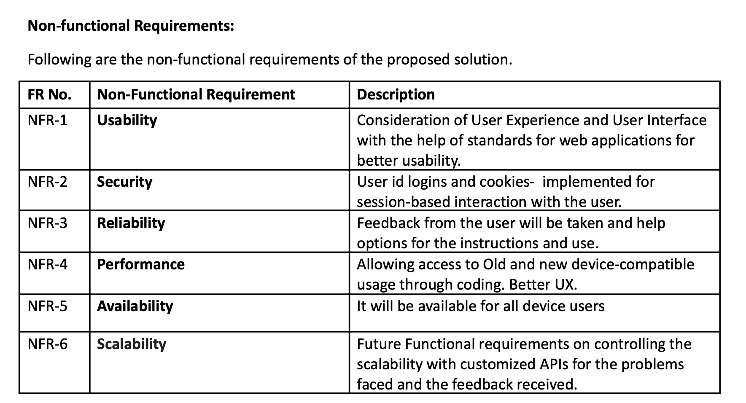

1. **PROJECT DESIGN** 
   1. **Data flow diagram**

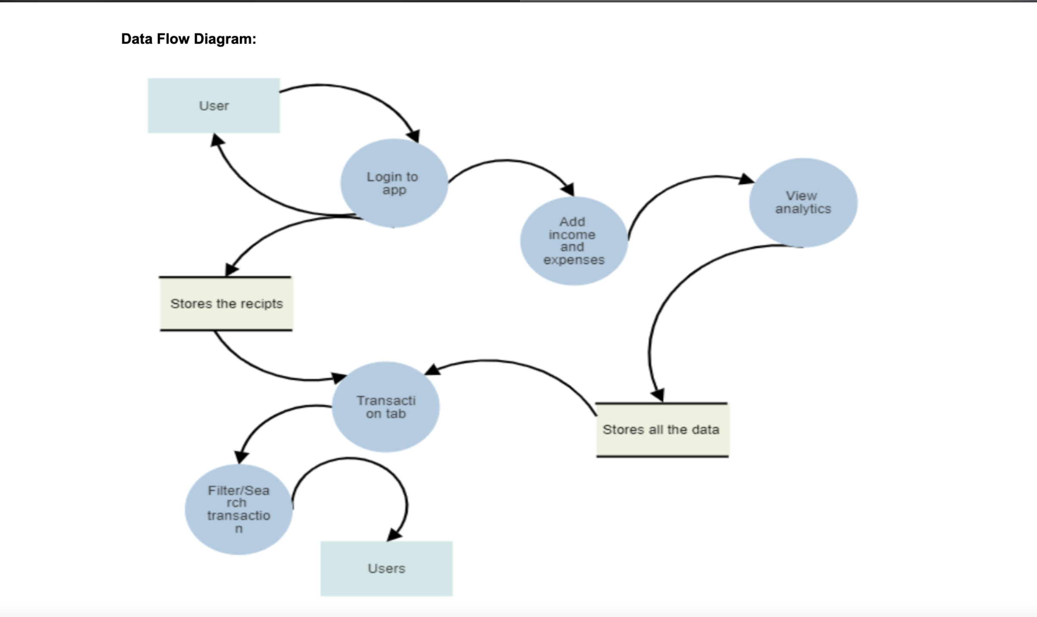

* 1. **Solution Architecture:**

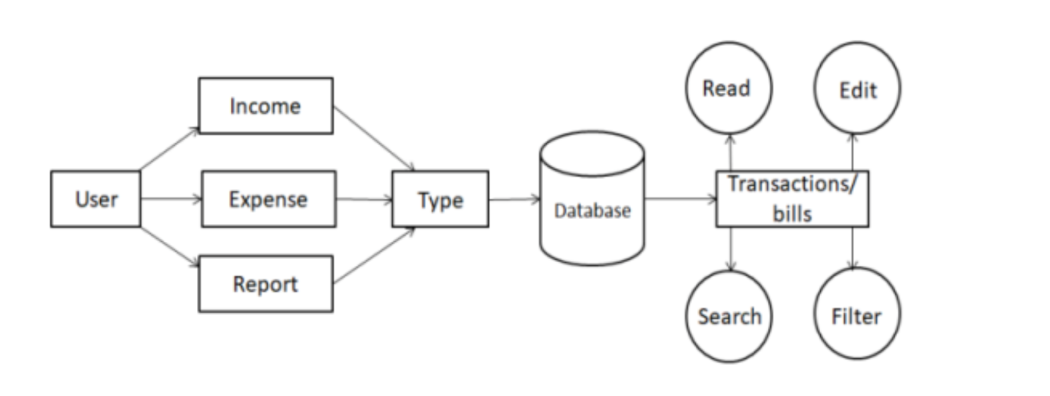

**Technical architecture**

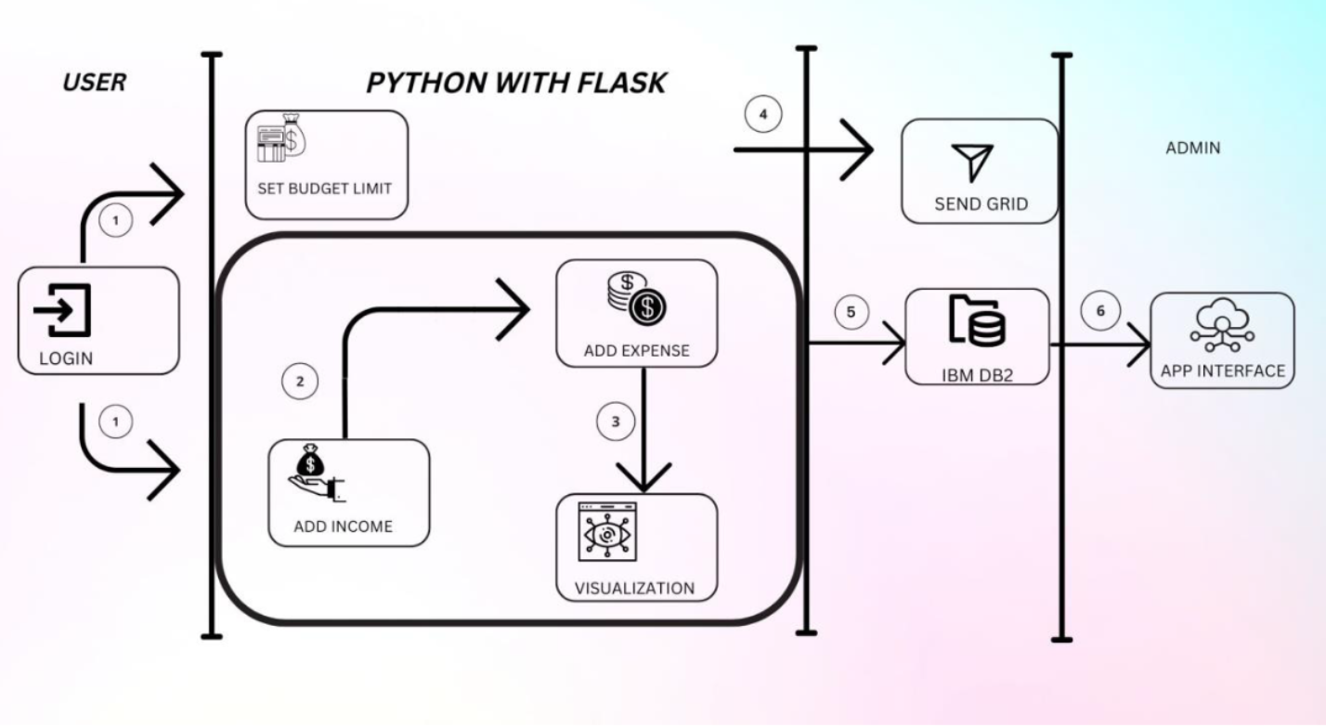

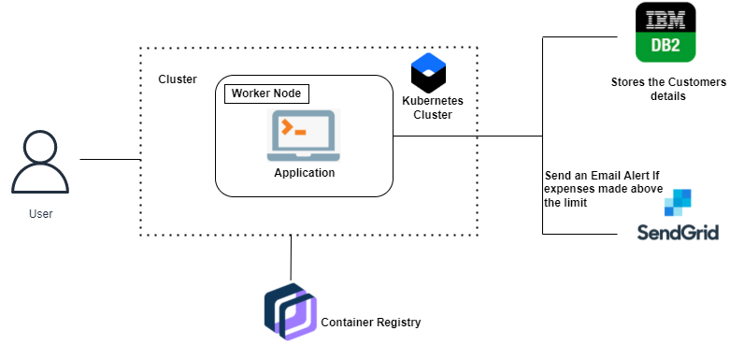

* 1. **User stories**

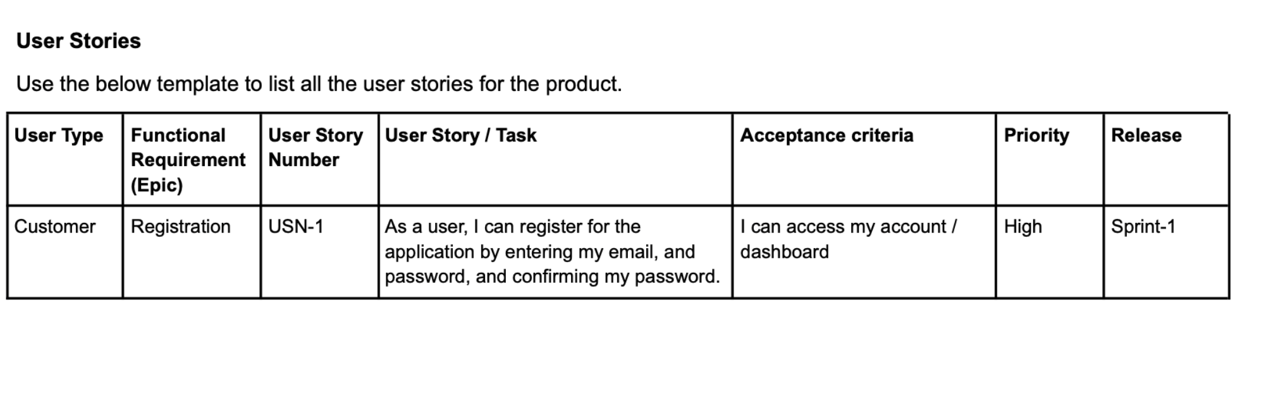

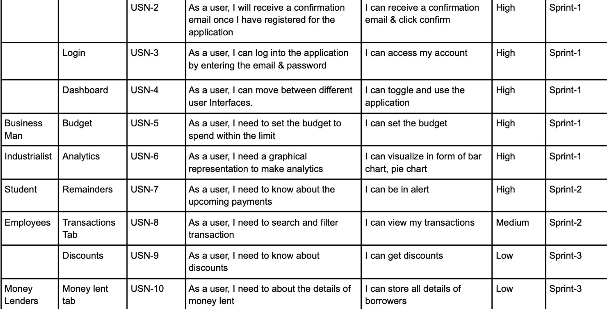

1. **PROJECT PLANNING & SCHEDULING** 
   1. **Sprint Planning & Estimation**

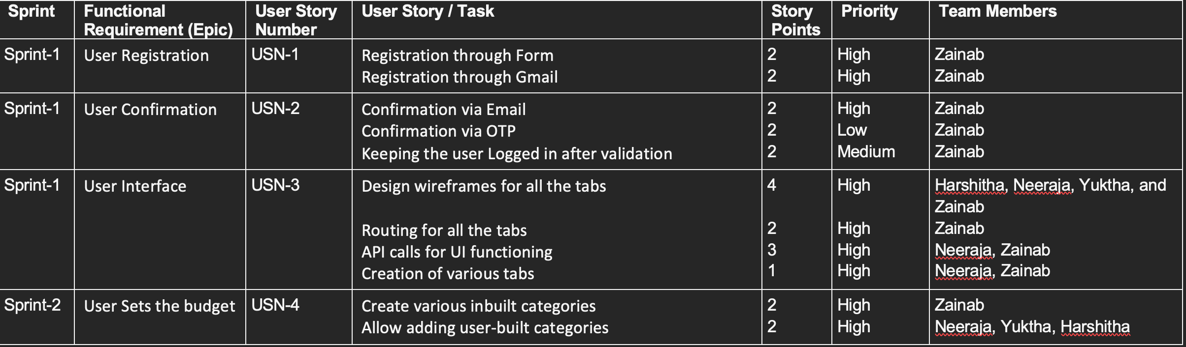

* 1. **Sprint Delivery Schedule:**

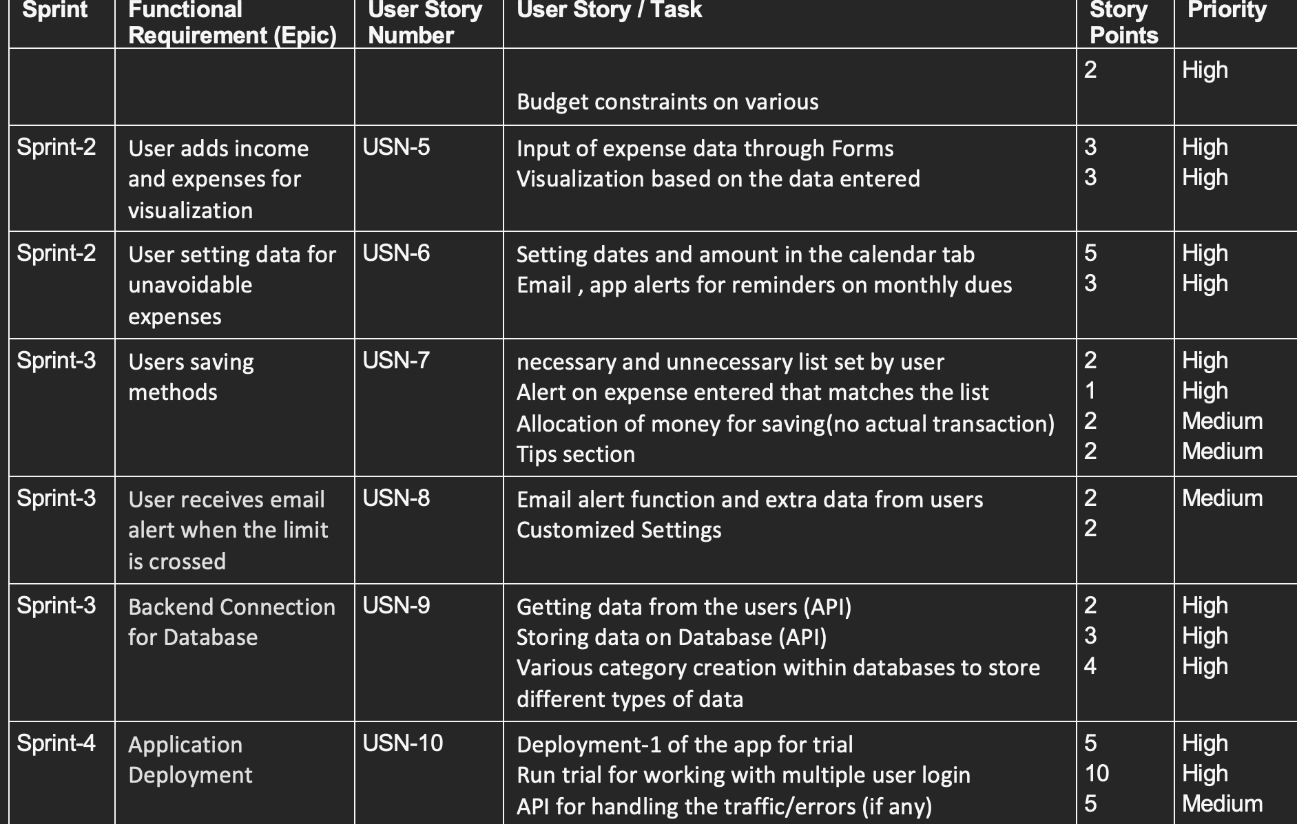

1. **CODING & SOLUTIONING** 
   1. **Feature 1**

**PERSONAL EXPENSE TRACKER**

**Description:**

**After making this application we assure that this application will help its users to manage the cost of their daily expenditure.**

**It will guide them and make them aware about their daily expenses. It will prove to be helpful for the people who are frustrated**

**with their daily budget management, irritated because of the amount**

**of expenses and wish to manage money and to preserve the record of**

**their daily cost which may be useful to change their way of spending**

**money.In short, this application will help its users to overcome the**

**wastage of money.**

**HOME PAGE :**

**SPRINT 1:**

**LandingPage:**

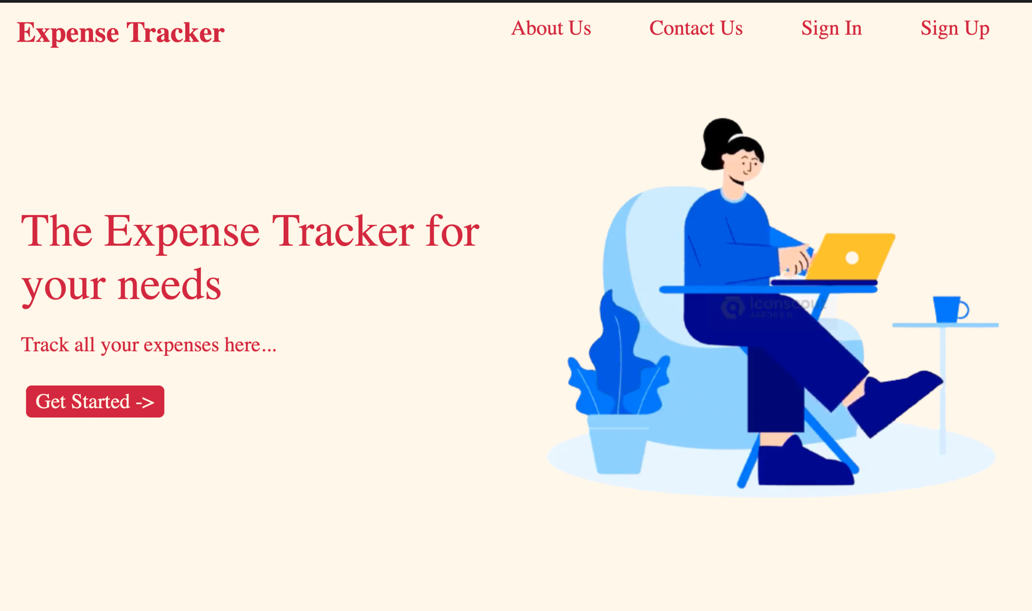

**SPRINT 1:**

**App.py:**

**from flask import Flask, request, redirect**

**from flask import Blueprint,render_template**

**app = Flask(__name__)**

**app.debug = True**

**@app.route('/')**

**def landingPage():**

**return render_template("landingPage.html")**

**@app.route('/navbar')**

**def navbar():**

**return render_template("Navbar.html")**

**@app.route('/contactus')**

**def contactus():**

**return render_template("contactUs.html")**

**@app.route('/signup')**

**def signup():**

**return render_template("signUp.html")**

**@app.route('/signin')**

**def signin():**

**return render_template("signIn.html")**

**@app.route('/aboutus')**

**def aboutus():**

**return render_template("aboutUs.html")**

**@app.route('/skeleton')**

**def skeleton():**

**return render_template("skeleton.html")**

**@app.route('/dashboard')**

**def dashboard():**

**return render_template("dashboard.html")**

**@app.route('/addingExpenses')**

**def addingExpenses():**

**return render_template("addingExpenses.html")**

**if __name__ == '__main__':**

**app.run()**

**Index code:**

**Navbar.html:**

**<!DOCTYPE html>**

**<html lang="en">**

**<head>**

**<meta charset="UTF-8" />**

**<meta http-equiv="X-UA-Compatible" content="IE=edge" />**

**<meta name="viewport" content="width=device-width, initial-scale=1.0" />**

**<link**

**rel="stylesheet"**

**href="{{url_for('static',filename='css/Navbar.css')}}"**

**/>**

**</head>**

**<body>**

**<nav>**

**<a href="/" class="appName">Expense Tracker</a>**

**<div class="rightNav">**

**<span><a href="/aboutus" class="landingLink"> About Us</a></span>**

**<span><a href="/contactus" class="landingLink"> Contact Us</a></span>**

**<span><a href="/signin" class="landingLink">Sign In</a> </span>**

**<span><a href="/signup" class="landingLink">Sign Up</a></span>**

**</div>**

**</nav>**

**</body>**

**</html>**

**Navbar.css:**

**nav {**

**display: flex;**

**justify-content: space-between;**

**}**

**.appName {**

**font-size: 2.5rem;**

**font-weight: bold;**

**color: #d32840;**

**text-decoration: none;**

**}**

**.landingLink {**

**text-decoration: none;**

**font-size: 1.8rem;**

**font-weight: 500;**

**margin: 0rem 1rem;**

**padding: 0.3rem 1rem;**

**color: #d32840;**

**}**

**.landingLink:hover {**

**border-bottom: 4px solid #d32840;**

**}**

**.active {**

**border-bottom: 4px solid #d32840;**

**}**

**SignIn.html:**

**<!DOCTYPE html>**

**<html lang="en">**

**<head>**

**<meta charset="UTF-8" />**

**<meta http-equiv="X-UA-Compatible" content="IE=edge" />**

**<meta name="viewport" content="width=device-width, initial-scale=1.0" />**

**<link**

**rel="stylesheet"**

**href="{{url_for('static',filename='css/signIn.css')}}"**

**/>**

**<title>signIn</title>**

**</head>**

**<body>**

**{% include 'Navbar.html' %}**

**<h1>Sign In Page</h1>**

**<div class="signin" style="border:1px solid rgb(30, 28, 28)">**

**<form action="">**

**<label for="username"><b>username</b></label>**

**<input type="text" placeholder="Enter username" name="uaername" required class="name"></br></br>**

**<label for="psw"><b>Password</b></label>**

**<input type="password" placeholder="Enter Password" name="psw" required class="psw"></br></br>**

**</form>**

**<p class="or">or</p>**

**<a href="/login" target="_blank"><button class="googlelogin">Signin with google</button></a>**

**</div>**

**</body>**

**</html>**

**SignIn.css:**

**\* {**

**background-color: #fff7e9;**

**margin: 0.4rem;**

**}**

**body{**

**color: red**

**}**

**.signin{**

**width:30%;**

**height: 50%;**

**margin: 3%;**

**}**

**.name,.psw,.googlelogin{**

**color: red;**

**border: 1px solid rgb(30, 28, 28);**

**padding: 1%;**

**}**

**.googlelogin{**

**margin-left: 25%;**

**}**

**.or{**

**padding-left: 35%;**

**}**

**SignUp.html:**

**<!DOCTYPE html>**

**<html lang="en">**

**<head>**

**<meta charset="UTF-8" />**

**<meta http-equiv="X-UA-Compatible" content="IE=edge" />**

**<meta name="viewport" content="width=device-width, initial-scale=1.0" />**

**<title>Sign Up</title>**

**<link**

**rel="stylesheet"**

**href="{{url_for('static',filename='css/signUp.css')}}"**

**/>**

**</head>**

**<body>**

**{% include 'Navbar.html' %}**

**<h1>Sign Up Page</h1>**

**<section class="signup" style="border:1px solid rgb(32, 30, 30)">**

**<form action="" class="hero">**

**<label for="fullname"><b>Full Name</b></label>**

**<input type="text" placeholder="Enter name" name="name" class="name" required></br></br>**

**<label for="email"><b>Email</b></label>**

**<input type="text" placeholder="Enter Email" name="email" class="email" required></br></br>**

**<label for="username"><b>Username</b></label>**

**<input type="text" placeholder="Enter username" name="uaername" class="username" required></br></br>**

**<label for="psw"><b>Password</b></label>**

**<input type="password" placeholder="Enter Password" name="psw" class="psw" required></br></br>**

**<label for="psw-repeat"><b>Repeat Password</b></label>**

**<input type="password" placeholder="Repeat Password" name="psw-repeat" class="psw-repeat" required></br></br>**

**<div class="clearfix">**

**<button type="button" class="cancelbtn">Cancel</button></br>**

**<button type="submit" class="signupbtn">Sign Up</button>**

**</form>**

**<p class="or">or</p>**

**<a href="/login" target="_blank"><button class="google">sign up with google</button></a>**

**</section>**

**</body>**

**</html>**

**SignUp.css:**

**\* {**

**background-color: #fff7e9;**

**margin: 0.4rem;**

**}**

**body{**

**color: red**

**}**

**.signup{**

**width:30%;**

**height: 50%;**

**margin: 3%;**

**}**

**.cancelbtn,.signupbtn,.name,.email,.psw,.psw-repeat,.username,.google,.login{**

**color: red;**

**border: 1px solid rgb(32, 30, 30);**

**padding: 1%;**

**}**

**.cancelbtn,.signupbtn,.or{**

**margin-left: 27%;**

**}**

**.google{**

**margin-left: 20%;**

**}**

**.or{**

**margin-left: 30%;**

**}**

**SPRINT 2:**

**AddingExpense:**

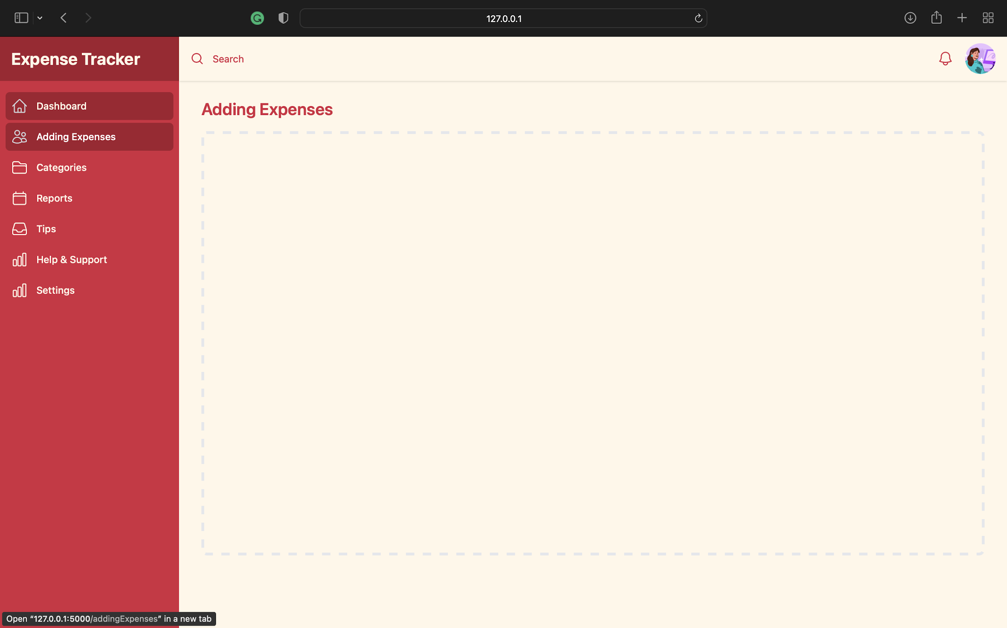

**Reports:**

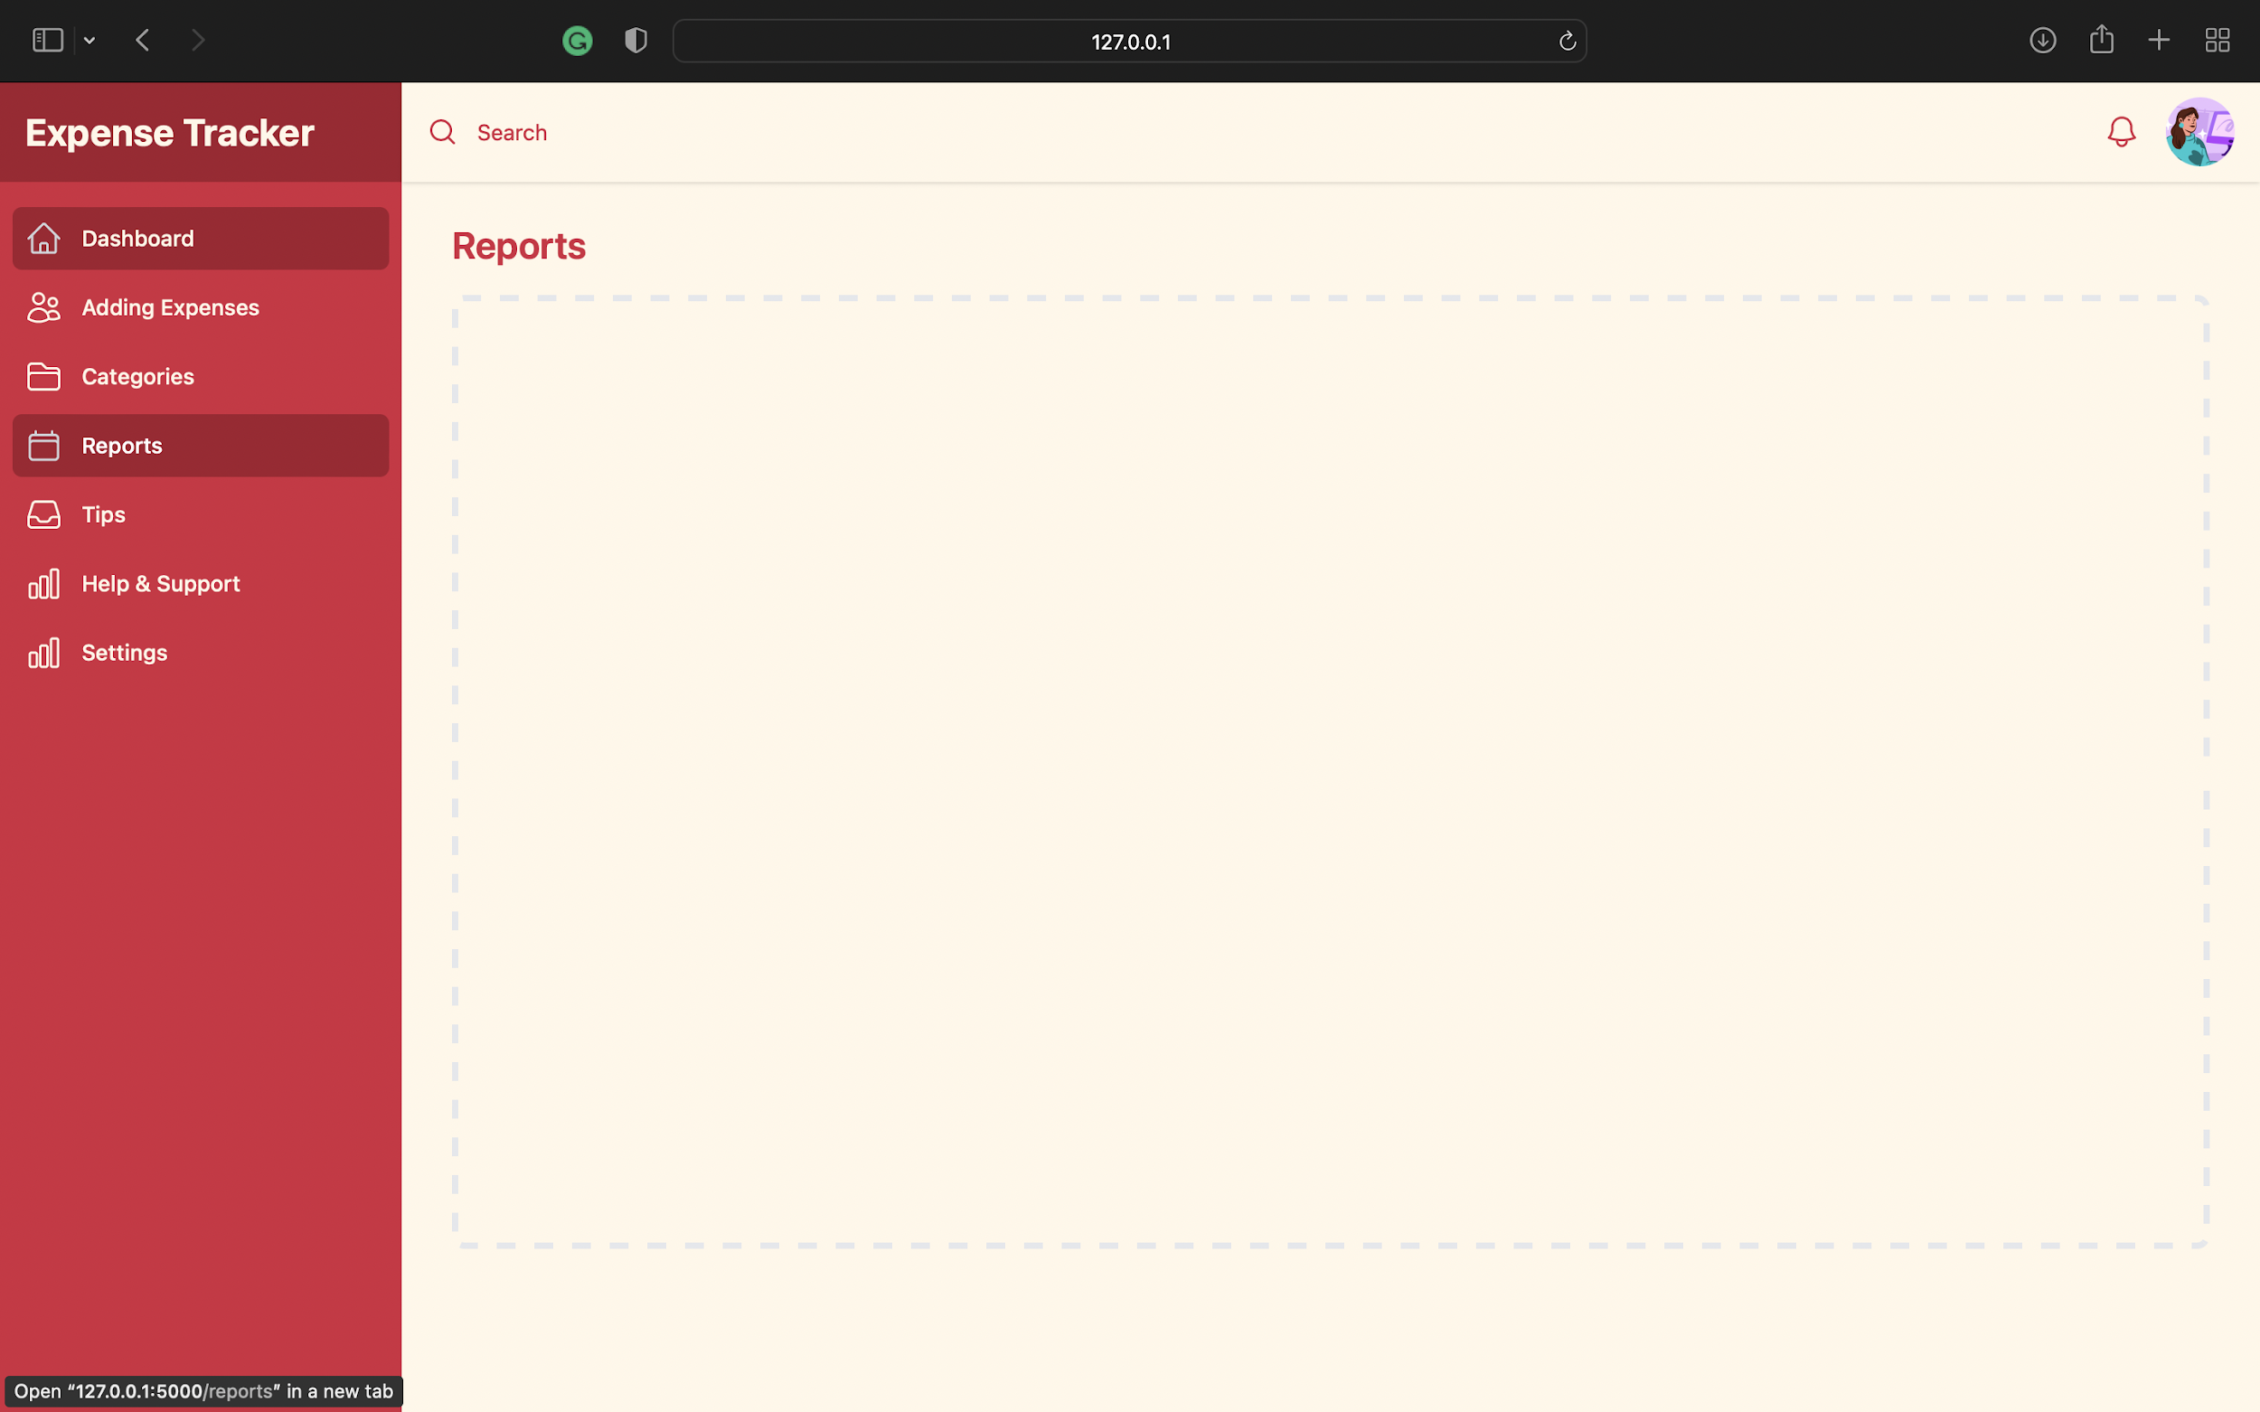

**PYTHON CODE FOR SPRINT 2:**

**from flask import Blueprint,render_template**

**views = Blueprint('views',__name__)**

**@views.route('/')**

**def landingPage():**

**return render_template("landingPage.html")**

**@views.route('/dashboard')**

**def dashboard():**

**return render_template("dashboard.html")**

**@views.route('/aboutus')**

**def aboutUs():**

**return render_template("aboutUs.html")**

**@views.route('/contactus')**

**def contactUs():**

**return render_template("contactUs.html")**

**@views.route('/transactions')**

**def transactions():**

**return render_template("transactions.html")**

**@views.route('/addingExpenses')**

**def addingExpenses():**

**return render_template("addingExpenses.html")**

**@views.route('/categories')**

**def categories():**

**return render_template("categories.html")**

**@views.route('/reports')**

**def reports():**

**return render_template("reports.html")**

**@views.route('/tips')**

**def tips():**

**return render_template("tips.html")**

**@views.route('/help&support')**

**def helpAndSupport():**

**return render_template("help&support.html")**

**@views.route('/settings')**

**def settings():**

**return render_template("settings.html")**

**@views.route('/notifications')**

**def settnotificationsings():**

**return render_template("notifications.html")**

**@views.route('/skeleton')**

**def skeleton():**

**return render_template("skeleton.html")**

**# stores main views or the url endpoints for the functioning of the frontend aspect**

**# anything that's not related to authentication and just for navigation**

**BASE CODE:**

**# stores database models in this**

**Skeleton.html:**

**<!DOCTYPE html>**

**<html lang="en">**

**<head>**

**<meta charset="UTF-8" />**

**<meta http-equiv="X-UA-Compatible" content="IE=edge" />**

**<meta name="viewport" content="width=device-width, initial-scale=1.0" />**

**<link**

**rel="stylesheet"**

**href="{{url_for('static',filename='css/skeleton.css')}}"**

**/>**

**<script src="https://cdn.tailwindcss.com"></script>**

**</head>**

**<body class="bg-[#fff7e9]">**

**<div>**

**<div class="relative z-40 md:hidden" role="dialog" aria-modal="true">**

**<div class="fixed inset-0 bg-[#d32840] bg-opacity-75"></div>**

**<div class="fixed inset-0 z-40 flex">**

**>**

**<div**

**class="relative flex w-full max-w-xs flex-1 flex-col bg-gray-800 pt-5 pb-4"**

**>**

**<div class="absolute top-0 right-0 -mr-12 pt-2">**

**<button**

**type="button"**

**class="ml-1 flex h-10 w-10 items-center justify-center rounded-full focus:outline-none focus:ring-2 focus:ring-inset focus:ring-white"**

**>**

**<span class="sr-only">Close sidebar</span>**

**<svg**

**class="h-6 w-6 text-white"**

**xmlns="http://www.w3.org/2000/svg"**

**fill="none"**

**viewBox="0 0 24 24"**

**stroke-width="1.5"**

**stroke="currentColor"**

**aria-hidden="true"**

**>**

**<path**

**stroke-linecap="round"**

**stroke-linejoin="round"**

**d="M6 18L18 6M6 6l12 12"**

**/>**

**</svg>**

**</button>**

**</div>**

**<div class="flex flex-shrink-0 items-center px-4">**

**</div>**

**<div class="mt-5 h-0 flex-1 overflow-y-auto">**

**<nav class="space-y-1 px-2 ">**

**<a**

**href="/dashboard"**

**class="bg-gray-900 text-white group flex items-center px-2 py-2 text-base font-medium rounded-md"**

**>**

**<!-- Heroicon name: outline/home -->**

**<svg**

**class="text-gray-300 mr-4 flex-shrink-0 h-6 w-6"**

**xmlns="http://www.w3.org/2000/svg"**

**fill="none"**

**viewBox="0 0 24 24"**

**stroke-width="1.5"**

**stroke="currentColor"**

**aria-hidden="true"**

**>**

**<path**

**stroke-linecap="round"**

**stroke-linejoin="round"**

**d="M2.25 12l8.954-8.955c.44-.439 1.152-.439 1.591 0L21.75 12M4.5 9.75v10.125c0 .621.504 1.125 1.125 1.125H9.75v-4.875c0-.621.504-1.125 1.125-1.125h2.25c.621 0 1.125.504 1.125 1.125V21h4.125c.621 0 1.125-.504 1.125-1.125V9.75M8.25 21h8.25"**

**/>**

**</svg>**

**Dashboard**

**</a>**

**<a**

**href="#"**

**class="text-gray-300 hover:bg-[#a31d2f] hover:text-white group flex items-center px-2 py-2 text-base font-medium rounded-md"**

**>**

**<!-- Heroicon name: outline/users -->**

**<svg**

**class="text-gray-400 group-hover:text-gray-300 mr-4 flex-shrink-0 h-6 w-6"**

**xmlns="http://www.w3.org/2000/svg"**

**fill="none"**

**viewBox="0 0 24 24"**

**stroke-width="1.5"**

**stroke="currentColor"**

**aria-hidden="true"**

**>**

**<path**

**stroke-linecap="round"**

**stroke-linejoin="round"**

**d="M15 19.128a9.38 9.38 0 002.625.372 9.337 9.337 0 004.121-.952 4.125 4.125 0 00-7.533-2.493M15 19.128v-.003c0-1.113-.285-2.16-.786-3.07M15 19.128v.106A12.318 12.318 0 018.624 21c-2.331 0-4.512-.645-6.374-1.766l-.001-.109a6.375 6.375 0 0111.964-3.07M12 6.375a3.375 3.375 0 11-6.75 0 3.375 3.375 0 016.75 0zm8.25 2.25a2.625 2.625 0 11-5.25 0 2.625 2.625 0 015.25 0z"**

**/>**

**</svg>**

**Team**

**</a>**

**<a**

**href="#"**

**class="text-gray-300 hover:bg-[#a31d2f] hover:text-white group flex items-center px-2 py-2 text-base font-medium rounded-md"**

**>**

**<!-- Heroicon name: outline/folder -->**

**<svg**

**class="text-gray-400 group-hover:text-gray-300 mr-4 flex-shrink-0 h-6 w-6"**

**xmlns="http://www.w3.org/2000/svg"**

**fill="none"**

**viewBox="0 0 24 24"**

**stroke-width="1.5"**

**stroke="currentColor"**

**aria-hidden="true"**

**>**

**<path**

**stroke-linecap="round"**

**stroke-linejoin="round"**

**d="M2.25 12.75V12A2.25 2.25 0 014.5 9.75h15A2.25 2.25 0 0121.75 12v.75m-8.69-6.44l-2.12-2.12a1.5 1.5 0 00-1.061-.44H4.5A2.25 2.25 0 002.25 6v12a2.25 2.25 0 002.25 2.25h15A2.25 2.25 0 0021.75 18V9a2.25 2.25 0 00-2.25-2.25h-5.379a1.5 1.5 0 01-1.06-.44z"**

**/>**

**</svg>**

**Projects**

**</a>**

**<a**

**href="#"**

**class="text-gray-300 hover:bg-gray-700 hover:text-white group flex items-center px-2 py-2 text-base font-medium rounded-md"**

**>**

**<!-- Heroicon name: outline/categories -->**

**<svg**

**class="text-gray-400 group-hover:text-gray-300 mr-4 flex-shrink-0 h-6 w-6"**

**xmlns="http://www.w3.org/2000/svg"**

**fill="none"**

**viewBox="0 0 24 24"**

**stroke-width="1.5"**

**stroke="currentColor"**

**aria-hidden="true"**

**>**

**<path**

**stroke-linecap="round"**

**stroke-linejoin="round"**

**d="M6.75 3v2.25M17.25 3v2.25M3 18.75V7.5a2.25 2.25 0 012.25-2.25h13.5A2.25 2.25 0 0121 7.5v11.25m-18 0A2.25 2.25 0 005.25 21h13.5A2.25 2.25 0 0021 18.75m-18 0v-7.5A2.25 2.25 0 015.25 9h13.5A2.25 2.25 0 0121 11.25v7.5"**

**/>**

**</svg>**

**Categories**

**</a>**

**<a**

**href="#"**

**class="text-gray-300 hover:bg-gray-700 hover:text-white group flex items-center px-2 py-2 text-base font-medium rounded-md"**

**>**

**<!-- Heroicon name: outline/inbox -->**

**<svg**

**class="text-gray-400 group-hover:text-gray-300 mr-4 flex-shrink-0 h-6 w-6"**

**xmlns="http://www.w3.org/2000/svg"**

**fill="none"**

**viewBox="0 0 24 24"**

**stroke-width="1.5"**

**stroke="currentColor"**

**aria-hidden="true"**

**>**

**<path**

**stroke-linecap="round"**

**stroke-linejoin="round"**

**d="M2.25 13.5h3.86a2.25 2.25 0 012.012 1.244l.256.512a2.25 2.25 0 002.013 1.244h3.218a2.25 2.25 0 002.013-1.244l.256-.512a2.25 2.25 0 012.013-1.244h3.859m-19.5.338V18a2.25 2.25 0 002.25 2.25h15A2.25 2.25 0 0021.75 18v-4.162c0-.224-.034-.447-.1-.661L19.24 5.338a2.25 2.25 0 00-2.15-1.588H6.911a2.25 2.25 0 00-2.15 1.588L2.35 13.177a2.25 2.25 0 00-.1.661z"**

**/>**

**</svg>**

**Documents**

**</a>**

**<a**

**href="#"**

**class="text-gray-300 hover:bg-gray-700 hover:text-white group flex items-center px-2 py-2 text-base font-medium rounded-md"**

**>**

**<!-- Heroicon name: outline/chart-bar -->**

**<svg**

**class="text-gray-400 group-hover:text-gray-300 mr-4 flex-shrink-0 h-6 w-6"**

**xmlns="http://www.w3.org/2000/svg"**

**fill="none"**

**viewBox="0 0 24 24"**

**stroke-width="1.5"**

**stroke="currentColor"**

**aria-hidden="true"**

**>**

**<path**

**stroke-linecap="round"**

**stroke-linejoin="round"**

**d="M3 13.125C3 12.504 3.504 12 4.125 12h2.25c.621 0 1.125.504 1.125 1.125v6.75C7.5 20.496 6.996 21 6.375 21h-2.25A1.125 1.125 0 013 19.875v-6.75zM9.75 8.625c0-.621.504-1.125 1.125-1.125h2.25c.621 0 1.125.504 1.125 1.125v11.25c0 .621-.504 1.125-1.125 1.125h-2.25a1.125 1.125 0 01-1.125-1.125V8.625zM16.5 4.125c0-.621.504-1.125 1.125-1.125h2.25C20.496 3 21 3.504 21 4.125v15.75c0 .621-.504 1.125-1.125 1.125h-2.25a1.125 1.125 0 01-1.125-1.125V4.125z"**

**/>**

**</svg>**

**Reports**

**</a>**

**</nav>**

**</div>**

**</div>**

**<div class="w-14 flex-shrink-0" aria-hidden="true">**

**<!-- Dummy element to force sidebar to shrink to fit close icon -->**

**</div>**

**</div>**

**</div>**

**<!-- Static sidebar for desktop -->**

**<div class="hidden md:fixed md:inset-y-0 md:flex md:w-64 md:flex-col">**

**<!-- Sidebar component, swap this element with another sidebar if you like -->**

**<div class="flex min-h-0 flex-1 flex-col bg-[#d32840]">**

**<div class="flex h-16 flex-shrink-0 items-center bg-[#a31d2f] px-4">**

**<a href='/' class="text-2xl font-bold text-[#fff7e9]">Expense Tracker</a>**

**</div>**

**<div class="flex flex-1 flex-col overflow-y-auto">**

**<nav class="flex-1 space-y-1 px-2 py-4">**

**<!-- Current: "bg-gray-900 text-white", Default: "text-gray-300 hover:bg-gray-700 hover:text-white" -->**

**<a**

**href="/dashboard"**

**class="bg-[#a31d2f] text-[#fff7e9] group flex items-center px-2 py-2 text-sm font-medium rounded-md"**

**>**

**<!--**

**Heroicon name: outline/home**

**Current: "text-gray-300", Default: "text-gray-400 group-hover:text-gray-300"**

**-->**

**<svg**

**class="text-gray-300 mr-3 flex-shrink-0 h-6 w-6"**

**xmlns="http://www.w3.org/2000/svg"**

**fill="none"**

**viewBox="0 0 24 24"**

**stroke-width="1.5"**

**stroke="currentColor"**

**aria-hidden="true"**

**>**

**<path**

**stroke-linecap="round"**

**stroke-linejoin="round"**

**d="M2.25 12l8.954-8.955c.44-.439 1.152-.439 1.591 0L21.75 12M4.5 9.75v10.125c0 .621.504 1.125 1.125 1.125H9.75v-4.875c0-.621.504-1.125 1.125-1.125h2.25c.621 0 1.125.504 1.125 1.125V21h4.125c.621 0 1.125-.504 1.125-1.125V9.75M8.25 21h8.25"**

**/>**

**</svg>**

**Dashboard**

**</a>**

**<a**

**href="/addingExpenses"**

**class="text-[#fff7e9] hover:bg-[#a31d2f] hover:text-white group flex items-center px-2 py-2 text-sm font-medium rounded-md"**

**>**

**<!-- Heroicon name: outline/users -->**

**<svg**

**class="text-[#fff7e9] group-hover:text-gray-300 mr-3 flex-shrink-0 h-6 w-6"**

**xmlns="http://www.w3.org/2000/svg"**

**fill="none"**

**viewBox="0 0 24 24"**

**stroke-width="1.5"**

**stroke="currentColor"**

**aria-hidden="true"**

**>**

**<path**

**stroke-linecap="round"**

**stroke-linejoin="round"**

**d="M15 19.128a9.38 9.38 0 002.625.372 9.337 9.337 0 004.121-.952 4.125 4.125 0 00-7.533-2.493M15 19.128v-.003c0-1.113-.285-2.16-.786-3.07M15 19.128v.106A12.318 12.318 0 018.624 21c-2.331 0-4.512-.645-6.374-1.766l-.001-.109a6.375 6.375 0 0111.964-3.07M12 6.375a3.375 3.375 0 11-6.75 0 3.375 3.375 0 016.75 0zm8.25 2.25a2.625 2.625 0 11-5.25 0 2.625 2.625 0 015.25 0z"**

**/>**

**</svg>**

**Adding Expenses**

**</a>**

**<a**

**href="/categories"**

**class="text-[#fff7e9] hover:bg-[#a31d2f] hover:text-white group flex items-center px-2 py-2 text-sm font-medium rounded-md"**

**>**

**<!-- Heroicon name: outline/folder -->**

**<svg**

**class="text-[#fff7e9] group-hover:text-gray-300 mr-3 flex-shrink-0 h-6 w-6"**

**xmlns="http://www.w3.org/2000/svg"**

**fill="none"**

**viewBox="0 0 24 24"**

**stroke-width="1.5"**

**stroke="currentColor"**

**aria-hidden="true"**

**>**

**<path**

**stroke-linecap="round"**

**stroke-linejoin="round"**

**d="M2.25 12.75V12A2.25 2.25 0 014.5 9.75h15A2.25 2.25 0 0121.75 12v.75m-8.69-6.44l-2.12-2.12a1.5 1.5 0 00-1.061-.44H4.5A2.25 2.25 0 002.25 6v12a2.25 2.25 0 002.25 2.25h15A2.25 2.25 0 0021.75 18V9a2.25 2.25 0 00-2.25-2.25h-5.379a1.5 1.5 0 01-1.06-.44z"**

**/>**

**</svg>**

**Categories**

**</a>**

**<a**

**href="/reports"**

**class="text-[#fff7e9] hover:bg-[#a31d2f] hover:text-white group flex items-center px-2 py-2 text-sm font-medium rounded-md"**

**>**

**<!-- Heroicon name: outline/categories -->**

**<svg**

**class="text-[#fff7e9] group-hover:text-gray-300 mr-3 flex-shrink-0 h-6 w-6"**

**xmlns="http://www.w3.org/2000/svg"**

**fill="none"**

**viewBox="0 0 24 24"**

**stroke-width="1.5"**

**stroke="currentColor"**

**aria-hidden="true"**

**>**

**<path**

**stroke-linecap="round"**

**stroke-linejoin="round"**

**d="M6.75 3v2.25M17.25 3v2.25M3 18.75V7.5a2.25 2.25 0 012.25-2.25h13.5A2.25 2.25 0 0121 7.5v11.25m-18 0A2.25 2.25 0 005.25 21h13.5A2.25 2.25 0 0021 18.75m-18 0v-7.5A2.25 2.25 0 015.25 9h13.5A2.25 2.25 0 0121 11.25v7.5"**

**/>**

**</svg>**

**Reports**

**</svg>**

**<a**

**href="/tips"**

**class="text-[#fff7e9] hover:bg-[#a31d2f] hover:text-white group flex items-center px-2 py-2 text-sm font-medium rounded-md"**

**>**

**<!-- Heroicon name: outline/inbox -->**

**<svg**

**class="text-[#fff7e9] group-hover:text-gray-300 mr-3 flex-shrink-0 h-6 w-6"**

**xmlns="http://www.w3.org/2000/svg"**

**fill="none"**

**viewBox="0 0 24 24"**

**stroke-width="1.5"**

**stroke="currentColor"**

**aria-hidden="true"**

**>**

**<path**

**stroke-linecap="round"**

**stroke-linejoin="round"**

**d="M2.25 13.5h3.86a2.25 2.25 0 012.012 1.244l.256.512a2.25 2.25 0 002.013 1.244h3.218a2.25 2.25 0 002.013-1.244l.256-.512a2.25 2.25 0 012.013-1.244h3.859m-19.5.338V18a2.25 2.25 0 002.25 2.25h15A2.25 2.25 0 0021.75 18v-4.162c0-.224-.034-.447-.1-.661L19.24 5.338a2.25 2.25 0 00-2.15-1.588H6.911a2.25 2.25 0 00-2.15 1.588L2.35 13.177a2.25 2.25 0 00-.1.661z"**

**/>**

**</svg>**

**Tips**

**</a>**

**<a**

**href="/help&support"**

**class="text-[#fff7e9] hover:bg-[#a31d2f] hover:text-white group flex items-center px-2 py-2 text-sm font-medium rounded-md"**

**>**

**<!-- Heroicon name: outline/chart-bar -->**

**<svg**

**class="text-[#fff7e9] group-hover:text-gray-300 mr-3 flex-shrink-0 h-6 w-6"**

**xmlns="http://www.w3.org/2000/svg"**

**fill="none"**

**viewBox="0 0 24 24"**

**stroke-width="1.5"**

**stroke="currentColor"**

**aria-hidden="true"**

**>**

**<path**

**stroke-linecap="round"**

**stroke-linejoin="round"**

**d="M3 13.125C3 12.504 3.504 12 4.125 12h2.25c.621 0 1.125.504 1.125 1.125v6.75C7.5 20.496 6.996 21 6.375 21h-2.25A1.125 1.125 0 013 19.875v-6.75zM9.75 8.625c0-.621.504-1.125 1.125-1.125h2.25c.621 0 1.125.504 1.125 1.125v11.25c0 .621-.504 1.125-1.125 1.125h-2.25a1.125 1.125 0 01-1.125-1.125V8.625zM16.5 4.125c0-.621.504-1.125 1.125-1.125h2.25C20.496 3 21 3.504 21 4.125v15.75c0 .621-.504 1.125-1.125 1.125h-2.25a1.125 1.125 0 01-1.125-1.125V4.125z"**

**/>**

**</svg>**

**Help & Support**

**</a>**

**<a**

**href="/settings"**

**class="text-[#fff7e9] hover:bg-[#a31d2f] hover:text-white group flex items-center px-2 py-2 text-sm font-medium rounded-md"**

**>**

**<!-- Heroicon name: outline/chart-bar -->**

**<svg**

**class="text-[#fff7e9] group-hover:text-gray-300 mr-3 flex-shrink-0 h-6 w-6"**

**xmlns="http://www.w3.org/2000/svg"**

**fill="none"**

**viewBox="0 0 24 24"**

**stroke-width="1.5"**

**stroke="currentColor"**

**aria-hidden="true"**

**>**

**<path**

**stroke-linecap="round"**

**stroke-linejoin="round"**

**d="M3 13.125C3 12.504 3.504 12 4.125 12h2.25c.621 0 1.125.504 1.125 1.125v6.75C7.5 20.496 6.996 21 6.375 21h-2.25A1.125 1.125 0 013 19.875v-6.75zM9.75 8.625c0-.621.504-1.125 1.125-1.125h2.25c.621 0 1.125.504 1.125 1.125v11.25c0 .621-.504 1.125-1.125 1.125h-2.25a1.125 1.125 0 01-1.125-1.125V8.625zM16.5 4.125c0-.621.504-1.125 1.125-1.125h2.25C20.496 3 21 3.504 21 4.125v15.75c0 .621-.504 1.125-1.125 1.125h-2.25a1.125 1.125 0 01-1.125-1.125V4.125z"**

**/>**

**</svg>**

**Settings**

**</a>**

**</nav>**

**</div>**

**</div>**

**</div>**

**<div class="flex flex-col md:pl-64">**

**<div class="sticky top-0 z-10 flex h-16 flex-shrink-0 bg-[#fff7e9] shadow">**

**<button**

**type="button"**

**class="border-r border-gray-200 px-4 text-gray-500 focus:outline-none focus:ring-2 focus:ring-inset focus:ring-indigo-500 md:hidden"**

**>**

**<span class="sr-only">Open sidebar</span>**

**<!-- Heroicon name: outline/bars-3-bottom-left -->**

**<svg**

**class="h-6 w-6"**

**xmlns="http://www.w3.org/2000/svg"**

**fill="none"**

**viewBox="0 0 24 24"**

**stroke-width="1.5"**

**stroke="currentColor"**

**aria-hidden="true"**

**>**

**<path**

**stroke-linecap="round"**

**stroke-linejoin="round"**

**d="M3.75 6.75h16.5M3.75 12h16.5m-16.5 5.25H12"**

**/>**

**</svg>**

**</button>**

**<div class="flex flex-1 justify-between px-4">**

**<div class="flex flex-1">**

**<form class="flex w-full md:ml-0" action="#" method="GET">**

**<label for="search-field" class="sr-only">Search</label>**

**<div**

**class="relative w-full text-gray-400 focus-within:text-gray-600"**

**>**

**<div**

**class="pointer-events-none absolute inset-y-0 left-0 flex items-center"**

**>**

**<!-- Heroicon name: mini/magnifying-glass -->**

**<svg**

**class="h-5 w-5 text-[#d32840]"**

**xmlns="http://www.w3.org/2000/svg"**

**viewBox="0 0 20 20"**

**fill="currentColor"**

**aria-hidden="true"**

**>**

**<path**

**fill-rule="evenodd"**

**d="M9 3.5a5.5 5.5 0 100 11 5.5 5.5 0 000-11zM2 9a7 7 0 1112.452 4.391l3.328 3.329a.75.75 0 11-1.06 1.06l-3.329-3.328A7 7 0 012 9z"**

**clip-rule="evenodd"**

**/>**

**</svg>**

**</div>**

**<input**

**id="search-field"**

**class="block h-full w-full border-transparent py-2 pl-8 pr-3 text-gray-900 placeholder-[#d32840] bg-[#fff7e9] focus:border-transparent focus:placeholder-gray-400 focus:outline-none focus:ring-0 sm:text-sm"**

**placeholder="Search"**

**type="search"**

**name="search"**

**/>**

**</div>**

**</form>**

**</div>**

**<div class="ml-4 flex items-center md:ml-6">**

**<button**

**type="button"**

**class="rounded-full bg-[#fff7e9] p-1 text-gray-400 hover:text-gray-500 focus:outline-none focus:ring-2 focus:ring-indigo-500 focus:ring-offset-2"**

**>**

**<span class="sr-only">View notifications</span>**

**<!-- Heroicon name: outline/bell -->**

**<svg**

**class="h-6 w-6 text-[#d32840]"**

**xmlns="http://www.w3.org/2000/svg"**

**fill="none"**

**viewBox="0 0 24 24"**

**stroke-width="1.5"**

**stroke="currentColor"**

**aria-hidden="true"**

**>**

**<path**

**stroke-linecap="round"**

**stroke-linejoin="round"**

**d="M14.857 17.082a23.848 23.848 0 005.454-1.31A8.967 8.967 0 0118 9.75v-.7V9A6 6 0 006 9v.75a8.967 8.967 0 01-2.312 6.022c1.733.64 3.56 1.085 5.455 1.31m5.714 0a24.255 24.255 0 01-5.714 0m5.714 0a3 3 0 11-5.714 0"**

**/>**

**</svg>**

**</button>**

**<!-- Profile dropdown -->**

**<div class="relative ml-3">**

**<div>**

**<button**

**type="button"**

**class="flex max-w-xs items-center rounded-full bg-white text-sm focus:outline-none focus:ring-2 focus:ring-indigo-500 focus:ring-offset-2"**

**id="user-menu-button"**

**aria-expanded="false"**

**aria-haspopup="true"**

**>**

**<span class="sr-only">Open user menu</span>**

**<img**

**class="h-11 w-11 rounded-full"**

**src="../static/images/woman-profile.jpg.webp"**

**alt=""**

**/>**

**</button>**

**</div>**

**<!--**

**Dropdown menu, show/hide based on menu state.**

**Entering: "transition ease-out duration-100"**

**From: "transform opacity-0 scale-95"**

**To: "transform opacity-100 scale-100"**

**Leaving: "transition ease-in duration-75"**

**From: "transform opacity-100 scale-100"**

**To: "transform opacity-0 scale-95"**

**-->**

**<!-- Active: "bg-gray-100", Not Active: "" -->**

**<!-- <div**

**class="absolute right-0 z-10 mt-2 w-48 origin-top-right rounded-md bg-white py-1 shadow-lg ring-1 ring-black ring-opacity-5 focus:outline-none"**

**role="menu"**

**aria-orientation="vertical"**

**aria-labelledby="user-menu-button"**

**tabindex="-1"**

**>**

**<a**

**href="#"**

**class="block px-4 py-2 text-sm text-gray-700"**

**role="menuitem"**

**tabindex="-1"**

**id="user-menu-item-0"**

**>Your Profile</a**

**>**

**<a**

**href="#"**

**class="block px-4 py-2 text-sm text-gray-700"**

**role="menuitem"**

**tabindex="-1"**

**id="user-menu-item-1"**

**>Settings</a**

**>**

**<a**

**href="#"**

**class="block px-4 py-2 text-sm text-gray-700"**

**role="menuitem"**

**tabindex="-1"**

**id="user-menu-item-2"**

**>Sign out</a**

**>**

**</div> -->**

**</div>**

**</div>**

**</div>**

**</div>**

**</div>**

**</div>**

**</body>**

**</html>**

**Dashboard.html:**

**<!DOCTYPE html>**

**<html lang="en">**

**<head>**

**<meta charset="UTF-8" />**

**<meta http-equiv="X-UA-Compatible" content="IE=edge" />**

**<meta name="viewport" content="width=device-width, initial-scale=1.0" />**

**<link**

**rel="stylesheet"**

**href="{{url_for('static',filename='css/skeleton.css')}}"**

**/>**

**<script src="https://cdn.tailwindcss.com"></script>**

**</head>**

**<body class="bg-[#fff7e9]">**

**<div>**

**<div class="relative z-40 md:hidden" role="dialog" aria-modal="true">**

**<div class="fixed inset-0 bg-[#d32840] bg-opacity-75"></div>**

**<div class="fixed inset-0 z-40 flex">**

**>**

**<div**

**class="relative flex w-full max-w-xs flex-1 flex-col bg-gray-800 pt-5 pb-4"**

**>**

**<div class="absolute top-0 right-0 -mr-12 pt-2">**

**<button**

**type="button"**

**class="ml-1 flex h-10 w-10 items-center justify-center rounded-full focus:outline-none focus:ring-2 focus:ring-inset focus:ring-white"**

**>**

**<span class="sr-only">Close sidebar</span>**

**<svg**

**class="h-6 w-6 text-white"**

**xmlns="http://www.w3.org/2000/svg"**

**fill="none"**

**viewBox="0 0 24 24"**

**stroke-width="1.5"**

**stroke="currentColor"**

**aria-hidden="true"**

**>**

**<path**

**stroke-linecap="round"**

**stroke-linejoin="round"**

**d="M6 18L18 6M6 6l12 12"**

**/>**

**</svg>**

**</button>**

**</div>**

**<div class="flex flex-shrink-0 items-center px-4">**

**</div>**

**<div class="mt-5 h-0 flex-1 overflow-y-auto">**

**<nav class="space-y-1 px-2 ">**

**<a**

**href="/dashboard"**

**class="bg-gray-900 text-white group flex items-center px-2 py-2 text-base font-medium rounded-md"**

**>**

**<!-- Heroicon name: outline/home -->**

**<svg**

**class="text-gray-300 mr-4 flex-shrink-0 h-6 w-6"**

**xmlns="http://www.w3.org/2000/svg"**

**fill="none"**

**viewBox="0 0 24 24"**

**stroke-width="1.5"**

**stroke="currentColor"**

**aria-hidden="true"**

**>**

**<path**

**stroke-linecap="round"**

**stroke-linejoin="round"**

**d="M2.25 12l8.954-8.955c.44-.439 1.152-.439 1.591 0L21.75 12M4.5 9.75v10.125c0 .621.504 1.125 1.125 1.125H9.75v-4.875c0-.621.504-1.125 1.125-1.125h2.25c.621 0 1.125.504 1.125 1.125V21h4.125c.621 0 1.125-.504 1.125-1.125V9.75M8.25 21h8.25"**

**/>**

**</svg>**

**Dashboard**

**</a>**

**<a**

**href="#"**

**class="text-gray-300 hover:bg-[#a31d2f] hover:text-white group flex items-center px-2 py-2 text-base font-medium rounded-md"**

**>**

**<!-- Heroicon name: outline/users -->**

**<svg**

**class="text-gray-400 group-hover:text-gray-300 mr-4 flex-shrink-0 h-6 w-6"**

**xmlns="http://www.w3.org/2000/svg"**

**fill="none"**

**viewBox="0 0 24 24"**

**stroke-width="1.5"**

**stroke="currentColor"**

**aria-hidden="true"**

**>**

**<path**

**stroke-linecap="round"**

**stroke-linejoin="round"**

**d="M15 19.128a9.38 9.38 0 002.625.372 9.337 9.337 0 004.121-.952 4.125 4.125 0 00-7.533-2.493M15 19.128v-.003c0-1.113-.285-2.16-.786-3.07M15 19.128v.106A12.318 12.318 0 018.624 21c-2.331 0-4.512-.645-6.374-1.766l-.001-.109a6.375 6.375 0 0111.964-3.07M12 6.375a3.375 3.375 0 11-6.75 0 3.375 3.375 0 016.75 0zm8.25 2.25a2.625 2.625 0 11-5.25 0 2.625 2.625 0 015.25 0z"**

**/>**

**</svg>**

**Team**

**</a>**

**<a**

**href="#"**

**class="text-gray-300 hover:bg-[#a31d2f] hover:text-white group flex items-center px-2 py-2 text-base font-medium rounded-md"**

**>**

**<!-- Heroicon name: outline/folder -->**

**<svg**

**class="text-gray-400 group-hover:text-gray-300 mr-4 flex-shrink-0 h-6 w-6"**

**xmlns="http://www.w3.org/2000/svg"**

**fill="none"**

**viewBox="0 0 24 24"**

**stroke-width="1.5"**

**stroke="currentColor"**

**aria-hidden="true"**

**>**

**<path**

**stroke-linecap="round"**

**stroke-linejoin="round"**

**d="M2.25 12.75V12A2.25 2.25 0 014.5 9.75h15A2.25 2.25 0 0121.75 12v.75m-8.69-6.44l-2.12-2.12a1.5 1.5 0 00-1.061-.44H4.5A2.25 2.25 0 002.25 6v12a2.25 2.25 0 002.25 2.25h15A2.25 2.25 0 0021.75 18V9a2.25 2.25 0 00-2.25-2.25h-5.379a1.5 1.5 0 01-1.06-.44z"**

**/>**

**</svg>**

**Projects**

**</a>**

**<a**

**href="#"**

**class="text-gray-300 hover:bg-gray-700 hover:text-white group flex items-center px-2 py-2 text-base font-medium rounded-md"**

**>**

**<!-- Heroicon name: outline/categories -->**

**<svg**

**class="text-gray-400 group-hover:text-gray-300 mr-4 flex-shrink-0 h-6 w-6"**

**xmlns="http://www.w3.org/2000/svg"**

**fill="none"**

**viewBox="0 0 24 24"**

**stroke-width="1.5"**

**stroke="currentColor"**

**aria-hidden="true"**

**>**

**<path**

**stroke-linecap="round"**

**stroke-linejoin="round"**

**d="M6.75 3v2.25M17.25 3v2.25M3 18.75V7.5a2.25 2.25 0 012.25-2.25h13.5A2.25 2.25 0 0121 7.5v11.25m-18 0A2.25 2.25 0 005.25 21h13.5A2.25 2.25 0 0021 18.75m-18 0v-7.5A2.25 2.25 0 015.25 9h13.5A2.25 2.25 0 0121 11.25v7.5"**

**/>**

**</svg>**

**Categories**

**</a>**

**<a**

**href="#"**

**class="text-gray-300 hover:bg-gray-700 hover:text-white group flex items-center px-2 py-2 text-base font-medium rounded-md"**

**>**

**<!-- Heroicon name: outline/inbox -->**

**<svg**

**class="text-gray-400 group-hover:text-gray-300 mr-4 flex-shrink-0 h-6 w-6"**

**xmlns="http://www.w3.org/2000/svg"**

**fill="none"**

**viewBox="0 0 24 24"**

**stroke-width="1.5"**

**stroke="currentColor"**

**aria-hidden="true"**

**>**

**<path**

**stroke-linecap="round"**

**stroke-linejoin="round"**

**d="M2.25 13.5h3.86a2.25 2.25 0 012.012 1.244l.256.512a2.25 2.25 0 002.013 1.244h3.218a2.25 2.25 0 002.013-1.244l.256-.512a2.25 2.25 0 012.013-1.244h3.859m-19.5.338V18a2.25 2.25 0 002.25 2.25h15A2.25 2.25 0 0021.75 18v-4.162c0-.224-.034-.447-.1-.661L19.24 5.338a2.25 2.25 0 00-2.15-1.588H6.911a2.25 2.25 0 00-2.15 1.588L2.35 13.177a2.25 2.25 0 00-.1.661z"**

**/>**

**</svg>**

**Documents**

**</a>**

**<a**

**href="#"**

**class="text-gray-300 hover:bg-gray-700 hover:text-white group flex items-center px-2 py-2 text-base font-medium rounded-md"**

**>**

**<!-- Heroicon name: outline/chart-bar -->**

**<svg**

**class="text-gray-400 group-hover:text-gray-300 mr-4 flex-shrink-0 h-6 w-6"**

**xmlns="http://www.w3.org/2000/svg"**

**fill="none"**

**viewBox="0 0 24 24"**

**stroke-width="1.5"**

**stroke="currentColor"**

**aria-hidden="true"**

**>**

**<path**

**stroke-linecap="round"**

**stroke-linejoin="round"**

**d="M3 13.125C3 12.504 3.504 12 4.125 12h2.25c.621 0 1.125.504 1.125 1.125v6.75C7.5 20.496 6.996 21 6.375 21h-2.25A1.125 1.125 0 013 19.875v-6.75zM9.75 8.625c0-.621.504-1.125 1.125-1.125h2.25c.621 0 1.125.504 1.125 1.125v11.25c0 .621-.504 1.125-1.125 1.125h-2.25a1.125 1.125 0 01-1.125-1.125V8.625zM16.5 4.125c0-.621.504-1.125 1.125-1.125h2.25C20.496 3 21 3.504 21 4.125v15.75c0 .621-.504 1.125-1.125 1.125h-2.25a1.125 1.125 0 01-1.125-1.125V4.125z"**

**/>**

**</svg>**

**Reports**

**</a>**

**</nav>**

**</div>**

**</div>**

**<div class="w-14 flex-shrink-0" aria-hidden="true">**

**<!-- Dummy element to force sidebar to shrink to fit close icon -->**

**</div>**

**</div>**

**</div>**

**<!-- Static sidebar for desktop -->**

**<div class="hidden md:fixed md:inset-y-0 md:flex md:w-64 md:flex-col">**

**<!-- Sidebar component, swap this element with another sidebar if you like -->**

**<div class="flex min-h-0 flex-1 flex-col bg-[#d32840]">**

**<div class="flex h-16 flex-shrink-0 items-center bg-[#a31d2f] px-4">**

**<a href='/' class="text-2xl font-bold text-[#fff7e9]">Expense Tracker</a>**

**</div>**

**<div class="flex flex-1 flex-col overflow-y-auto">**

**<nav class="flex-1 space-y-1 px-2 py-4">**

**<!-- Current: "bg-gray-900 text-white", Default: "text-gray-300 hover:bg-gray-700 hover:text-white" -->**

**<a**

**href="/dashboard"**

**class="bg-[#a31d2f] text-[#fff7e9] group flex items-center px-2 py-2 text-sm font-medium rounded-md"**

**>**

**<!--**

**Heroicon name: outline/home**

**Current: "text-gray-300", Default: "text-gray-400 group-hover:text-gray-300"**

**-->**

**<svg**

**class="text-gray-300 mr-3 flex-shrink-0 h-6 w-6"**

**xmlns="http://www.w3.org/2000/svg"**

**fill="none"**

**viewBox="0 0 24 24"**

**stroke-width="1.5"**

**stroke="currentColor"**

**aria-hidden="true"**

**>**

**<path**

**stroke-linecap="round"**

**stroke-linejoin="round"**

**d="M2.25 12l8.954-8.955c.44-.439 1.152-.439 1.591 0L21.75 12M4.5 9.75v10.125c0 .621.504 1.125 1.125 1.125H9.75v-4.875c0-.621.504-1.125 1.125-1.125h2.25c.621 0 1.125.504 1.125 1.125V21h4.125c.621 0 1.125-.504 1.125-1.125V9.75M8.25 21h8.25"**

**/>**

**</svg>**

**Dashboard**

**</a>**

**<a**

**href="/addingExpenses"**

**class="text-[#fff7e9] hover:bg-[#a31d2f] hover:text-white group flex items-center px-2 py-2 text-sm font-medium rounded-md"**

**>**

**<!-- Heroicon name: outline/users -->**

**<svg**

**class="text-[#fff7e9] group-hover:text-gray-300 mr-3 flex-shrink-0 h-6 w-6"**

**xmlns="http://www.w3.org/2000/svg"**

**fill="none"**

**viewBox="0 0 24 24"**

**stroke-width="1.5"**

**stroke="currentColor"**

**aria-hidden="true"**

**>**

**<path**

**stroke-linecap="round"**

**stroke-linejoin="round"**

**d="M15 19.128a9.38 9.38 0 002.625.372 9.337 9.337 0 004.121-.952 4.125 4.125 0 00-7.533-2.493M15 19.128v-.003c0-1.113-.285-2.16-.786-3.07M15 19.128v.106A12.318 12.318 0 018.624 21c-2.331 0-4.512-.645-6.374-1.766l-.001-.109a6.375 6.375 0 0111.964-3.07M12 6.375a3.375 3.375 0 11-6.75 0 3.375 3.375 0 016.75 0zm8.25 2.25a2.625 2.625 0 11-5.25 0 2.625 2.625 0 015.25 0z"**

**/>**

**</svg>**

**Adding Expenses**

**</a>**

**<a**

**href="/categories"**

**class="text-[#fff7e9] hover:bg-[#a31d2f] hover:text-white group flex items-center px-2 py-2 text-sm font-medium rounded-md"**

**>**

**<!-- Heroicon name: outline/folder -->**

**<svg**

**class="text-[#fff7e9] group-hover:text-gray-300 mr-3 flex-shrink-0 h-6 w-6"**

**xmlns="http://www.w3.org/2000/svg"**

**fill="none"**

**viewBox="0 0 24 24"**

**stroke-width="1.5"**

**stroke="currentColor"**

**aria-hidden="true"**

**>**

**<path**

**stroke-linecap="round"**

**stroke-linejoin="round"**

**d="M2.25 12.75V12A2.25 2.25 0 014.5 9.75h15A2.25 2.25 0 0121.75 12v.75m-8.69-6.44l-2.12-2.12a1.5 1.5 0 00-1.061-.44H4.5A2.25 2.25 0 002.25 6v12a2.25 2.25 0 002.25 2.25h15A2.25 2.25 0 0021.75 18V9a2.25 2.25 0 00-2.25-2.25h-5.379a1.5 1.5 0 01-1.06-.44z"**

**/>**

**</svg>**

**Categories**

**</a>**

**<a**

**href="/reports"**

**class="text-[#fff7e9] hover:bg-[#a31d2f] hover:text-white group flex items-center px-2 py-2 text-sm font-medium rounded-md"**

**>**

**<!-- Heroicon name: outline/categories -->**

**<svg**

**class="text-[#fff7e9] group-hover:text-gray-300 mr-3 flex-shrink-0 h-6 w-6"**

**xmlns="http://www.w3.org/2000/svg"**

**fill="none"**

**viewBox="0 0 24 24"**

**stroke-width="1.5"**

**stroke="currentColor"**

**aria-hidden="true"**

**>**

**<path**

**stroke-linecap="round"**

**stroke-linejoin="round"**

**d="M6.75 3v2.25M17.25 3v2.25M3 18.75V7.5a2.25 2.25 0 012.25-2.25h13.5A2.25 2.25 0 0121 7.5v11.25m-18 0A2.25 2.25 0 005.25 21h13.5A2.25 2.25 0 0021 18.75m-18 0v-7.5A2.25 2.25 0 015.25 9h13.5A2.25 2.25 0 0121 11.25v7.5"**

**/>**

**</svg>**

**Reports**

**</svg>**

**<a**

**href="/tips"**

**class="text-[#fff7e9] hover:bg-[#a31d2f] hover:text-white group flex items-center px-2 py-2 text-sm font-medium rounded-md"**

**>**

**<!-- Heroicon name: outline/inbox -->**

**<svg**

**class="text-[#fff7e9] group-hover:text-gray-300 mr-3 flex-shrink-0 h-6 w-6"**

**xmlns="http://www.w3.org/2000/svg"**

**fill="none"**

**viewBox="0 0 24 24"**

**stroke-width="1.5"**

**stroke="currentColor"**

**aria-hidden="true"**

**>**

**<path**

**stroke-linecap="round"**

**stroke-linejoin="round"**

**d="M2.25 13.5h3.86a2.25 2.25 0 012.012 1.244l.256.512a2.25 2.25 0 002.013 1.244h3.218a2.25 2.25 0 002.013-1.244l.256-.512a2.25 2.25 0 012.013-1.244h3.859m-19.5.338V18a2.25 2.25 0 002.25 2.25h15A2.25 2.25 0 0021.75 18v-4.162c0-.224-.034-.447-.1-.661L19.24 5.338a2.25 2.25 0 00-2.15-1.588H6.911a2.25 2.25 0 00-2.15 1.588L2.35 13.177a2.25 2.25 0 00-.1.661z"**

**/>**

**</svg>**

**Tips**

**</a>**

**<a**

**href="/help&support"**

**class="text-[#fff7e9] hover:bg-[#a31d2f] hover:text-white group flex items-center px-2 py-2 text-sm font-medium rounded-md"**

**>**

**<!-- Heroicon name: outline/chart-bar -->**

**<svg**

**class="text-[#fff7e9] group-hover:text-gray-300 mr-3 flex-shrink-0 h-6 w-6"**

**xmlns="http://www.w3.org/2000/svg"**

**fill="none"**

**viewBox="0 0 24 24"**

**stroke-width="1.5"**

**stroke="currentColor"**

**aria-hidden="true"**

**>**

**<path**

**stroke-linecap="round"**

**stroke-linejoin="round"**

**d="M3 13.125C3 12.504 3.504 12 4.125 12h2.25c.621 0 1.125.504 1.125 1.125v6.75C7.5 20.496 6.996 21 6.375 21h-2.25A1.125 1.125 0 013 19.875v-6.75zM9.75 8.625c0-.621.504-1.125 1.125-1.125h2.25c.621 0 1.125.504 1.125 1.125v11.25c0 .621-.504 1.125-1.125 1.125h-2.25a1.125 1.125 0 01-1.125-1.125V8.625zM16.5 4.125c0-.621.504-1.125 1.125-1.125h2.25C20.496 3 21 3.504 21 4.125v15.75c0 .621-.504 1.125-1.125 1.125h-2.25a1.125 1.125 0 01-1.125-1.125V4.125z"**

**/>**

**</svg>**

**Help & Support**

**</a>**

**<a**

**href="/settings"**

**class="text-[#fff7e9] hover:bg-[#a31d2f] hover:text-white group flex items-center px-2 py-2 text-sm font-medium rounded-md"**

**>**

**<!-- Heroicon name: outline/chart-bar -->**

**<svg**

**class="text-[#fff7e9] group-hover:text-gray-300 mr-3 flex-shrink-0 h-6 w-6"**

**xmlns="http://www.w3.org/2000/svg"**

**fill="none"**

**viewBox="0 0 24 24"**

**stroke-width="1.5"**

**stroke="currentColor"**

**aria-hidden="true"**

**>**

**<path**

**stroke-linecap="round"**

**stroke-linejoin="round"**

**d="M3 13.125C3 12.504 3.504 12 4.125 12h2.25c.621 0 1.125.504 1.125 1.125v6.75C7.5 20.496 6.996 21 6.375 21h-2.25A1.125 1.125 0 013 19.875v-6.75zM9.75 8.625c0-.621.504-1.125 1.125-1.125h2.25c.621 0 1.125.504 1.125 1.125v11.25c0 .621-.504 1.125-1.125 1.125h-2.25a1.125 1.125 0 01-1.125-1.125V8.625zM16.5 4.125c0-.621.504-1.125 1.125-1.125h2.25C20.496 3 21 3.504 21 4.125v15.75c0 .621-.504 1.125-1.125 1.125h-2.25a1.125 1.125 0 01-1.125-1.125V4.125z"**

**/>**

**</svg>**

**Settings**

**</a>**

**</nav>**

**</div>**

**</div>**

**</div>**

**<div class="flex flex-col md:pl-64">**

**<div class="sticky top-0 z-10 flex h-16 flex-shrink-0 bg-[#fff7e9] shadow">**

**<button**

**type="button"**

**class="border-r border-gray-200 px-4 text-gray-500 focus:outline-none focus:ring-2 focus:ring-inset focus:ring-indigo-500 md:hidden"**

**>**

**<span class="sr-only">Open sidebar</span>**

**<!-- Heroicon name: outline/bars-3-bottom-left -->**

**<svg**

**class="h-6 w-6"**

**xmlns="http://www.w3.org/2000/svg"**

**fill="none"**

**viewBox="0 0 24 24"**

**stroke-width="1.5"**

**stroke="currentColor"**

**aria-hidden="true"**

**>**

**<path**

**stroke-linecap="round"**

**stroke-linejoin="round"**

**d="M3.75 6.75h16.5M3.75 12h16.5m-16.5 5.25H12"**

**/>**

**</svg>**

**</button>**

**<div class="flex flex-1 justify-between px-4">**

**<div class="flex flex-1">**

**<form class="flex w-full md:ml-0" action="#" method="GET">**

**<label for="search-field" class="sr-only">Search</label>**

**<div**

**class="relative w-full text-gray-400 focus-within:text-gray-600"**

**>**

**<div**

**class="pointer-events-none absolute inset-y-0 left-0 flex items-center"**

**>**

**<!-- Heroicon name: mini/magnifying-glass -->**

**<svg**

**class="h-5 w-5 text-[#d32840]"**

**xmlns="http://www.w3.org/2000/svg"**

**viewBox="0 0 20 20"**

**fill="currentColor"**

**aria-hidden="true"**

**>**

**<path**

**fill-rule="evenodd"**

**d="M9 3.5a5.5 5.5 0 100 11 5.5 5.5 0 000-11zM2 9a7 7 0 1112.452 4.391l3.328 3.329a.75.75 0 11-1.06 1.06l-3.329-3.328A7 7 0 012 9z"**

**clip-rule="evenodd"**

**/>**

**</svg>**

**</div>**

**<input**

**id="search-field"**

**class="block h-full w-full border-transparent py-2 pl-8 pr-3 text-gray-900 placeholder-[#d32840] bg-[#fff7e9] focus:border-transparent focus:placeholder-gray-400 focus:outline-none focus:ring-0 sm:text-sm"**

**placeholder="Search"**

**type="search"**

**name="search"**

**/>**

**</div>**

**</form>**

**</div>**

**<div class="ml-4 flex items-center md:ml-6">**

**<button**

**type="button"**

**class="rounded-full bg-[#fff7e9] p-1 text-gray-400 hover:text-gray-500 focus:outline-none focus:ring-2 focus:ring-indigo-500 focus:ring-offset-2"**

**>**

**<span class="sr-only">View notifications</span>**

**<!-- Heroicon name: outline/bell -->**

**<svg**

**class="h-6 w-6 text-[#d32840]"**

**xmlns="http://www.w3.org/2000/svg"**

**fill="none"**

**viewBox="0 0 24 24"**

**stroke-width="1.5"**

**stroke="currentColor"**

**aria-hidden="true"**

**>**

**<path**

**stroke-linecap="round"**

**stroke-linejoin="round"**

**d="M14.857 17.082a23.848 23.848 0 005.454-1.31A8.967 8.967 0 0118 9.75v-.7V9A6 6 0 006 9v.75a8.967 8.967 0 01-2.312 6.022c1.733.64 3.56 1.085 5.455 1.31m5.714 0a24.255 24.255 0 01-5.714 0m5.714 0a3 3 0 11-5.714 0"**

**/>**

**</svg>**

**</button>**

**<!-- Profile dropdown -->**

**<div class="relative ml-3">**

**<div>**

**<button**

**type="button"**

**class="flex max-w-xs items-center rounded-full bg-white text-sm focus:outline-none focus:ring-2 focus:ring-indigo-500 focus:ring-offset-2"**

**id="user-menu-button"**

**aria-expanded="false"**

**aria-haspopup="true"**

**>**

**<span class="sr-only">Open user menu</span>**

**<img**

**class="h-11 w-11 rounded-full"**

**src="../static/images/woman-profile.jpg.webp"**

**alt=""**

**/>**

**</button>**

**</div>**

**<!--**

**Dropdown menu, show/hide based on menu state.**

**Entering: "transition ease-out duration-100"**

**From: "transform opacity-0 scale-95"**

**To: "transform opacity-100 scale-100"**

**Leaving: "transition ease-in duration-75"**

**From: "transform opacity-100 scale-100"**

**To: "transform opacity-0 scale-95"**

**-->**

**<!-- Active: "bg-gray-100", Not Active: "" -->**

**<!-- <div**

**class="absolute right-0 z-10 mt-2 w-48 origin-top-right rounded-md bg-white py-1 shadow-lg ring-1 ring-black ring-opacity-5 focus:outline-none"**

**role="menu"**

**aria-orientation="vertical"**

**aria-labelledby="user-menu-button"**

**tabindex="-1"**

**>**

**<a**

**href="#"**

**class="block px-4 py-2 text-sm text-gray-700"**

**role="menuitem"**

**tabindex="-1"**

**id="user-menu-item-0"**

**>Your Profile</a**

**>**

**<a**

**href="#"**

**class="block px-4 py-2 text-sm text-gray-700"**

**role="menuitem"**

**tabindex="-1"**

**id="user-menu-item-1"**

**>Settings</a**

**>**

**<a**

**href="#"**

**class="block px-4 py-2 text-sm text-gray-700"**

**role="menuitem"**

**tabindex="-1"**

**id="user-menu-item-2"**

**>Sign out</a**

**>**

**</div> -->**

**</div>**

**</div>**

**</div>**

**</div>**

**</div>**

**</div>**

**</body>**

**</html>**

**Landingpage.html:**

**<!DOCTYPE html>**

**<html lang="en">**

**<head>**

**<meta charset="UTF-8" />**

**<meta http-equiv="X-UA-Compatible" content="IE=edge" />**

**<meta name="viewport" content="width=device-width, initial-scale=1.0" />**

**<link**

**rel="stylesheet"**

**href="{{url_for('static',filename='css/landingPage.css')}}"**

**/>**

**<title>Expense Tracker Landing Page</title>**

**</head>**

**<body>**

**{% include 'Navbar.html' %}**

**<div class="contents">**

**<div class="leftContents">**

**<p class="message1">The Expense Tracker for your needs</p>**

**<p class="message2">Track all your expenses here...</p>**

**<div>**

**<a href="/dashboard" class="getStartedButton">Get Started -></a>**

**</div>**

**</div>**

**<div class="rightContents">**

**<img**

**src="../static/images/landing_page_img.png"**

**alt="Landing Page Gif woman working on laptop"**

**class="landing_page_gif"**

**height="90%"**

**width="100%"**

**/>**

**</div>**

**</div>**

**</body>**

**</html>**

**FEATURE 2:**

**SPRINT 3:**

**PYTHON CODE FOR SPRINT 3:**

**from flask import Flask, render_template, redirect, request, url_for, flash app = Flask(_name_)**

**@app.route('/')**

**def index():**

**return render_template('Contact.html')**

**@app.route('/Addingexpenses')**

**def addcategory():**

**return render_template('Addingexpenses.html')**

**@app.route('/expensestatus')**

**def expensestatus():**

**return render_template('expensestatus.html')**

**if _name_ == '_main_':**

**app.run(host='0.0.0.0',port=8080,debug=True)**

**BASE CODE:**

**Contact.html:**

**<!DOCTYPE html>**

**<html lang="en">**

**<head>**

**<meta charset="UTF-8" />**

**<meta http-equiv="X-UA-Compatible" content="IE=edge" />**

**<meta name="viewport" content="width=device-width, initial-scale=1.0" />**

**<link**

**rel="stylesheet"**

**href="{{url_for('static',filename='contactUs.css')}}"**

**/>**

**<title>Contact Us</title>**

**</head>**

**<body>**

**{% include 'Navbar.html' %}**

**<h1>Contact Us Page</h1>**

**<script>**

**window.watsonAssistantChatOptions = {**

**integrationID: "65e6917c-135a-4648-9eef-f0b647fdac98", // The ID of this integration.**

**region: "jp-tok", // The region your integration is hosted in.**

**serviceInstanceID: "6031e5ab-decf-4990-ad01-54cf7a987e0e", // The ID of your service instance.**

**onLoad: function(instance) { instance.render(); }**

**};**

**setTimeout(function(){**

**const t=document.createElement('script');**

**t.src="https://web-chat.global.assistant.watson.appdomain.cloud/versions/" + (window.watsonAssistantChatOptions.clientVersion || 'latest') + "/WatsonAssistantChatEntry.js";**

**document.head.appendChild(t);**

**});**

**</script>**

**</body>**

**</html>**

**Contactus.css:**

**\* {**

**background-color: #fff7e9;**

**margin: 0.4rem;**

**}**

**Style.css:**

**\* {**

**margin: 0;**

**padding: 0;**

**box-sizing: border-box;**

**}**

**.clearfix::after {**

**content: "";**

**display: table;**

**clear: both;**

**}**

**body {**

**color: #555;**

**font-family: Open Sans;**

**font-size: 16px;**

**position: relative;**

**height: 100vh;**

**font-weight: 400;**

**}**

**.left-container {**

**height: 100vh;**

**background-color: rgb(222, 28, 28);;**

**background-size: cover;**

**background-position: center;**

**position: relative;**

**}**

**.right-container {**

**height: 100vh;**

**width: 100%;**

**position: relative;**

**}**

**.header {**

**font-weight: 700;**

**font-size: 36px;**

**}**

**.sub-text {**

**font-size: 22px;**

**font-weight: 400;**

**}**

**.month-container {**

**padding-top: 25%;**

**padding-left: 5%;**

**padding-right: 5%;**

**}**

**.calc-container {**

**padding-top: 12%;**

**padding-left: 5%;**

**padding-right: 5%;**

**}**

**.fs-white {**

**color: #ffffff;**

**}**

**.fs-dark-grey {**

**color: #4e4e4e;**

**}**

**.budget-container {**

**display: inline-block;**

**background: #ffffff;**

**border-radius: 8px;**

**box-shadow: 0 6px 4px #000000;**

**}**

**.month-amount {**

**font-size: 36px;**

**font-weight: 700;**

**}**

**.bottom-border {**

**border-bottom: 1px solid #00446D;**

**}**

**.expense-row {**

**padding: 10px;**

**}**

**.expense-date {**

**color: rgb(222, 28, 28);**

**}**

**.expense-text {**

**color: rgb(222, 28, 28);**

**}**

**.expense-list {**

**overflow-y: scroll;**

**}**

**.fs-15 {**

**font-size: 15px;**

**}**

**.expense-value {**

**text-align: end;**

**}**

**.expense-saving {**

**color: #039300;**

**}**

**.expense-cost {**

**color: #E40000;**

**}**

**.expense-investment {**

**color: #f48803;**

**}**

**#expense-chart {**

**margin: 20% 0;**

**}**

**.btn-submit-expense {**

**border-radius: 50%;**

**}**

**.currency-select {**

**margin: 0 4%;**

**}**

**.selected-currency {**

**color: #ffffff;**

**font-size: 12px;**

**font-weight: 700;**

**margin-top: 1%;**

**}**

**Addingexpenses.html:**

**<!DOCTYPE html>**

**<html lang="en">**

**<head>**

**<meta charset="UTF-8">**

**<meta name="viewport" content="width=device-width, initial-scale=1">**

**<title>Expense Manager</title>**

**<!-- Icon Bar link-->**

**<link rel = "icon" href = "image/wallet2.svg" type = "image/x-icon">**

**<link rel="stylesheet" href="https://maxcdn.bootstrapcdn.com/bootstrap/4.0.0/css/bootstrap.min.css"**

**integrity="sha384-Gn5384xqQ1aoWXA+058RXPxPg6fy4IWvTNh0E263XmFcJlSAwiGgFAW/dAiS6JXm" crossorigin="anonymous">**

**<link**

**rel="stylesheet"**

**href="{{url_for('static',filename='style.css')}}"**

**/>**

**<link href="https://fonts.googleapis.com/css2?family=Open+Sans:wght@400;700&display=swap" rel="stylesheet">**

**<link href="https://cdnjs.cloudflare.com/ajax/libs/Chart.js/2.9.3/Chart.css" rel="stylesheet">**

**<script src="https://code.jquery.com/jquery-3.2.1.slim.min.js"**

**integrity="sha384-KJ3o2DKtIkvYIK3UENzmM7KCkRr/rE9/Qpg6aAZGJwFDMVNA/GpGFF93hXpG5KkN"**

**crossorigin="anonymous"></script>**

**<script src="https://cdnjs.cloudflare.com/ajax/libs/popper.js/1.12.9/umd/popper.min.js"**

**integrity="sha384-ApNbgh9B+Y1QKtv3Rn7W3mgPxhU9K/ScQsAP7hUibX39j7fakFPskvXusvfa0b4Q"**

**crossorigin="anonymous"></script>**

**<script src="https://maxcdn.bootstrapcdn.com/bootstrap/4.0.0/js/bootstrap.min.js"**

**integrity="sha384-JZR6Spejh4U02d8jOt6vLEHfe/JQGiRRSQQxSfFWpi1MquVdAyjUar5+76PVCmYl"**

**crossorigin="anonymous"></script>**

**<script src="https://cdnjs.cloudflare.com/ajax/libs/Chart.js/2.9.3/Chart.js" crossorigin="anonymous"></script>**

**<!-- Bootstrap CSS -->**

**<link href="https://cdn.jsdelivr.net/npm/bootstrap@5.0.0-beta1/dist/css/bootstrap.min.css" rel="stylesheet" integrity="sha384-giJF6kkoqNQ00vy+HMDP7azOuL0xtbfIcaT9wjKHr8RbDVddVHyTfAAsrekwKmP1" crossorigin="anonymous">**

**<!-- PDF -->**

**<script src="html2pdf.bundle.min.js"></script>**

**<script>**

**function generatePDF() {**

**// Choose the element that our invoice is rendered in.**

**const element = document.getElementById("invoice");**

**// Choose the element and save the PDF for our user.**

**html2pdf()**

**.from(element)**

**.save();**

**}**

**</script>**

**</head>**

**<body>**

**<!-- NAV BAR -->**

**<nav class="navbar navbar-expand-lg navbar-dark bg-primary">**

**<div class="container-fluid">**

**<a class="navbar-brand active" href="#">Adding Expenses</a>**

**<button class="navbar-toggler" type="button" data-bs-toggle="collapse" data-bs-target="#navbarSupportedContent" aria-controls="navbarSupportedContent" aria-expanded="false" aria-label="Toggle navigation">**

**<span class="navbar-toggler-icon"></span>**

**</button>**

**<div class="collapse navbar-collapse" id="navbarSupportedContent">**

**</div>**

**<div><button type="button" class="btn btn-danger" onclick="generatePDF()">Generate PDF</button></div>**

**</div>**

**</nav>**

**<!-- GEnerating PDF File -->**

**<div id="invoice">**

**<!-- Container For Showing EXPENSE ANF Income -->**

**<div class="row">**

**<div class="col-4 left-container">**

**<div class="month-container">**

**<div class="header fs-white">Your Budget</div>**

**<div id="current-month" class="sub-text fs-white"></div>**

**<div class="budget-container p-2 mt-4">**

**<span id="month-budget" class="month-amount">₹ 0</span>**

**</div>**

**</div>**

**<div class="chart-container">**

**<canvas id="expense-chart"></canvas>**

**</div>**

**</div>**

**<div class="col-7 right-container">**

**<div class="calc-container">**

**<div class="header fs-dark-grey">Track Your Budget</div>**

**<div class="dropdown open">**

**<button class="btn btn-info dropdown-toggle"**

**type="button" id="dropdownMenu3" data-toggle="dropdown"**

**aria-haspopup="true" aria-expanded="false">**

**Expense Type**

**</button>**

**<div class="dropdown-menu">**

**<a class="dropdown-item" id="type-savings">Savings</a>**

**<a class="dropdown-item" id="type-expense">Expense</a>**

**<a class="dropdown-item" id="type-investment">Investment</a>**

**</div>**

**</div>**

**<div class="mt-3 tracking-text text-capitalize sub-text bottom-border">Tracking Savings 💰</div>**

**<div class="row mt-4">**

**<div class="col-7">**

**<input class="form-control input-expense-description" type="text" placeholder="Description">**

**</div>**

**<div class="col-4">**

**<input class="form-control input-expense-value" type="number" placeholder="Value">**

**</div>**

**<div class="col-1">**

**<button type="button" class="btn btn-success btn-submit-expense">&check;</button>**

**</div>**

**</div>**

**<div class="expense-list mt-4">**

**</div>**

**</div>**

**</div>**

**</div>**

**<!-- Closing div for PDF -->**

**</div>**

**<script src="https://cdn.jsdelivr.net/npm/bootstrap@5.0.0-beta1/dist/js/bootstrap.bundle.min.js" integrity="sha384-ygbV9kiqUc6oa4msXn9868pTtWMgiQaeYH7/t7LECLbyPA2x65Kgf80OJFdroafW" crossorigin="anonymous"></script>**

**<script>**

**let ExpenseController = (() => {**

**let total = 0, savings = 0, expenses = 0, investments = 0;**

**return {**

**inputEntry(userInput) {**

**if (userInput['expenseType'] === 'savings') {**

**savings += userInput['value'];**

**total += userInput['value'];**

**}**

**if (userInput['expenseType'] === 'investment') {**

**investments += userInput['value'];**

**total -= userInput['value'];**

**}**

**if (userInput['expenseType'] === 'expense') {**

**expenses += userInput['value'];**

**total -= userInput['value'];**

**}**

**},**

**getSavingsData() {**

**return savings;**

**},**

**getExpensesData() {**

**return expenses;**

**},**

**getInvestmentData() {**

**return investments;**

**},**

**getTotalData() {**

**return total;**

**}**

**}**

**})();**

**let UIController = (() => {**

**let expenseType = 'savings';**

**let HTMLStrings = {**

**inExpenseDescription: '.input-expense-description',**

**inExpenseValue: '.input-expense-value',**

**btnSubmitExpense: '.btn-submit-expense',**

**expenseList: '.expense-list',**

**currentMonth: '#current-month',**

**typeExpense: '#type-expense',**

**typeSavings: '#type-savings',**

**typeInvestment: '#type-investment',**

**trackingText: '.tracking-text',**

**expenseChart: '#expense-chart',**

**monthBudget: '#month-budget'**

**};**

**return {**

**numberFormat(number) {**

**return Intl.NumberFormat('en-IN').format(number);**

**},**

**showCurrentMonth() {**

**let now, month, year, months;**

**now = new Date();**

**month = now.getMonth();**

**year = now.getFullYear();**

**months = [**

**'January', 'February', 'March', 'April', 'May', 'June', 'July', 'August', 'September', 'October',**

**'November', 'December'**

**];**

**document.querySelector(HTMLStrings.currentMonth).textContent = months[month] + " " + year;**

**},**

**getHTMLStrings() {**

**return HTMLStrings;**

**},**

**setExpenseType(type) {**

**console.log('here', type);**

**this.expenseType = type;**

**let emoji ="💰";**

**if (type === 'savings') {**

**emoji ="💰";**

**if (document.querySelector(HTMLStrings.btnSubmitExpense).classList.contains('btn-warning')) {**

**document.querySelector(HTMLStrings.btnSubmitExpense).classList.remove('btn-warning');**

**}**

**if (document.querySelector(HTMLStrings.btnSubmitExpense).classList.contains('btn-danger')) {**

**document.querySelector(HTMLStrings.btnSubmitExpense).classList.remove('btn-danger');**

**}**

**if (!document.querySelector(HTMLStrings.btnSubmitExpense).classList.contains('btn-success')) {**

**document.querySelector(HTMLStrings.btnSubmitExpense).classList.add('btn-success');**

**}**

**}**

**if (type === 'expense') {**

**emoji = "🧾";**

**if (document.querySelector(HTMLStrings.btnSubmitExpense).classList.contains('btn-warning')) {**

**document.querySelector(HTMLStrings.btnSubmitExpense).classList.remove('btn-warning');**

**}**

**if (document.querySelector(HTMLStrings.btnSubmitExpense).classList.contains('btn-success')) {**

**document.querySelector(HTMLStrings.btnSubmitExpense).classList.remove('btn-success');**

**}**

**if (!document.querySelector(HTMLStrings.btnSubmitExpense).classList.contains('btn-danger')) {**

**document.querySelector(HTMLStrings.btnSubmitExpense).classList.add('btn-danger');**

**}**

**}**

**if (type === 'investment') {**

**emoji = "🏠";**

**if (document.querySelector(HTMLStrings.btnSubmitExpense).classList.contains('btn-danger')) {**

**document.querySelector(HTMLStrings.btnSubmitExpense).classList.remove('btn-danger');**

**}**

**if (document.querySelector(HTMLStrings.btnSubmitExpense).classList.contains('btn-success')) {**

**document.querySelector(HTMLStrings.btnSubmitExpense).classList.remove('btn-success');**

**}**

**if (!document.querySelector(HTMLStrings.btnSubmitExpense).classList.contains('btn-warning')) {**

**document.querySelector(HTMLStrings.btnSubmitExpense).classList.add('btn-warning');**

**}**

**}**

**document.querySelector(HTMLStrings.trackingText).textContent = "Tracking " + type + " " + emoji;**

**},**

**getUserExpenseInput() {**

**return {**

**description: document.querySelector(HTMLStrings.inExpenseDescription).value,**

**value: parseInt(document.querySelector(HTMLStrings.inExpenseValue).value),**

**date: new Date().toLocaleDateString(),**

**expenseType: this.expenseType ? this.expenseType : 'savings'**

**}**

**},**

**addListItem (inputObj) {**

**let html, element;**

**element = HTMLStrings.expenseList;**

**if (inputObj['expenseType'] === 'savings') {**

**html = '<div class="bottom-border"> <div class="row expense-row"><div class="col-2 expense-date fs-15">' + inputObj['date'] + ' </div><div class="col-8 expense-text fs-15"> ' + inputObj['description'] + ' </div><div class="col-2 expense-value expense-saving fs-15"> ₹ ' + this.numberFormat(inputObj['value']) + ' </div></div>'**

**} else if (inputObj['expenseType'] === 'expense') {**

**html = '<div class="bottom-border"> <div class="row expense-row"><div class="col-2 expense-date fs-15">' + inputObj['date'] + ' </div><div class="col-8 expense-text fs-15"> ' + inputObj['description'] + ' </div><div class="col-2 expense-value expense-cost fs-15"> ₹ ' + this.numberFormat(inputObj['value']) + ' </div></div>'**

**} else if (inputObj['expenseType'] === 'investment') {**

**html = '<div class="bottom-border"> <div class="row expense-row"><div class="col-2 expense-date fs-15">' + inputObj['date'] + ' </div><div class="col-8 expense-text fs-15"> ' + inputObj['description'] + ' </div><div class="col-2 expense-value expense-investment fs-15"> ₹ ' + this.numberFormat(inputObj['value']) + ' </div></div>'**

**}**

**document.querySelector(element).insertAdjacentHTML('beforeend', html);**

**document.querySelector(HTMLStrings.inExpenseValue).value = "";**

**document.querySelector(HTMLStrings.inExpenseDescription).value = "";**

**},**

**updateOverallTotal(totalValue) {**

**document.querySelector(HTMLStrings.monthBudget).textContent = "₹ " + this.numberFormat(totalValue);**

**if (totalValue > 0) {**

**if (document.querySelector(HTMLStrings.monthBudget).classList.contains('expense-cost')) {**

**document.querySelector(HTMLStrings.monthBudget).classList.remove('expense-cost');**

**}**

**document.querySelector(HTMLStrings.monthBudget).classList.add('expense-saving');**

**} else {**

**if (document.querySelector(HTMLStrings.monthBudget).classList.contains('expense-saving')) {**

**document.querySelector(HTMLStrings.monthBudget).classList.remove('expense-saving');**

**}**

**document.querySelector(HTMLStrings.monthBudget).classList.add('expense-cost');**

**}**

**},**

**displayChart(savings = 0, expenses = 0, investments = 0) {**

**let ctx = document.querySelector(HTMLStrings.expenseChart);**

**let expenseChart = new Chart(ctx, {**

**type: 'doughnut',**

**data: {**

**labels: ['Savings', 'Expenses', 'Investments'],**

**datasets: [{**

**data: [savings, expenses, investments],**

**backgroundColor: [**

**'rgba(32, 137, 56, 1)',**

**'rgba(255, 84, 98, 1)',**

**'rgba(255, 206, 86, 1)'**

**],**

**borderWidth: 0.5**

**}]**

**},**

**options: {**

**legend: {**

**labels: {**

**fontColor: 'white'**

**}**

**}**

**}**

**});**

**}**

**}**

**})();**

**((UIController, ExpenseController) => {**

**let HTMLStrings = UIController.getHTMLStrings();**

**let setupEventListeners = () => {**

**document.querySelector(HTMLStrings.btnSubmitExpense).addEventListener('click', addExpense);**

**document.querySelector(HTMLStrings.typeExpense).addEventListener('click', () => {**

**setExpenseType('expense')**

**});**

**document.querySelector(HTMLStrings.typeInvestment).addEventListener('click', () => {**

**setExpenseType('investment')**

**});**

**document.querySelector(HTMLStrings.typeSavings).addEventListener('click', () => {**

**setExpenseType('savings')**

**});**

**};**

**let setExpenseType = (type) => {**

**UIController.setExpenseType(type);**

**}**

**let addExpense = () => {**

**let input = UIController.getUserExpenseInput();**

**console.log(input);**

**if (input.description !== "" && !isNaN(input.value) && input.value > 0) {**

**console.log('Adding item');**

**UIController.addListItem(input);**

**ExpenseController.inputEntry(input);**

**UIController.updateOverallTotal(ExpenseController.getTotalData());**

**UIController.displayChart(ExpenseController.getSavingsData(), ExpenseController.getExpensesData(),**

**ExpenseController.getInvestmentData());**

**}**

**}**

**let init = () => {**

**console.log('Initializing...');**

**setupEventListeners();**

**UIController.showCurrentMonth();**

**}**

**init();**

**})(UIController, ExpenseController);**

**</script>**

**</body>**

**</html>**

**SPRINT 4:**

**CHECK THE EXPENSES**

**ALERT**



**PYTHON CODE FOR SPRINT 4:**

**Budget.py:**

**import os**

**import re**

**import tendie_categories**

**from flask import request, session**

**from flask_session import Session**

**from sqlalchemy import create_engine**

**from sqlalchemy.orm import scoped_session, sessionmaker**

**from datetime import datetime**

**from helpers import convertSQLToDict**

**# Create engine object to manage connections to DB, and scoped session to separate user interactions with DB**

**engine = create_engine(os.getenv("DATABASE_URL"))**

**db = scoped_session(sessionmaker(bind=engine))**

**# Get the users budgets**

**def getBudgets(userID):**

**results = db.execute(**

**"SELECT id, name, year, amount FROM budgets WHERE user_id = :usersID ORDER BY name ASC", {"usersID": userID}).fetchall()**

**budgets_query = convertSQLToDict(results)**

**if budgets_query:**

**# Create a dict with budget year as key and empty list as value which will store all budgets for that year**

**budgets = {budget['year']: [] for budget in budgets_query}**

**# Update the dict by inserting budget info as values**

**for budget in budgets_query:**

**budgets[budget['year']].append(**

**{'amount': budget['amount'], 'id': budget['id'], 'name': budget['name']})**

**return budgets**

**else:**

**return None**

**# Get a users budget by the budget ID**

**def getBudgetByID(budgetID, userID):**

**results = db.execute(**

**"SELECT name, amount, year, id FROM budgets WHERE user_id = :usersID AND id = :budgetID", {"usersID": userID, "budgetID": budgetID}).fetchall()**

**budget = convertSQLToDict(results)**

**return budget[0]**

**# Get total amount budgeted by year**

**def getTotalBudgetedByYear(userID, year=None):**

**# Default to getting current years budgets**

**if not year:**

**year = datetime.now().year**

**amount = db.execute(**

**"SELECT SUM(amount) AS amount FROM budgets WHERE user_id = :usersID AND year = :year", {"usersID": userID, "year": year}).fetchone()[0]**

**if amount is None:**

**return 0**

**else:**

**return amount**

**# Generates a budget data structure from the users input when submitting a new or updated budget**

**def generateBudgetFromForm(formData):**

**budget = {"name": None, "year": None, "amount": None, "categories": []}**

**counter = 0**

**# Loop through all of the form data to extract budgets details and store in the budget dict**

**for key, value in formData:**

**counter += 1**

**# First 3 keys represent the name/year/amount from the form, all other keys represent dynamically loaded categories from the form**

**if counter <= 3:**

**# Check name for invalid chars and uniqueness**

**if key == "name":**

**# Invalid chars are all special chars except underscores, spaces, and hyphens (uses same regex as what's on the HTML page)**

**validBudgetName = re.search("^([a-zA-Z0-9_\s\-]*)$", value)**

**if validBudgetName:**

**budget[key] = value.strip()**

**else:**

**return {"apology": "Please enter a budget name without special characters except underscores, spaces, and hyphens"}**

**# Check if year is valid**

**elif key == "year":**

**budgetYear = int(value)**

**currentYear = datetime.now().year**

**if 2020 <= budgetYear <= currentYear:**

**budget[key] = budgetYear**

**else:**

**return {"apology": f"Please select a valid budget year: 2020 through {currentYear}"}**

**# Convert the amount from string to float**

**else:**

**amount = float(value.strip())**

**budget[key] = amount**

**# All other keys will provide the *category* name / percent budgeted**

**else:**

**# Skip iteration if value is empty (empty means the user doesnt want the category in their budget)**

**if value == '':**

**continue**

**# Need to split the key since the HTML elements are loaded dynamically and named like 'categories.1', 'categories.2', etc.**

**cleanKey = key.split(".")**

**# Store the category name and associated % the user wants budgetd for the category**

**category = {"name": None, "percent": None}**

**if cleanKey[0] == "categories":**

**category["name"] = value.strip()**

**# Get the percent value and convert to decimal**

**percent = (int(formData[counter][1].strip()) / 100)**

**category["percent"] = percent**

**# Add the category to the list of categories within the dict**

**budget[cleanKey[0]].append(category)**

**# Pass on this field because we grab the percent above (Why? It's easier to keep these 2 lines than rewrite many lines. This is the lowest of low pri TODOs)**

**elif cleanKey[0] == "categoryPercent":**

**pass**

**else:**

**return {"apology": "Only categories and their percentage of the overall budget are allowed to be stored"}**

**return budget**

**# Create a new budget**

**# Note: due to DB design, this is a 2 step process: 1) create a budget (name/year/amount) in budgets table, 2) create 1:M records in budgetCategories (budgetID + categoryID + percentAmount)**

**def createBudget(budget, userID):**

**# Verify the budget name is not a duplicate of an existing budget**

**uniqueBudgetName = isUniqueBudgetName(budget["name"], None, userID)**

**if not uniqueBudgetName:**

**return {"apology": "Please enter a unique budget name, not a duplicate."}**

**# Insert new budget into DB**

**newBudgetID = db.execute("INSERT INTO budgets (name, year, amount, user_id) VALUES (:budgetName, :budgetYear, :budgetAmount, :usersID) RETURNING id",**

**{"budgetName": budget["name"], "budgetYear": budget["year"], "budgetAmount": budget["amount"], "usersID": userID}).fetchone()[0]**

**db.commit()**

**# Get category IDs from DB for the new budget**

**categoryIDS = getBudgetCategoryIDS(budget["categories"], userID)**

**# Insert a record for each category in the new budget**

**addCategory(newBudgetID, categoryIDS)**

**return budget**

**# When creating or updating a budget, add the spending categories and % budgeted per category to a budgets record in the DB**

**def addCategory(budgetID, categoryIDS):**

**# Insert a record for each category in the new budget**

**for categoryID in categoryIDS:**

**db.execute("INSERT INTO budgetCategories (budgets_id, category_id, amount) VALUES (:budgetID, :categoryID, :percentAmount)",**

**{"budgetID": budgetID, "categoryID": categoryID["id"], "percentAmount": categoryID["amount"]})**

**db.commit()**

**# Update an existing budget**

**# Note: due to DB design, this is a 3 step process: 1) update a budget (name/year/amount) in budgets table, 2) delete the existing spending categories for the budget, 3) create 1:M records in budgetCategories (budgetID + categoryID + percentAmount)**

**def updateBudget(oldBudgetName, budget, userID):**

**# Query the DB for the budget ID**

**oldBudgetID = getBudgetID(oldBudgetName, userID)**

**# Verify the budget name is not a duplicate of an existing budget**

**uniqueBudgetName = isUniqueBudgetName(**

**budget["name"], oldBudgetID, userID)**

**if not uniqueBudgetName:**

**return {"apology": "Please enter a unique budget name, not a duplicate."}**

**# Update the budget name, year, and amount in DB**

**db.execute("UPDATE budgets SET name = :budgetName, year = :budgetYear, amount = :budgetAmount WHERE id = :oldBudgetID AND user_id = :usersID",**

**{"budgetName": budget["name"], "budgetYear": budget["year"], "budgetAmount": budget["amount"], "oldBudgetID": oldBudgetID, "usersID": userID})**

**db.commit()**

**# Delete existing category records for the budget**

**db.execute("DELETE FROM budgetCategories WHERE budgets_id = :oldBudgetID",**

**{"oldBudgetID": oldBudgetID})**

**db.commit()**

**# Get category IDs from DB for the new budget**

**categoryIDS = getBudgetCategoryIDS(budget["categories"], userID)**

**# Insert a record for each category in the new budget**

**addCategory(oldBudgetID, categoryIDS)**

**return budget**

**# Get a budgets associated category ids**

**def getBudgetCategoryIDS(categories, userID):**

**# Get the category IDs from the DB for the updated budget**

**categoryIDS = []**

**for category in categories:**

**# Get the category ID**

**categoryID = db.execute("SELECT categories.id FROM userCategories INNER JOIN categories ON userCategories.category_id = categories.id WHERE userCategories.user_id = :usersID AND categories.name = :categoryName",**

**{"usersID": userID, "categoryName": category["name"]}).fetchone()[0]**

**# Store the category ID and associated percent amount into a dict**

**id_amount = {"id": None, "amount": None}**

**id_amount["id"] = categoryID**

**id_amount["amount"] = category["percent"]**

**# Add the dictionary to the list of categoryIDs**

**categoryIDS.append(id_amount)**

**return categoryIDS**

**# Delete an existing budget**

**def deleteBudget(budgetName, userID):**

**# Query the DB for the budget ID**

**budgetID = getBudgetID(budgetName, userID)**

**if budgetID:**

**# Delete the records for budgetCategories**

**db.execute("DELETE FROM budgetCategories WHERE budgets_id = :budgetID",**

**{"budgetID": budgetID})**

**db.commit()**

**# Delete the budget**

**db.execute("DELETE FROM budgets WHERE id = :budgetID",**

**{"budgetID": budgetID})**

**db.commit()**

**return budgetName**

**else:**

**return None**

**# Get budget ID from DB**

**def getBudgetID(budgetName, userID):**

**# Query the DB for a budget ID based on the user and the supplied budget name**

**budgetID = db.execute("SELECT id FROM budgets WHERE user_id = :usersID AND name = :budgetName",**

**{"usersID": userID, "budgetName": budgetName}).fetchone()[0]**

**if not budgetID:**

**return None**

**else:**

**return budgetID**

**# Get and return a bool based on whether or not a new/updated budget name already exists for the user**

**def isUniqueBudgetName(budgetName, budgetID, userID):**

**if budgetID == None:**

**# Verify the net-new created budget name is not already existing in the users existing budgets**

**results = db.execute(**

**"SELECT name FROM budgets WHERE user_id = :usersID", {"usersID": userID}).fetchall()**

**existingBudgets = convertSQLToDict(results)**

**else:**

**# Verify the updated budget name is not already existing in the users existing budgets**

**results = db.execute(**

**"SELECT name FROM budgets WHERE user_id = :usersID AND NOT id = :oldBudgetID", {"usersID": userID, "oldBudgetID": budgetID}).fetchall()**

**existingBudgets = convertSQLToDict(results)**

**# Loop through all budgets and compare names**

**isUniqueName = True**

**for budget in existingBudgets:**

**if budgetName.lower() == budget["name"].lower():**

**isUniqueName = False**

**break**

**if isUniqueName:**

**return True**

**else:**

**return False**

**# Generate a complete, updatable budget that includes the budget name, amount, and all categories (selected/unselected categories and % budgeted for)**

**def getUpdatableBudget(budget, userID):**

**# Get the users library of spend categories**

**categories = tendie_categories.getSpendCategories(userID)**

**# Get the budget's spend categories and % amount for each category**

**results = db.execute("SELECT DISTINCT categories.name, budgetCategories.amount FROM budgetCategories INNER JOIN categories ON budgetCategories.category_id = categories.id INNER JOIN budgets ON budgetCategories.budgets_id = budgets.id WHERE budgets.id = :budgetsID",**

**{"budgetsID": budget["id"]}).fetchall()**

**budgetCategories = convertSQLToDict(results)**

**# Add 'categories' as a new key/value pair to the existing budget dict**

**budget["categories"] = []**

**# Populate the categories by looping through and adding all their categories**

**for category in categories:**

**for budgetCategory in budgetCategories:**

**# Mark the category as checked/True if it exists in the budget that the user wants to update**

**if category["name"] == budgetCategory["name"]:**

**# Convert the percentage (decimal) into a whole integer to be consistent with UX**

**amount = round(budgetCategory["amount"] * 100)**

**budget["categories"].append(**

**{"name": category["name"], "amount": amount, "checked": True})**

**break**

**else:**

**budget["categories"].append(**

**{"name": category["name"], "amount": None, "checked": False})**

**return budget**

**Reports.py:**

**import os**

**import calendar**

**import copy**

**import tendie_expenses**

**import tendie_dashboard**

**import tendie_categories**

**import tendie_budgets**

**from flask import request, session**

**from flask_session import Session**

**from sqlalchemy import create_engine**

**from sqlalchemy.orm import scoped_session, sessionmaker**

**from helpers import convertSQLToDict**

**from datetime import datetime**

**# Create engine object to manage connections to DB, and scoped session to separate user interactions with DB**

**engine = create_engine(os.getenv("DATABASE_URL"))**

**db = scoped_session(sessionmaker(bind=engine))**

**# Generates data needed for the budget report by looping through each budget and adding expense history where categories match between budgets and expenses**

**# TODO: This data/reporting becomes less beneficial when users have multiple budgets that have the same categories checked because 1 expense with 'Category A' will be associated with for example 3 budgets that have 'Category A' checked**

**def generateBudgetsReport(userID, year=None):**

**# Create data structure to hold users category spending data**

**budgetsReport = []**

**# Default to getting current years budgets**

**if not year:**

**year = datetime.now().year**

**# Get every budgets spent/remaining for the user**

**budgetsReport = tendie_dashboard.getBudgets(userID, year)**

**# Loop through the budgets and add a new key/value pair to hold expense details per budget**

**if budgetsReport:**

**for record in budgetsReport:**

**budgetID = tendie_budgets.getBudgetID(record["name"], userID)**

**results = db.execute("SELECT expenses.description, expenses.category, expenses.expenseDate, expenses.payer, expenses.amount FROM expenses WHERE user_id = :usersID AND date_part('year', date(expensedate)) = :year AND category IN (SELECT categories.name FROM budgetcategories INNER JOIN categories on budgetcategories.category_id = categories.id WHERE budgetcategories.budgets_id = :budgetID)",**

**{"usersID": userID, "year": year, "budgetID": budgetID}).fetchall()**

**expenseDetails = convertSQLToDict(results)**

**record["expenses"] = expenseDetails**

**return budgetsReport**

**# Generates data needed for the monthly spending report**

**def generateMonthlyReport(userID, year=None):**

**# Default to getting current years reports**

**if not year:**

**year = datetime.now().year**

**# Create data structure to hold users monthly spending data for the chart (monthly summed data)**

**spending_month_chart = tendie_dashboard.getMonthlySpending(userID, year)**

**# Get the spending data from DB for the table (individual expenses per month)**

**results = db.execute(**

**"SELECT description, category, expensedate, amount, payer FROM expenses WHERE user_id = :usersID AND date_part('year', date(expensedate)) = :year ORDER BY id ASC", {"usersID": userID, "year": year}).fetchall()**

**spending_month_table = convertSQLToDict(results)**

**# Combine both data points (chart and table) into a single data structure**

**monthlyReport = {"chart": spending_month_chart,**

**"table": spending_month_table}**

**return monthlyReport**

**# Generates data needed for the spending trends report**

**def generateSpendingTrendsReport(userID, year=None):**

**# Default to getting current years reports**

**if not year:**

**year = datetime.now().year**

**# Get chart data for spending trends**

**spending_trends_chart = tendie_dashboard.getSpendingTrends(userID, year)**

**# Data structure for spending trends table**

**categories = []**

**category = {"name": None, "expenseMonth": 0,**

**"expenseCount": 0, "amount": 0}**

**spending_trends_table = {**

**"January": [],**

**"February": [],**

**"March": [],**

**"April": [],**

**"May": [],**

**"June": [],**

**"July": [],**

**"August": [],**

**"September": [],**

**"October": [],**

**"November": [],**

**"December": []**

**}**

**# Get all of the users categories first (doesn't include old categories the user deleted but are still tracked in Expenses)**

**categories_active = tendie_categories.getSpendCategories(userID)**

**# Get any categories that are in expenses but no longer exist as a selectable category for the user (because they deleted the category)**

**categories_inactive = tendie_categories.getSpendCategories_Inactive(userID)**

**# First fill using the users current categories, and then inactive categories from Expenses**

**for activeCategory in categories_active:**

**category["name"] = activeCategory["name"]**

**categories.append(category.copy())**

**for inactiveCategory in categories_inactive:**

**category["name"] = inactiveCategory["category"]**

**categories.append(category.copy())**

**# Place a deep copy of the categories into each month (need deep copy here because every category may have unique spend data month to month. TODO: optimize this for memory/performance later)**

**for month in spending_trends_table.keys():**

**spending_trends_table[month] = copy.deepcopy(categories)**

**# Get expense data for each category by month (retrieves the total amount of expenses per category by month, and the total count of expenses per category by month. Assumes there is at least 1 expense for the category)**

**results = db.execute(**

**"SELECT date_part('month', date(expensedate)) AS monthofcategoryexpense, category AS name, COUNT(category) AS count, SUM(amount) AS amount FROM expenses WHERE user_id = :usersID AND date_part('year', date(expensedate)) = :year GROUP BY date_part('month', date(expensedate)), category ORDER BY COUNT(category) DESC",**

**{"usersID": userID, "year": year}).fetchall()**

**spending_trends_table_query = convertSQLToDict(results)**

**# Loop thru each monthly category expense from above DB query and update the data structure that holds all monthly category expenses**

**for categoryExpense in spending_trends_table_query:**

**# Get the key (month) for the data structure**

**monthOfExpense = calendar.month_name[int(**

**categoryExpense["monthofcategoryexpense"])]**

**# Traverse the data structure: 1) go to the dict month based on the category expense date, 2) loop thru each dict category until a match in name occurs with the expense, 3) update the dict month/amount/count properties to match the DB record**

**for category in spending_trends_table[monthOfExpense]:**

**if category["name"] == categoryExpense["name"]:**

**category["expenseMonth"] = categoryExpense["monthofcategoryexpense"]**

**category["expenseCount"] = categoryExpense["count"]**

**category["amount"] = categoryExpense["amount"]**

**break**

**else:**

**continue**

**# Calculates and stores the amount spent per category for the table (note: can't get this to work in jinja with the spending_trends_table dict because of how jinja scopes variables. TODO: rethink data-structure to combine these)**

**numberOfCategories = len(categories)**

**categoryTotal = 0**

**# Loops through every month per category and sums up the monthly amounts**

**for i in range(numberOfCategories):**

**for month in spending_trends_table.keys():**

**categoryTotal += spending_trends_table[month][i]["amount"]**

**categories[i]["amount"] = categoryTotal**

**categoryTotal = 0**

**# Combine both data points (chart, table, categories) into a single data structure**

**spendingTrendsReport = {"chart": spending_trends_chart,**

**"table": spending_trends_table, "categories": categories}**

**return spendingTrendsReport**

**# Generates data needed for the payers spending report**

**def generatePayersReport(userID, year=None):**

**# Default to getting current years reports**

**if not year:**

**year = datetime.now().year**

**# First get all of the payers from expenses table (this may include payers that don't exist anymore for the user (i.e. deleted the payer and didn't update expense records))**

**results_payers = db.execute(**

**"SELECT payer AS name, SUM(amount) AS amount FROM expenses WHERE user_id = :usersID AND date_part('year', date(expensedate)) = :year GROUP BY payer ORDER BY amount DESC", {"usersID": userID, "year": year}).fetchall()**

**payers = convertSQLToDict(results_payers)**

**# Now get any payers the user has in their account but haven't expensed anything**

**results_nonExpensePayers = db.execute(**

**"SELECT name FROM payers WHERE user_id = :usersID AND name NOT IN (SELECT payer FROM expenses WHERE expenses.user_id = :usersID AND date_part('year', date(expensedate)) = :year)", {"usersID": userID, "year": year}).fetchall()**

**nonExpensePayers = convertSQLToDict(results_nonExpensePayers)**

**# Add the non-expense payers to the payers data structure and set their amounts to 0**

**for payer in nonExpensePayers:**

**newPayer = {"name": payer["name"], "amount": 0}**

**payers.append(newPayer)**

**# Calculate the total paid for all payers combined**

**totalPaid = 0**

**for payer in payers:**

**totalPaid = totalPaid + payer["amount"]**

**# Calculate the % paid per payer and add to the data structure**

**if totalPaid != 0:**

**for payer in payers:**

**payer["percentAmount"] = round((payer["amount"] / totalPaid) * 100)**

**return payers**

**else:**

**return None**

1. **Testing** 
   1. **Testcase**

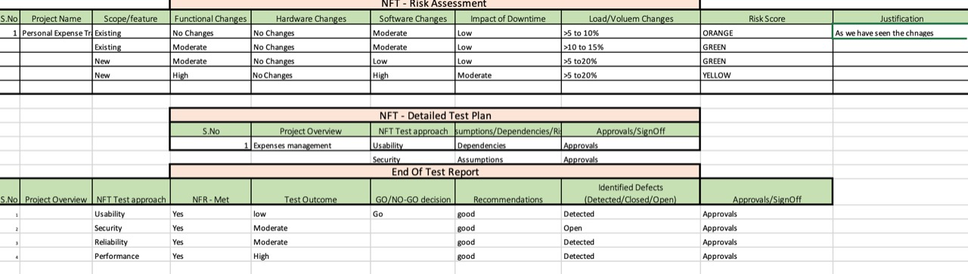

* 1. **Performance Testing**

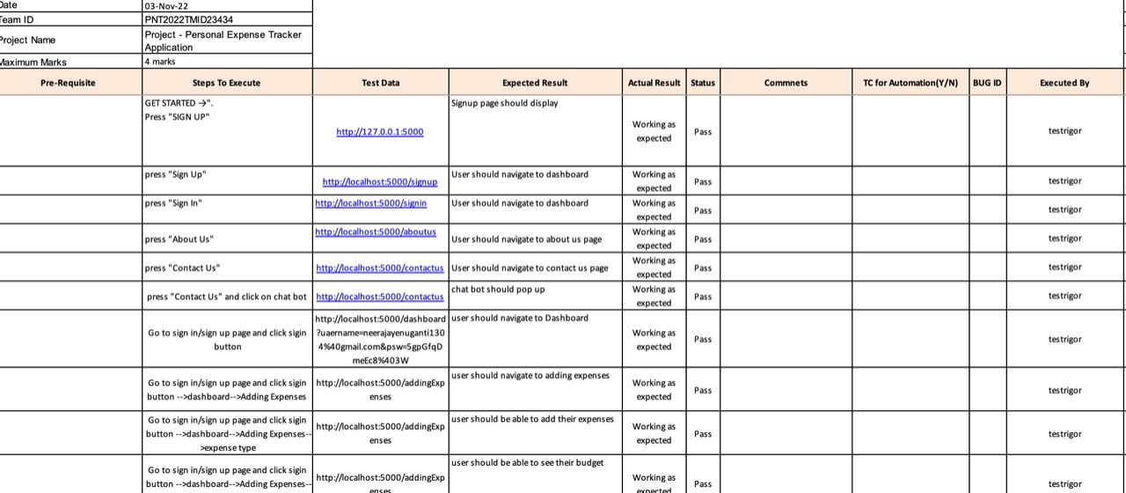

1. **RESULTS** 
   1. **Performance Metrics**

**Software quality is a measurement of something intangible,**

**“how good” a software product really is. Some of the aspects of**

**Software quality taken are**

**a. Scalability**

**b. Speed**

**c. Stability**

**d. Reliability**

**e. Security**

**f**. **Maintainability and code quality**

1. **ADVANTAGES:**
2. **Track your expenses anywhere any time.**

**2. Manage your money and budget without any financial paperwork**

**3. Flexible and adaptive application suited to personal and business man.**

**4. It helps to track the daily expenses in extra efficient and manageable way. 5. It can reduce the manual calculation for the expenses**

**DISADVANTAGES:**

**1. Automating everything to do with your finances can make you financially lazy 2. Rigid Decision making and only consider financial out comes**

**3. May less secure sometimes**

**4. loading of views may be dependent on records.**

**5. Data Maintenance may be difficult due to entering data by user**

1. **Conclusion**

**After making this application we assure that this application will help its users to managethe cost of their daily expenditure. It will guide them and make them aware about theirdaily expenses. It will prove to be helpful for the people who are frustrated with their dailybudget management, irritated because of the amount of expenses and wish to managemoney and to preserve the record of their daily cost which may be useful to change theirway of spending money. In short, this application will help its users to overcome thewastage of money.**

1. **Future Scope**

**1. We are trying to make this app synchronize with mail and bank account so upcoming bill alert should mail and transaction should stop if there is less balance in account.**

**2. More Functionality like capture receipt, add location, backup data will be added very soon.**

**3. We are trying to increase software performance by using maximum use of core. 4. We will try to develop more user friendly Application.**

**5. The sms sending and receiving module will be created to inform about upcoming bills.**

**6. The automation email generation with bill detail will be created to make Application more automated and less user efforts.**

1. **APPENDIX**

**Python code**

**from flask import Flask, request, redirect**

**from flask import Blueprint,render_template**

**app = Flask(__name__)**

**app.debug = True**

**@app.route('/')**

**def landingPage():**

**return render_template("landingPage.html")**

**@app.route('/navbar')**

**def navbar():**

**return render_template("Navbar.html")**

**@app.route('/contactus')**

**def contactus():**

**return render_template("contactUs.html")**

**@app.route('/signup')**

**def signup():**

**return render_template("signUp.html")**

**@app.route('/signin')**

**def signin():**

**return render_template("signIn.html")**

**@app.route('/aboutus')**

**def aboutus():**

**return render_template("aboutUs.html")**

**@app.route('/skeleton')**

**def skeleton():**

**return render_template("skeleton.html")**

**@app.route('/dashboard')**

**def dashboard():**

**return render_template("dashboard.html")**

**@app.route('/addingExpenses')**

**def addingExpenses():**

**return render_template("addingExpenses.html")**

**if __name__ == '__main__':**

**app.run()**

**INDEX CODE:**  
**NavBar.html:**

**<!DOCTYPE html>**

**<html lang="en">**

**<head>**

**<meta charset="UTF-8" />**

**<meta http-equiv="X-UA-Compatible" content="IE=edge" />**

**<meta name="viewport" content="width=device-width, initial-scale=1.0" />**

**<link**

**rel="stylesheet"**

**href="{{url_for('static',filename='Navbar.css')}}"**

**/>**

**</head>**

**<body>**

**<nav>**

**<a href="/" class="appName">Expense Tracker</a>**

**<div class="rightNav">**

**<span><a href="/aboutus" class="landingLink"> About Us</a></span>**

**<span><a href="/contactus" class="landingLink"> Contact Us</a></span>**

**<span><a href="/signin" class="landingLink">Sign In</a> </span>**

**<span><a href="/signup" class="landingLink">Sign Up</a></span>**

**</div>**

**</nav>**

**</body>**

**</html>**

**AboutUs.css:**

**<!DOCTYPE html>**

**<html lang="en">**

**<head>**

**<meta charset="UTF-8" />**

**<meta http-equiv="X-UA-Compatible" content="IE=edge" />**

**<meta name="viewport" content="width=device-width, initial-scale=1.0" />**

**<link**

**rel="stylesheet"**

**href="{{url_for('static',filename='aboutUs.css')}}"**

**/>**

**<title>About Us</title>**

**</head>**

**<body>**

**{% include 'Navbar.html' %}**

**<h1>About Us Page</h1>**

**<div class="about">**

**<p><pre><i>We four friends developed this expense tracker that will help everyone track their expenses.**

**Expense Tracker helps you to get your finances into the shape so that you don't need to stress about every**

**penny that you spend. If you know how much and what on you spend, it is easier to change your financial**

**habits, if you feel like that's what you need. Having a complete picture of your finances in one place.**

**make them easier to manage.</i></pre></p>**

**<p><pre><i>This app allows you to input your income and expenses and gives analytics and insights in the form of**

**graphs and bars which help you to track your expenses. It also provides various functionalites such as**

**creation of budget, gives alert of the upcoming transactions, Information about discounts and various**

**other functions that helps you to save money</i></pre></p>**

**</div>**

**</body>**

**</html>**

**AddingExpense.html:**

**<!DOCTYPE html>**

**<html lang="en">**

**<head>**

**<meta charset="UTF-8">**

**<meta name="viewport" content="width=device-width, initial-scale=1">**

**<title>Expense Manager</title>**

**<!-- Icon Bar link-->**

**<link rel = "icon" href = "image/wallet2.svg" type = "image/x-icon">**

**<link rel="stylesheet" href="https://maxcdn.bootstrapcdn.com/bootstrap/4.0.0/css/bootstrap.min.css"**

**integrity="sha384-Gn5384xqQ1aoWXA+058RXPxPg6fy4IWvTNh0E263XmFcJlSAwiGgFAW/dAiS6JXm" crossorigin="anonymous">**

**<link**

**rel="stylesheet"**

**href="{{url_for('static',filename='style.css')}}"**

**/>**

**<link href="https://fonts.googleapis.com/css2?family=Open+Sans:wght@400;700&display=swap" rel="stylesheet">**

**<link href="https://cdnjs.cloudflare.com/ajax/libs/Chart.js/2.9.3/Chart.css" rel="stylesheet">**

**<script src="https://code.jquery.com/jquery-3.2.1.slim.min.js"**

**integrity="sha384-KJ3o2DKtIkvYIK3UENzmM7KCkRr/rE9/Qpg6aAZGJwFDMVNA/GpGFF93hXpG5KkN"**

**crossorigin="anonymous"></script>**

**<script src="https://cdnjs.cloudflare.com/ajax/libs/popper.js/1.12.9/umd/popper.min.js"**

**integrity="sha384-ApNbgh9B+Y1QKtv3Rn7W3mgPxhU9K/ScQsAP7hUibX39j7fakFPskvXusvfa0b4Q"**

**crossorigin="anonymous"></script>**

**<script src="https://maxcdn.bootstrapcdn.com/bootstrap/4.0.0/js/bootstrap.min.js"**

**integrity="sha384-JZR6Spejh4U02d8jOt6vLEHfe/JQGiRRSQQxSfFWpi1MquVdAyjUar5+76PVCmYl"**

**crossorigin="anonymous"></script>**

**<script src="https://cdnjs.cloudflare.com/ajax/libs/Chart.js/2.9.3/Chart.js" crossorigin="anonymous"></script>**

**<!-- Bootstrap CSS -->**

**<link href="https://cdn.jsdelivr.net/npm/bootstrap@5.0.0-beta1/dist/css/bootstrap.min.css" rel="stylesheet" integrity="sha384-giJF6kkoqNQ00vy+HMDP7azOuL0xtbfIcaT9wjKHr8RbDVddVHyTfAAsrekwKmP1" crossorigin="anonymous">**

**<!-- PDF -->**

**<script src="html2pdf.bundle.min.js"></script>**

**<script>**

**function generatePDF() {**

**// Choose the element that our invoice is rendered in.**

**const element = document.getElementById("invoice");**

**// Choose the element and save the PDF for our user.**

**html2pdf()**

**.from(element)**

**.save();**

**}**

**</script>**

**</head>**

**<body>**

**<!-- NAV BAR -->**

**<nav class="navbar navbar-expand-lg navbar-dark bg-primary">**

**<div class="container-fluid">**

**<a class="navbar-brand active" href="#">Adding Expenses</a>**

**<button class="navbar-toggler" type="button" data-bs-toggle="collapse" data-bs-target="#navbarSupportedContent" aria-controls="navbarSupportedContent" aria-expanded="false" aria-label="Toggle navigation">**

**<span class="navbar-toggler-icon"></span>**

**</button>**

**<div class="collapse navbar-collapse" id="navbarSupportedContent">**

**</div>**

**<div><button type="button" class="btn btn-danger" onclick="generatePDF()">Generate PDF</button></div>**

**</div>**

**</nav>**

**<!-- GEnerating PDF File -->**

**<div id="invoice">**

**<!-- Container For Showing EXPENSE ANF Income -->**

**<div class="row">**

**<div class="col-4 left-container">**

**<div class="month-container">**

**<div class="header fs-white">Your Budget</div>**

**<div id="current-month" class="sub-text fs-white"></div>**

**<div class="budget-container p-2 mt-4">**

**<span id="month-budget" class="month-amount">₹ 0</span>**

**</div>**

**</div>**

**<div class="chart-container">**

**<canvas id="expense-chart"></canvas>**

**</div>**

**</div>**

**<div class="col-7 right-container">**

**<div class="calc-container">**

**<div class="header fs-dark-grey">Track Your Budget</div>**

**<div class="dropdown open">**

**<button class="btn btn-info dropdown-toggle"**

**type="button" id="dropdownMenu3" data-toggle="dropdown"**

**aria-haspopup="true" aria-expanded="false">**

**Expense Type**

**</button>**

**<div class="dropdown-menu">**

**<a class="dropdown-item" id="type-savings">Savings</a>**

**<a class="dropdown-item" id="type-expense">Expense</a>**

**<a class="dropdown-item" id="type-investment">Investment</a>**

**</div>**

**</div>**

**<div class="mt-3 tracking-text text-capitalize sub-text bottom-border">Tracking Savings 💰</div>**

**<div class="row mt-4">**

**<div class="col-7">**

**<input class="form-control input-expense-description" type="text" placeholder="Description">**

**</div>**

**<div class="col-4">**

**<input class="form-control input-expense-value" type="number" placeholder="Value">**

**</div>**

**<div class="col-1">**

**<button type="button" class="btn btn-success btn-submit-expense">&check;</button>**

**</div>**

**</div>**

**<div class="expense-list mt-4">**

**</div>**

**</div>**

**</div>**

**</div>**

**<!-- Closing div for PDF -->**

**</div>**

**<script src="https://cdn.jsdelivr.net/npm/bootstrap@5.0.0-beta1/dist/js/bootstrap.bundle.min.js" integrity="sha384-ygbV9kiqUc6oa4msXn9868pTtWMgiQaeYH7/t7LECLbyPA2x65Kgf80OJFdroafW" crossorigin="anonymous"></script>**

**<script>**

**let ExpenseController = (() => {**

**let total = 0, savings = 0, expenses = 0, investments = 0;**

**return {**

**inputEntry(userInput) {**

**if (userInput['expenseType'] === 'savings') {**

**savings += userInput['value'];**

**total += userInput['value'];**

**}**

**if (userInput['expenseType'] === 'investment') {**

**investments += userInput['value'];**

**total -= userInput['value'];**

**}**

**if (userInput['expenseType'] === 'expense') {**

**expenses += userInput['value'];**

**total -= userInput['value'];**

**}**

**},**

**getSavingsData() {**

**return savings;**

**},**

**getExpensesData() {**

**return expenses;**

**},**

**getInvestmentData() {**

**return investments;**

**},**

**getTotalData() {**

**return total;**

**}**

**}**

**})();**

**let UIController = (() => {**

**let expenseType = 'savings';**

**let HTMLStrings = {**

**inExpenseDescription: '.input-expense-description',**

**inExpenseValue: '.input-expense-value',**

**btnSubmitExpense: '.btn-submit-expense',**

**expenseList: '.expense-list',**

**currentMonth: '#current-month',**

**typeExpense: '#type-expense',**

**typeSavings: '#type-savings',**

**typeInvestment: '#type-investment',**

**trackingText: '.tracking-text',**

**expenseChart: '#expense-chart',**

**monthBudget: '#month-budget'**

**};**

**return {**

**numberFormat(number) {**

**return Intl.NumberFormat('en-IN').format(number);**

**},**

**showCurrentMonth() {**

**let now, month, year, months;**

**now = new Date();**

**month = now.getMonth();**

**year = now.getFullYear();**

**months = [**

**'January', 'February', 'March', 'April', 'May', 'June', 'July', 'August', 'September', 'October',**

**'November', 'December'**

**];**

**document.querySelector(HTMLStrings.currentMonth).textContent = months[month] + " " + year;**

**},**

**getHTMLStrings() {**

**return HTMLStrings;**

**},**

**setExpenseType(type) {**

**console.log('here', type);**

**this.expenseType = type;**

**let emoji ="💰";**

**if (type === 'savings') {**

**emoji ="💰";**

**if (document.querySelector(HTMLStrings.btnSubmitExpense).classList.contains('btn-warning')) {**

**document.querySelector(HTMLStrings.btnSubmitExpense).classList.remove('btn-warning');**

**}**

**if (document.querySelector(HTMLStrings.btnSubmitExpense).classList.contains('btn-danger')) {**

**document.querySelector(HTMLStrings.btnSubmitExpense).classList.remove('btn-danger');**

**}**

**if (!document.querySelector(HTMLStrings.btnSubmitExpense).classList.contains('btn-success')) {**

**document.querySelector(HTMLStrings.btnSubmitExpense).classList.add('btn-success');**

**}**

**}**

**if (type === 'expense') {**

**emoji = "🧾";**

**if (document.querySelector(HTMLStrings.btnSubmitExpense).classList.contains('btn-warning')) {**

**document.querySelector(HTMLStrings.btnSubmitExpense).classList.remove('btn-warning');**

**}**

**if (document.querySelector(HTMLStrings.btnSubmitExpense).classList.contains('btn-success')) {**

**document.querySelector(HTMLStrings.btnSubmitExpense).classList.remove('btn-success');**

**}**

**if (!document.querySelector(HTMLStrings.btnSubmitExpense).classList.contains('btn-danger')) {**

**document.querySelector(HTMLStrings.btnSubmitExpense).classList.add('btn-danger');**

**}**

**}**

**if (type === 'investment') {**

**emoji = "🏠";**

**if (document.querySelector(HTMLStrings.btnSubmitExpense).classList.contains('btn-danger')) {**

**document.querySelector(HTMLStrings.btnSubmitExpense).classList.remove('btn-danger');**

**}**

**if (document.querySelector(HTMLStrings.btnSubmitExpense).classList.contains('btn-success')) {**

**document.querySelector(HTMLStrings.btnSubmitExpense).classList.remove('btn-success');**

**}**

**if (!document.querySelector(HTMLStrings.btnSubmitExpense).classList.contains('btn-warning')) {**

**document.querySelector(HTMLStrings.btnSubmitExpense).classList.add('btn-warning');**

**}**

**}**

**document.querySelector(HTMLStrings.trackingText).textContent = "Tracking " + type + " " + emoji;**

**},**

**getUserExpenseInput() {**

**return {**

**description: document.querySelector(HTMLStrings.inExpenseDescription).value,**

**value: parseInt(document.querySelector(HTMLStrings.inExpenseValue).value),**

**date: new Date().toLocaleDateString(),**

**expenseType: this.expenseType ? this.expenseType : 'savings'**

**}**

**},**

**addListItem (inputObj) {**

**let html, element;**

**element = HTMLStrings.expenseList;**

**if (inputObj['expenseType'] === 'savings') {**

**html = '<div class="bottom-border"> <div class="row expense-row"><div class="col-2 expense-date fs-15">' + inputObj['date'] + ' </div><div class="col-8 expense-text fs-15"> ' + inputObj['description'] + ' </div><div class="col-2 expense-value expense-saving fs-15"> ₹ ' + this.numberFormat(inputObj['value']) + ' </div></div>'**

**} else if (inputObj['expenseType'] === 'expense') {**

**html = '<div class="bottom-border"> <div class="row expense-row"><div class="col-2 expense-date fs-15">' + inputObj['date'] + ' </div><div class="col-8 expense-text fs-15"> ' + inputObj['description'] + ' </div><div class="col-2 expense-value expense-cost fs-15"> ₹ ' + this.numberFormat(inputObj['value']) + ' </div></div>'**

**} else if (inputObj['expenseType'] === 'investment') {**

**html = '<div class="bottom-border"> <div class="row expense-row"><div class="col-2 expense-date fs-15">' + inputObj['date'] + ' </div><div class="col-8 expense-text fs-15"> ' + inputObj['description'] + ' </div><div class="col-2 expense-value expense-investment fs-15"> ₹ ' + this.numberFormat(inputObj['value']) + ' </div></div>'**

**}**

**document.querySelector(element).insertAdjacentHTML('beforeend', html);**

**document.querySelector(HTMLStrings.inExpenseValue).value = "";**

**document.querySelector(HTMLStrings.inExpenseDescription).value = "";**

**},**

**updateOverallTotal(totalValue) {**

**document.querySelector(HTMLStrings.monthBudget).textContent = "₹ " + this.numberFormat(totalValue);**

**if (totalValue > 0) {**

**if (document.querySelector(HTMLStrings.monthBudget).classList.contains('expense-cost')) {**

**document.querySelector(HTMLStrings.monthBudget).classList.remove('expense-cost');**

**}**

**document.querySelector(HTMLStrings.monthBudget).classList.add('expense-saving');**

**} else {**

**if (document.querySelector(HTMLStrings.monthBudget).classList.contains('expense-saving')) {**

**document.querySelector(HTMLStrings.monthBudget).classList.remove('expense-saving');**

**}**

**document.querySelector(HTMLStrings.monthBudget).classList.add('expense-cost');**

**}**

**},**

**displayChart(savings = 0, expenses = 0, investments = 0) {**

**let ctx = document.querySelector(HTMLStrings.expenseChart);**

**let expenseChart = new Chart(ctx, {**

**type: 'doughnut',**

**data: {**

**labels: ['Savings', 'Expenses', 'Investments'],**

**datasets: [{**

**data: [savings, expenses, investments],**

**backgroundColor: [**

**'rgba(32, 137, 56, 1)',**

**'rgba(255, 84, 98, 1)',**

**'rgba(255, 206, 86, 1)'**

**],**

**borderWidth: 0.5**

**}]**

**},**

**options: {**

**legend: {**

**labels: {**

**fontColor: 'white'**

**}**

**}**

**}**

**});**

**}**

**}**

**})();**

**((UIController, ExpenseController) => {**

**let HTMLStrings = UIController.getHTMLStrings();**

**let setupEventListeners = () => {**

**document.querySelector(HTMLStrings.btnSubmitExpense).addEventListener('click', addExpense);**

**document.querySelector(HTMLStrings.typeExpense).addEventListener('click', () => {**

**setExpenseType('expense')**

**});**

**document.querySelector(HTMLStrings.typeInvestment).addEventListener('click', () => {**

**setExpenseType('investment')**

**});**

**document.querySelector(HTMLStrings.typeSavings).addEventListener('click', () => {**

**setExpenseType('savings')**

**});**

**};**

**let setExpenseType = (type) => {**

**UIController.setExpenseType(type);**

**}**

**let addExpense = () => {**

**let input = UIController.getUserExpenseInput();**

**console.log(input);**

**if (input.description !== "" && !isNaN(input.value) && input.value > 0) {**

**console.log('Adding item');**

**UIController.addListItem(input);**

**ExpenseController.inputEntry(input);**

**UIController.updateOverallTotal(ExpenseController.getTotalData());**

**UIController.displayChart(ExpenseController.getSavingsData(), ExpenseController.getExpensesData(),**

**ExpenseController.getInvestmentData());**

**}**

**}**

**let init = () => {**

**console.log('Initializing...');**

**setupEventListeners();**

**UIController.showCurrentMonth();**

**}**

**init();**

**})(UIController, ExpenseController);**

**</script>**

**</body>**

**</html>**

**ContactUs.html:**

**<!DOCTYPE html>**

**<html lang="en">**

**<head>**

**<meta charset="UTF-8" />**

**<meta http-equiv="X-UA-Compatible" content="IE=edge" />**

**<meta name="viewport" content="width=device-width, initial-scale=1.0" />**

**<link**

**rel="stylesheet"**

**href="{{url_for('static',filename='contactUs.css')}}"**

**/>**

**<title>Contact Us</title>**

**</head>**

**<body>**

**{% include 'Navbar.html' %}**

**<h1>Contact Us Page</h1>**

**<script>**

**window.watsonAssistantChatOptions = {**

**integrationID: "65e6917c-135a-4648-9eef-f0b647fdac98", // The ID of this integration.**

**region: "jp-tok", // The region your integration is hosted in.**

**serviceInstanceID: "6031e5ab-decf-4990-ad01-54cf7a987e0e", // The ID of your service instance.**

**onLoad: function(instance) { instance.render(); }**

**};**

**setTimeout(function(){**

**const t=document.createElement('script');**

**t.src="https://web-chat.global.assistant.watson.appdomain.cloud/versions/" + (window.watsonAssistantChatOptions.clientVersion || 'latest') + "/WatsonAssistantChatEntry.js";**

**document.head.appendChild(t);**

**});**

**</script>**

**</body>**

**</html>**

**Dashboard.html:**

**<!DOCTYPE html>**

**<html lang="en">**

**<head>**

**<meta charset="UTF-8" />**

**<meta http-equiv="X-UA-Compatible" content="IE=edge" />**

**<meta name="viewport" content="width=device-width, initial-scale=1.0" />**

**<title>Dashboard</title>**

**</head>**

**<body>**

**{% include 'skeleton.html' %}**

**<div class="flex flex-col md:pl-64">**

**<main class="flex-1">**

**<div class="py-6">**

**<div class="mx-auto max-w-7xl px-4 sm:px-6 md:px-8">**

**<h1 class="text-2xl font-semibold text-[#d32840]">Dashboard</h1>**

**</div>**

**<div class="mx-auto max-w-7xl px-4 sm:px-6 md:px-8">**

**<!-- Replace with your content -->**

**<div class="py-4">**

**<div**

**class="h-[38rem] rounded-lg border-4 border-dashed border-gray-200"**

**></div>**

**</div>**

**<!-- /End replace -->**

**</div>**

**</div>**

**</main>**

**</div>**

**</body>**

**</html>**

**LandingPage.html:**

**<!DOCTYPE html>**

**<html lang="en">**

**<head>**

**<meta charset="UTF-8" />**

**<meta http-equiv="X-UA-Compatible" content="IE=edge" />**

**<meta name="viewport" content="width=device-width, initial-scale=1.0" />**

**<link**

**rel="stylesheet"**

**href="{{url_for('static',filename='landingPage.css')}}"**

**/>**

**<title>Expense Tracker Landing Page</title>**

**</head>**

**<body>**

**{% include 'Navbar.html' %}**

**<div class="contents">**

**<div class="leftContents">**

**<p class="message1">The Expense Tracker for your needs</p>**

**<p class="message2">Track all your expenses here...</p>**

**<div>**

**<a href="/dashboard" class="getStartedButton">Get Started -></a>**

**</div>**

**</div>**

**<div class="rightContents">**

**<img**

**src="../static/images/landing_page_img.png"**

**alt="Landing Page Gif woman working on laptop"**

**class="landing_page_gif"**

**height="90%"**

**width="100%"**

**/>**

**</div>**

**</div>**

**</body>**

**</html>**

**SignIn.html:**

**<!DOCTYPE html>**

**<html lang="en">**

**<head>**

**<meta charset="UTF-8" />**

**<meta http-equiv="X-UA-Compatible" content="IE=edge" />**

**<meta name="viewport" content="width=device-width, initial-scale=1.0" />**

**<link**

**rel="stylesheet"**

**href="{{url_for('static',filename='signIn.css')}}"**

**/>**

**<title>signIn</title>**

**</head>**

**<body>**

**{% include 'Navbar.html' %}**

**<h1>Sign In Page</h1>**

**<div class="signin" style="border:1px solid rgb(30, 28, 28)">**

**<form action="/dashboard">**

**<label for="username"><b>username</b></label>**

**<input type="text" placeholder="Enter username" name="uaername" required class="name"></br></br>**

**<label for="psw"><b>Password</b></label>**

**<input type="password" placeholder="Enter Password" name="psw" required class="psw"></br></br>**

**<a href="/dashboard" target="_blank"><button type="submit" class="signinbtn">Sign in</button></a>**

**</form>**

**<p class="or">or</p>**

**<a href="/login" target="_blank"><button class="googlelogin">Signin with google</button></a>**

**</div>**

**</body>**

**</html>**

**SignUp.html:**

**<!DOCTYPE html>**

**<html lang="en">**

**<head>**

**<meta charset="UTF-8" />**

**<meta http-equiv="X-UA-Compatible" content="IE=edge" />**

**<meta name="viewport" content="width=device-width, initial-scale=1.0" />**

**<title>Sign Up</title>**

**<link**

**rel="stylesheet"**

**href="{{url_for('static',filename='signUp.css')}}"**

**/>**

**</head>**

**<body>**

**{% include 'Navbar.html' %}**

**<h1>Sign Up Page</h1>**

**<section class="signup" style="border:1px solid rgb(32, 30, 30)">**

**<form action="/dashboard" class="hero">**

**<label for="fullname"><b>Full Name</b></label>**

**<input type="text" placeholder="Enter name" name="name" class="name" required></br></br>**

**<label for="email"><b>Email</b></label>**

**<input type="text" placeholder="Enter Email" name="email" class="email" required></br></br>**

**<label for="username"><b>Username</b></label>**

**<input type="text" placeholder="Enter username" name="uaername" class="username" required></br></br>**

**<label for="psw"><b>Password</b></label>**

**<input type="password" placeholder="Enter Password" name="psw" class="psw" required></br></br>**

**<label for="psw-repeat"><b>Repeat Password</b></label>**

**<input type="password" placeholder="Repeat Password" name="psw-repeat" class="psw-repeat" required></br></br>**

**<div class="clearfix">**

**<button type="button" class="cancelbtn">Cancel</button></br>**

**<a href="/dashboard" target="_blank"><button type="submit" class="signupbtn">Sign Up</button></a>**

**</form>**

**<p class="or">or</p>**

**<a href="/login" target="_blank"><button class="google">sign up with google</button></a>**

**</section>**

**</body>**

**</html>**

**Skeleton.html:**

**<!DOCTYPE html>**

**<html lang="en">**

**<head>**

**<meta charset="UTF-8" />**

**<meta http-equiv="X-UA-Compatible" content="IE=edge" />**

**<meta name="viewport" content="width=device-width, initial-scale=1.0" />**

**<link**

**rel="stylesheet"**

**href="{{url_for('static',filename='css/skeleton.css')}}"**

**/>**

**<script src="https://cdn.tailwindcss.com"></script>**

**</head>**

**<body class="bg-[#fff7e9]">**

**<div>**

**<div class="relative z-40 md:hidden" role="dialog" aria-modal="true">**

**<div class="fixed inset-0 bg-[#d32840] bg-opacity-75"></div>**

**<div class="fixed inset-0 z-40 flex">**

**>**

**<div**

**class="relative flex w-full max-w-xs flex-1 flex-col bg-gray-800 pt-5 pb-4"**

**>**

**<div class="absolute top-0 right-0 -mr-12 pt-2">**

**<button**

**type="button"**

**class="ml-1 flex h-10 w-10 items-center justify-center rounded-full focus:outline-none focus:ring-2 focus:ring-inset focus:ring-white"**

**>**

**<span class="sr-only">Close sidebar</span>**

**<svg**

**class="h-6 w-6 text-white"**

**xmlns="http://www.w3.org/2000/svg"**

**fill="none"**

**viewBox="0 0 24 24"**

**stroke-width="1.5"**

**stroke="currentColor"**

**aria-hidden="true"**

**>**

**<path**

**stroke-linecap="round"**

**stroke-linejoin="round"**

**d="M6 18L18 6M6 6l12 12"**

**/>**

**</svg>**

**</button>**

**</div>**

**<div class="flex flex-shrink-0 items-center px-4">**

**</div>**

**<div class="mt-5 h-0 flex-1 overflow-y-auto">**

**<nav class="space-y-1 px-2 ">**

**<a**

**href="/dashboard"**

**class="bg-gray-900 text-white group flex items-center px-2 py-2 text-base font-medium rounded-md"**

**>**

**<!-- Heroicon name: outline/home -->**

**<svg**

**class="text-gray-300 mr-4 flex-shrink-0 h-6 w-6"**

**xmlns="http://www.w3.org/2000/svg"**

**fill="none"**

**viewBox="0 0 24 24"**

**stroke-width="1.5"**

**stroke="currentColor"**

**aria-hidden="true"**

**>**

**<path**

**stroke-linecap="round"**

**stroke-linejoin="round"**

**d="M2.25 12l8.954-8.955c.44-.439 1.152-.439 1.591 0L21.75 12M4.5 9.75v10.125c0 .621.504 1.125 1.125 1.125H9.75v-4.875c0-.621.504-1.125 1.125-1.125h2.25c.621 0 1.125.504 1.125 1.125V21h4.125c.621 0 1.125-.504 1.125-1.125V9.75M8.25 21h8.25"**

**/>**

**</svg>**

**Dashboard**

**</a>**

**<a**

**href="#"**

**class="text-gray-300 hover:bg-[#a31d2f] hover:text-white group flex items-center px-2 py-2 text-base font-medium rounded-md"**

**>**

**<!-- Heroicon name: outline/users -->**

**<svg**

**class="text-gray-400 group-hover:text-gray-300 mr-4 flex-shrink-0 h-6 w-6"**

**xmlns="http://www.w3.org/2000/svg"**

**fill="none"**

**viewBox="0 0 24 24"**

**stroke-width="1.5"**

**stroke="currentColor"**

**aria-hidden="true"**

**>**

**<path**

**stroke-linecap="round"**

**stroke-linejoin="round"**

**d="M15 19.128a9.38 9.38 0 002.625.372 9.337 9.337 0 004.121-.952 4.125 4.125 0 00-7.533-2.493M15 19.128v-.003c0-1.113-.285-2.16-.786-3.07M15 19.128v.106A12.318 12.318 0 018.624 21c-2.331 0-4.512-.645-6.374-1.766l-.001-.109a6.375 6.375 0 0111.964-3.07M12 6.375a3.375 3.375 0 11-6.75 0 3.375 3.375 0 016.75 0zm8.25 2.25a2.625 2.625 0 11-5.25 0 2.625 2.625 0 015.25 0z"**

**/>**

**</svg>**

**Team**

**</a>**

**<a**

**href="#"**

**class="text-gray-300 hover:bg-[#a31d2f] hover:text-white group flex items-center px-2 py-2 text-base font-medium rounded-md"**

**>**

**<!-- Heroicon name: outline/folder -->**

**<svg**

**class="text-gray-400 group-hover:text-gray-300 mr-4 flex-shrink-0 h-6 w-6"**

**xmlns="http://www.w3.org/2000/svg"**

**fill="none"**

**viewBox="0 0 24 24"**

**stroke-width="1.5"**

**stroke="currentColor"**

**aria-hidden="true"**

**>**

**<path**

**stroke-linecap="round"**

**stroke-linejoin="round"**

**d="M2.25 12.75V12A2.25 2.25 0 014.5 9.75h15A2.25 2.25 0 0121.75 12v.75m-8.69-6.44l-2.12-2.12a1.5 1.5 0 00-1.061-.44H4.5A2.25 2.25 0 002.25 6v12a2.25 2.25 0 002.25 2.25h15A2.25 2.25 0 0021.75 18V9a2.25 2.25 0 00-2.25-2.25h-5.379a1.5 1.5 0 01-1.06-.44z"**

**/>**

**</svg>**

**Projects**

**</a>**

**<a**

**href="#"**

**class="text-gray-300 hover:bg-gray-700 hover:text-white group flex items-center px-2 py-2 text-base font-medium rounded-md"**

**>**

**<!-- Heroicon name: outline/categories -->**

**<svg**

**class="text-gray-400 group-hover:text-gray-300 mr-4 flex-shrink-0 h-6 w-6"**

**xmlns="http://www.w3.org/2000/svg"**

**fill="none"**

**viewBox="0 0 24 24"**

**stroke-width="1.5"**

**stroke="currentColor"**

**aria-hidden="true"**

**>**

**<path**

**stroke-linecap="round"**

**stroke-linejoin="round"**

**d="M6.75 3v2.25M17.25 3v2.25M3 18.75V7.5a2.25 2.25 0 012.25-2.25h13.5A2.25 2.25 0 0121 7.5v11.25m-18 0A2.25 2.25 0 005.25 21h13.5A2.25 2.25 0 0021 18.75m-18 0v-7.5A2.25 2.25 0 015.25 9h13.5A2.25 2.25 0 0121 11.25v7.5"**

**/>**

**</svg>**

**Categories**

**</a>**

**<a**

**href="#"**

**class="text-gray-300 hover:bg-gray-700 hover:text-white group flex items-center px-2 py-2 text-base font-medium rounded-md"**

**>**

**<!-- Heroicon name: outline/inbox -->**

**<svg**

**class="text-gray-400 group-hover:text-gray-300 mr-4 flex-shrink-0 h-6 w-6"**

**xmlns="http://www.w3.org/2000/svg"**

**fill="none"**

**viewBox="0 0 24 24"**

**stroke-width="1.5"**

**stroke="currentColor"**

**aria-hidden="true"**

**>**

**<path**

**stroke-linecap="round"**

**stroke-linejoin="round"**

**d="M2.25 13.5h3.86a2.25 2.25 0 012.012 1.244l.256.512a2.25 2.25 0 002.013 1.244h3.218a2.25 2.25 0 002.013-1.244l.256-.512a2.25 2.25 0 012.013-1.244h3.859m-19.5.338V18a2.25 2.25 0 002.25 2.25h15A2.25 2.25 0 0021.75 18v-4.162c0-.224-.034-.447-.1-.661L19.24 5.338a2.25 2.25 0 00-2.15-1.588H6.911a2.25 2.25 0 00-2.15 1.588L2.35 13.177a2.25 2.25 0 00-.1.661z"**

**/>**

**</svg>**

**Documents**

**</a>**

**<a**

**href="#"**

**class="text-gray-300 hover:bg-gray-700 hover:text-white group flex items-center px-2 py-2 text-base font-medium rounded-md"**

**>**

**<!-- Heroicon name: outline/chart-bar -->**

**<svg**

**class="text-gray-400 group-hover:text-gray-300 mr-4 flex-shrink-0 h-6 w-6"**

**xmlns="http://www.w3.org/2000/svg"**

**fill="none"**

**viewBox="0 0 24 24"**

**stroke-width="1.5"**

**stroke="currentColor"**

**aria-hidden="true"**

**>**

**<path**

**stroke-linecap="round"**

**stroke-linejoin="round"**

**d="M3 13.125C3 12.504 3.504 12 4.125 12h2.25c.621 0 1.125.504 1.125 1.125v6.75C7.5 20.496 6.996 21 6.375 21h-2.25A1.125 1.125 0 013 19.875v-6.75zM9.75 8.625c0-.621.504-1.125 1.125-1.125h2.25c.621 0 1.125.504 1.125 1.125v11.25c0 .621-.504 1.125-1.125 1.125h-2.25a1.125 1.125 0 01-1.125-1.125V8.625zM16.5 4.125c0-.621.504-1.125 1.125-1.125h2.25C20.496 3 21 3.504 21 4.125v15.75c0 .621-.504 1.125-1.125 1.125h-2.25a1.125 1.125 0 01-1.125-1.125V4.125z"**

**/>**

**</svg>**

**Reports**

**</a>**

**</nav>**

**</div>**

**</div>**

**<div class="w-14 flex-shrink-0" aria-hidden="true">**

**<!-- Dummy element to force sidebar to shrink to fit close icon -->**

**</div>**

**</div>**

**</div>**

**<!-- Static sidebar for desktop -->**

**<div class="hidden md:fixed md:inset-y-0 md:flex md:w-64 md:flex-col">**

**<!-- Sidebar component, swap this element with another sidebar if you like -->**

**<div class="flex min-h-0 flex-1 flex-col bg-[#d32840]">**

**<div class="flex h-16 flex-shrink-0 items-center bg-[#a31d2f] px-4">**

**<a href='/' class="text-2xl font-bold text-[#fff7e9]">Expense Tracker</a>**

**</div>**

**<div class="flex flex-1 flex-col overflow-y-auto">**

**<nav class="flex-1 space-y-1 px-2 py-4">**

**<!-- Current: "bg-gray-900 text-white", Default: "text-gray-300 hover:bg-gray-700 hover:text-white" -->**

**<a**

**href="/dashboard"**

**class="bg-[#a31d2f] text-[#fff7e9] group flex items-center px-2 py-2 text-sm font-medium rounded-md"**

**>**

**<!--**

**Heroicon name: outline/home**

**Current: "text-gray-300", Default: "text-gray-400 group-hover:text-gray-300"**

**-->**

**<svg**

**class="text-gray-300 mr-3 flex-shrink-0 h-6 w-6"**

**xmlns="http://www.w3.org/2000/svg"**

**fill="none"**

**viewBox="0 0 24 24"**

**stroke-width="1.5"**

**stroke="currentColor"**

**aria-hidden="true"**

**>**

**<path**

**stroke-linecap="round"**

**stroke-linejoin="round"**

**d="M2.25 12l8.954-8.955c.44-.439 1.152-.439 1.591 0L21.75 12M4.5 9.75v10.125c0 .621.504 1.125 1.125 1.125H9.75v-4.875c0-.621.504-1.125 1.125-1.125h2.25c.621 0 1.125.504 1.125 1.125V21h4.125c.621 0 1.125-.504 1.125-1.125V9.75M8.25 21h8.25"**

**/>**

**</svg>**

**Dashboard**

**</a>**

**<a**

**href="/addingExpenses"**

**class="text-[#fff7e9] hover:bg-[#a31d2f] hover:text-white group flex items-center px-2 py-2 text-sm font-medium rounded-md"**

**>**

**<!-- Heroicon name: outline/users -->**

**<svg**

**class="text-[#fff7e9] group-hover:text-gray-300 mr-3 flex-shrink-0 h-6 w-6"**

**xmlns="http://www.w3.org/2000/svg"**

**fill="none"**

**viewBox="0 0 24 24"**

**stroke-width="1.5"**

**stroke="currentColor"**

**aria-hidden="true"**

**>**

**<path**

**stroke-linecap="round"**

**stroke-linejoin="round"**

**d="M15 19.128a9.38 9.38 0 002.625.372 9.337 9.337 0 004.121-.952 4.125 4.125 0 00-7.533-2.493M15 19.128v-.003c0-1.113-.285-2.16-.786-3.07M15 19.128v.106A12.318 12.318 0 018.624 21c-2.331 0-4.512-.645-6.374-1.766l-.001-.109a6.375 6.375 0 0111.964-3.07M12 6.375a3.375 3.375 0 11-6.75 0 3.375 3.375 0 016.75 0zm8.25 2.25a2.625 2.625 0 11-5.25 0 2.625 2.625 0 015.25 0z"**

**/>**

**</svg>**

**Adding Expenses**

**</a>**

**<a**

**href="/categories"**

**class="text-[#fff7e9] hover:bg-[#a31d2f] hover:text-white group flex items-center px-2 py-2 text-sm font-medium rounded-md"**

**>**

**<!-- Heroicon name: outline/folder -->**

**<svg**

**class="text-[#fff7e9] group-hover:text-gray-300 mr-3 flex-shrink-0 h-6 w-6"**

**xmlns="http://www.w3.org/2000/svg"**

**fill="none"**

**viewBox="0 0 24 24"**

**stroke-width="1.5"**

**stroke="currentColor"**

**aria-hidden="true"**

**>**

**<path**

**stroke-linecap="round"**

**stroke-linejoin="round"**

**d="M2.25 12.75V12A2.25 2.25 0 014.5 9.75h15A2.25 2.25 0 0121.75 12v.75m-8.69-6.44l-2.12-2.12a1.5 1.5 0 00-1.061-.44H4.5A2.25 2.25 0 002.25 6v12a2.25 2.25 0 002.25 2.25h15A2.25 2.25 0 0021.75 18V9a2.25 2.25 0 00-2.25-2.25h-5.379a1.5 1.5 0 01-1.06-.44z"**

**/>**

**</svg>**

**Categories**

**</a>**

**<a**

**href="/reports"**

**class="text-[#fff7e9] hover:bg-[#a31d2f] hover:text-white group flex items-center px-2 py-2 text-sm font-medium rounded-md"**

**>**

**<!-- Heroicon name: outline/categories -->**

**<svg**

**class="text-[#fff7e9] group-hover:text-gray-300 mr-3 flex-shrink-0 h-6 w-6"**

**xmlns="http://www.w3.org/2000/svg"**

**fill="none"**

**viewBox="0 0 24 24"**

**stroke-width="1.5"**

**stroke="currentColor"**

**aria-hidden="true"**

**>**

**<path**

**stroke-linecap="round"**

**stroke-linejoin="round"**

**d="M6.75 3v2.25M17.25 3v2.25M3 18.75V7.5a2.25 2.25 0 012.25-2.25h13.5A2.25 2.25 0 0121 7.5v11.25m-18 0A2.25 2.25 0 005.25 21h13.5A2.25 2.25 0 0021 18.75m-18 0v-7.5A2.25 2.25 0 015.25 9h13.5A2.25 2.25 0 0121 11.25v7.5"**

**/>**

**</svg>**

**Reports**

**</svg>**

**<a**

**href="/tips"**

**class="text-[#fff7e9] hover:bg-[#a31d2f] hover:text-white group flex items-center px-2 py-2 text-sm font-medium rounded-md"**

**>**

**<!-- Heroicon name: outline/inbox -->**

**<svg**

**class="text-[#fff7e9] group-hover:text-gray-300 mr-3 flex-shrink-0 h-6 w-6"**

**xmlns="http://www.w3.org/2000/svg"**

**fill="none"**

**viewBox="0 0 24 24"**

**stroke-width="1.5"**

**stroke="currentColor"**

**aria-hidden="true"**

**>**

**<path**

**stroke-linecap="round"**

**stroke-linejoin="round"**

**d="M2.25 13.5h3.86a2.25 2.25 0 012.012 1.244l.256.512a2.25 2.25 0 002.013 1.244h3.218a2.25 2.25 0 002.013-1.244l.256-.512a2.25 2.25 0 012.013-1.244h3.859m-19.5.338V18a2.25 2.25 0 002.25 2.25h15A2.25 2.25 0 0021.75 18v-4.162c0-.224-.034-.447-.1-.661L19.24 5.338a2.25 2.25 0 00-2.15-1.588H6.911a2.25 2.25 0 00-2.15 1.588L2.35 13.177a2.25 2.25 0 00-.1.661z"**

**/>**

**</svg>**

**Tips**

**</a>**

**<a**

**href="/help&support"**

**class="text-[#fff7e9] hover:bg-[#a31d2f] hover:text-white group flex items-center px-2 py-2 text-sm font-medium rounded-md"**

**>**

**<!-- Heroicon name: outline/chart-bar -->**

**<svg**

**class="text-[#fff7e9] group-hover:text-gray-300 mr-3 flex-shrink-0 h-6 w-6"**

**xmlns="http://www.w3.org/2000/svg"**

**fill="none"**

**viewBox="0 0 24 24"**

**stroke-width="1.5"**

**stroke="currentColor"**

**aria-hidden="true"**

**>**

**<path**

**stroke-linecap="round"**

**stroke-linejoin="round"**

**d="M3 13.125C3 12.504 3.504 12 4.125 12h2.25c.621 0 1.125.504 1.125 1.125v6.75C7.5 20.496 6.996 21 6.375 21h-2.25A1.125 1.125 0 013 19.875v-6.75zM9.75 8.625c0-.621.504-1.125 1.125-1.125h2.25c.621 0 1.125.504 1.125 1.125v11.25c0 .621-.504 1.125-1.125 1.125h-2.25a1.125 1.125 0 01-1.125-1.125V8.625zM16.5 4.125c0-.621.504-1.125 1.125-1.125h2.25C20.496 3 21 3.504 21 4.125v15.75c0 .621-.504 1.125-1.125 1.125h-2.25a1.125 1.125 0 01-1.125-1.125V4.125z"**

**/>**

**</svg>**

**Help & Support**

**</a>**

**<a**

**href="/settings"**

**class="text-[#fff7e9] hover:bg-[#a31d2f] hover:text-white group flex items-center px-2 py-2 text-sm font-medium rounded-md"**

**>**

**<!-- Heroicon name: outline/chart-bar -->**

**<svg**

**class="text-[#fff7e9] group-hover:text-gray-300 mr-3 flex-shrink-0 h-6 w-6"**

**xmlns="http://www.w3.org/2000/svg"**

**fill="none"**

**viewBox="0 0 24 24"**

**stroke-width="1.5"**

**stroke="currentColor"**

**aria-hidden="true"**

**>**

**<path**

**stroke-linecap="round"**

**stroke-linejoin="round"**

**d="M3 13.125C3 12.504 3.504 12 4.125 12h2.25c.621 0 1.125.504 1.125 1.125v6.75C7.5 20.496 6.996 21 6.375 21h-2.25A1.125 1.125 0 013 19.875v-6.75zM9.75 8.625c0-.621.504-1.125 1.125-1.125h2.25c.621 0 1.125.504 1.125 1.125v11.25c0 .621-.504 1.125-1.125 1.125h-2.25a1.125 1.125 0 01-1.125-1.125V8.625zM16.5 4.125c0-.621.504-1.125 1.125-1.125h2.25C20.496 3 21 3.504 21 4.125v15.75c0 .621-.504 1.125-1.125 1.125h-2.25a1.125 1.125 0 01-1.125-1.125V4.125z"**

**/>**

**</svg>**

**Settings**

**</a>**

**</nav>**

**</div>**

**</div>**

**</div>**

**<div class="flex flex-col md:pl-64">**

**<div class="sticky top-0 z-10 flex h-16 flex-shrink-0 bg-[#fff7e9] shadow">**

**<button**

**type="button"**

**class="border-r border-gray-200 px-4 text-gray-500 focus:outline-none focus:ring-2 focus:ring-inset focus:ring-indigo-500 md:hidden"**

**>**

**<span class="sr-only">Open sidebar</span>**

**<!-- Heroicon name: outline/bars-3-bottom-left -->**

**<svg**

**class="h-6 w-6"**

**xmlns="http://www.w3.org/2000/svg"**

**fill="none"**

**viewBox="0 0 24 24"**

**stroke-width="1.5"**

**stroke="currentColor"**

**aria-hidden="true"**

**>**

**<path**

**stroke-linecap="round"**

**stroke-linejoin="round"**

**d="M3.75 6.75h16.5M3.75 12h16.5m-16.5 5.25H12"**

**/>**

**</svg>**

**</button>**

**<div class="flex flex-1 justify-between px-4">**

**<div class="flex flex-1">**

**<form class="flex w-full md:ml-0" action="#" method="GET">**

**<label for="search-field" class="sr-only">Search</label>**

**<div**

**class="relative w-full text-gray-400 focus-within:text-gray-600"**

**>**

**<div**

**class="pointer-events-none absolute inset-y-0 left-0 flex items-center"**

**>**

**<!-- Heroicon name: mini/magnifying-glass -->**

**<svg**

**class="h-5 w-5 text-[#d32840]"**

**xmlns="http://www.w3.org/2000/svg"**

**viewBox="0 0 20 20"**

**fill="currentColor"**

**aria-hidden="true"**

**>**

**<path**

**fill-rule="evenodd"**

**d="M9 3.5a5.5 5.5 0 100 11 5.5 5.5 0 000-11zM2 9a7 7 0 1112.452 4.391l3.328 3.329a.75.75 0 11-1.06 1.06l-3.329-3.328A7 7 0 012 9z"**

**clip-rule="evenodd"**

**/>**

**</svg>**

**</div>**

**<input**

**id="search-field"**

**class="block h-full w-full border-transparent py-2 pl-8 pr-3 text-gray-900 placeholder-[#d32840] bg-[#fff7e9] focus:border-transparent focus:placeholder-gray-400 focus:outline-none focus:ring-0 sm:text-sm"**

**placeholder="Search"**

**type="search"**

**name="search"**

**/>**

**</div>**

**</form>**

**</div>**

**<div class="ml-4 flex items-center md:ml-6">**

**<button**

**type="button"**

**class="rounded-full bg-[#fff7e9] p-1 text-gray-400 hover:text-gray-500 focus:outline-none focus:ring-2 focus:ring-indigo-500 focus:ring-offset-2"**

**>**

**<span class="sr-only">View notifications</span>**

**<!-- Heroicon name: outline/bell -->**

**<svg**

**class="h-6 w-6 text-[#d32840]"**

**xmlns="http://www.w3.org/2000/svg"**

**fill="none"**

**viewBox="0 0 24 24"**

**stroke-width="1.5"**

**stroke="currentColor"**

**aria-hidden="true"**

**>**

**<path**

**stroke-linecap="round"**

**stroke-linejoin="round"**

**d="M14.857 17.082a23.848 23.848 0 005.454-1.31A8.967 8.967 0 0118 9.75v-.7V9A6 6 0 006 9v.75a8.967 8.967 0 01-2.312 6.022c1.733.64 3.56 1.085 5.455 1.31m5.714 0a24.255 24.255 0 01-5.714 0m5.714 0a3 3 0 11-5.714 0"**

**/>**

**</svg>**

**</button>**

**<!-- Profile dropdown -->**

**<div class="relative ml-3">**

**<div>**

**<button**

**type="button"**

**class="flex max-w-xs items-center rounded-full bg-white text-sm focus:outline-none focus:ring-2 focus:ring-indigo-500 focus:ring-offset-2"**

**id="user-menu-button"**

**aria-expanded="false"**

**aria-haspopup="true"**

**>**

**<span class="sr-only">Open user menu</span>**

**<img**

**class="h-11 w-11 rounded-full"**

**src="../static/images/woman-profile.jpg.webp"**

**alt=""**

**/>**

**</button>**

**</div>**

**<!--**

**Dropdown menu, show/hide based on menu state.**

**Entering: "transition ease-out duration-100"**

**From: "transform opacity-0 scale-95"**

**To: "transform opacity-100 scale-100"**

**Leaving: "transition ease-in duration-75"**

**From: "transform opacity-100 scale-100"**

**To: "transform opacity-0 scale-95"**

**-->**

**<!-- Active: "bg-gray-100", Not Active: "" -->**

**<!-- <div**

**class="absolute right-0 z-10 mt-2 w-48 origin-top-right rounded-md bg-white py-1 shadow-lg ring-1 ring-black ring-opacity-5 focus:outline-none"**

**role="menu"**

**aria-orientation="vertical"**

**aria-labelledby="user-menu-button"**

**tabindex="-1"**

**>**

**<a**

**href="#"**

**class="block px-4 py-2 text-sm text-gray-700"**

**role="menuitem"**

**tabindex="-1"**

**id="user-menu-item-0"**

**>Your Profile</a**

**>**

**<a**

**href="#"**

**class="block px-4 py-2 text-sm text-gray-700"**

**role="menuitem"**

**tabindex="-1"**

**id="user-menu-item-1"**

**>Settings</a**

**>**

**<a**

**href="#"**

**class="block px-4 py-2 text-sm text-gray-700"**

**role="menuitem"**

**tabindex="-1"**

**id="user-menu-item-2"**

**>Sign out</a**

**>**

**</div> -->**

**</div>**

**</div>**

**</div>**

**</div>**

**</div>**

**</div>**

**</body>**

**</html>**

**GITHUB LINK:** [**https://github.com/IBM-EPBL/IBM-Project-28085-1660106526**](https://github.com/IBM-EPBL/IBM-Project-28085-1660106526)

**PROJECT DEMO:** [**https://drive.google.com/file/d/15XdGOs4Ps8fhk5wJDA8UAmhC4UPxTEsf/view?usp=share_link**](https://drive.google.com/file/d/15XdGOs4Ps8fhk5wJDA8UAmhC4UPxTEsf/view?usp=share_link)

**LINK: https://drive.google.com/file/d/1ot0ail93JVJjsgVTS GY1D7Pc7pXGDfNw/view**